MISSOURI CANCER REGISTRY

Cancer Reporting Manual for
Non-hospital Facilities

Updated January 2026

Table of Contents

Introduction 5
- General Instructions 6
  - Submission Guidelines 7
  - Reportability 8
    - Mandatory 8
    - Voluntary 9
  - Confidentiality and HIPAA 10
  - Reportable Terminology 10
  - Cases Not Required to be Reported 11
  - Reporting Deaths 11
- Casefinding Techniques 12-13
- Cancer Reporting 13
  - Patient Identification Information 13
Patient Name 13
Address at Diagnosis 14
Date of Birth 14
Social Security Number 14
Race 14
Hispanic Origin 14
Sex 14
Tobacco History 14
Alcohol History 15
Marital Status at Diagnosis 15
Vital Status 15
Usual or Longest held Occupation 15
Occupation and Industry 15
  - Cancer Identification/Staging/Treatment 15
New versus Recurrence 15
Procedure Performed 15
Surgical Procedure Type 15
Primary Site 15
Date of Diagnosis 16
Laterality 16
Ulceration 16
Breslow’s Information 16
Histology 16
Grade 17
Lymph Node Involvement 17
Pre Op Tumor Markers 17
SEER Staging of Disease 18-19
Staging Procedures 19
Distant Metastasis 19
Chemotherapy 19
Hormone Treatment 19
Radiation Treatment 19
Radiation Modality 19

Other Treatment 20
Date of Last Contact or Death 20
Supportive Care 20
Follow-back 20
- Web Plus 22
  - General Instructions 22
Login 22
Beginning a New Abstract 23
Icons Explained 24-25
Saving an Abstract 26
Locating/Opening a Saved Abstract 26
Edit Errors 27
Releasing a Completed Abstract 27
Logging out 28
Follow-back 28-29
  - Web Plus Quick Reference Guide 30
  - Completed Melanoma Case (Example) 31-33
- Appendices 34
- Quick Guide to Reporting 34
- Information Required to Complete Patient Report 35
- General Staging and TNM Staging 36-38
- Casefinding List 39
- Resources/References 40-41
- FAQs About MCR 42-44
- Disease Process Information for LTCFs 45-52

INTRODUCTION

The Missouri Cancer Registry Cancer Reporting Instruction Manual has been written to assist non-hospital facilities in reporting cancer cases to the Missouri Cancer Registry (MCR).
Established in 1972, the Missouri Cancer Registry serves as a statewide cancer database. Cancer reporting for Missouri hospitals was voluntary from 1977 until 1984, when the Missouri General Assembly passed a bill to require cancer reporting of inpatient cancer cases. Consequently, 1985 represents the first year that Missouri cancer incidence rates can be calculated.

Responding to public health needs, the United States (US) Congress established the National Program of Cancer Registries (NPCR) in 1992. Administered by the Centers for Disease Control and Prevention (CDC), this program provides funds to enhance or establish state central cancer registries. Missouri became a NPCR state in 1995, with 1996 designated as MCR’s index (reference) year.

NPCR requires state central registries to:

- Collect incidence data on residents,
- Follow stringent data management procedures,
- Provide training for state personnel, hospital registry and Non-hospital reporting facility staff,
- Publish an annual report within 24 months of the end of the diagnostic year,
- Conduct case-finding audits at selected facilities and
- Have legislation in place that mandates reporting of cases by all types of facilities that diagnose and/or treat cancer.

In 1999, the late Governor Mel Carnahan signed an expanded cancer reporting law. This law requires that pathology laboratories, ambulatory surgery centers, freestanding cancer clinics and treatment centers, physicians and Non-hospital facilities report cancer cases.
The expanded cancer reporting law was necessary not only because it is required by the CDC, but also due to the significant change in the patterns of health care. In recent years, this shift to outpatient diagnosis and treatment has resulted in underreporting of certain types of cancer cases (e.g. melanoma of the skin, bladder cancer, prostate cancer, etc.). Without complete data, the Missouri Department of Health and Senior Services (DHSS) cannot conduct accurate epidemiological studies or develop a comprehensive cancer prevention and control strategy.

Missouri Cancer Registry staff are available to provide one-on-one training workshops and educational presentations, as well as analysis of information submitted for special studies. Such studies can be customized based on the requirements of the hospital, physician, or health agency. Please refer to Appendix 5 to select the appropriate contact personnel.

GENERAL INSTRUCTIONS
The following information provides some basic rules regarding cancer reporting to the states’ central registry.

The cancer reporting law applies to all types of Non-hospital facilities:
  - Pathology laboratories,
  - Physician offices, ambulatory surgical centers, free-standing cancer clinics and treatment centers (collectively to be referred to in the remainder of this document as “physician reporting”), and
  - Residential care facilities or assisted living facilities, intermediate care facilities or skilled nursing facilities (collectively to be referred to in the remainder of this document as “long-term care facilities” or LTCF)

The instructions that follow in this manual will include paragraphs particular to given facility types.

All cancer cases diagnosed and/or treated for cancer

in your facility must be reported to MCR.

All reporting is to be done electronically using Web Plus. Web Plus is a free software offered to all medical facilities reporting cases to the Missouri Cancer Registry. Forms within Web Plus are tailored to each physician reporting facility type and sometimes even to a specific cancer site.
There may be times when the medical record does not have all of the appropriate information to assist in coding these fields. If there is insufficient information to complete all of the items/fields, complete the form with as much information as possible. The name of the attending physician and the hospital in which the patient may have been admitted should be included on the form so that the facility can be contacted if more information is needed. If information cannot be found, please document by writing “unknown” or “information not available”, rather than leave fields blank.
In addition to the instructions in this manual, there is a lot of educational information on our website. We also have Educational Webinars and Recordings linked under the Education tab of the MCR website. Condensed instructions for Web Plus are included in Section III of this manual, as well as a more detailed instructions located on our website. These materials should help to clarify the kind of information we are seeking.

We do not want this process to be labor intensive. Your comments and suggestions about ways to improve the form, the reporting process, etc., are always welcome.

SUBMISSION GUIDELINES

Methods of Reporting:

  - Electronic via Web Plus (most Physician offices, Ambulatory Surgery Centers, Radiation Therapy Treatment Centers) https://webplusmo.umh.edu/webplus/logonen.aspx

  - Electronic via DHSS HL7 messages (most Pathology Labs)
If more than one cancer primary is diagnosed simultaneously, or assigned to you in Web Plus, please complete a patient record for each primary within Web Plus.

Web Plus users will have appropriate forms assigned within Web Plus, customized for each facility type and when appropriate, cancer site. If information is incomplete, a representative from the Missouri Cancer Registry will contact your office to gather the information required to complete case entry into the state system.

Time Period for Reporting
All cancer cases being reported to the Missouri Cancer Registry must be submitted within 6 months following initial diagnosis and/or first course of treatment. If a case requires longer than 6 months to yield sufficient information to complete, an extension may be granted by phoning the Missouri Cancer Registry at 573-882-7775.

# of Reportable Cases/Year | Reporting Interval
>75 | Monthly
25-74 | Every other month
<25 | Quarterly

REPORTABILITY
- MANDATORY REPORTING
  - Health Care Providers Who Must Report
All health care providers who diagnose and/or treat cancer patients must report confirmed cases of cancer to the Missouri Cancer Registry (MCR). The types of providers listed below are included in this requirement.
    - Hospitals
    - Physicians
    - Pathology laboratories
    - Freestanding radiation or medical oncology clinics
    - Ambulatory outpatient surgical centers
    - Long-term care facilities

  - Determining Responsibility for Reporting
- Physicians must report all required cancer cases that are not referred to a hospital for further diagnosis or treatment. This includes:
  - Patients who are clinically diagnosed and refuse or do not require further work-up or treatment
  - Patients who are newly diagnosed in the physician’s own laboratory facility or by sending a specimen from the office to an outside laboratory, whether hospital or independent
  - Patients whose first course treatment is initiated in the physician’s office or clinic. This includes cancer treatment by surgery, radiation, chemotherapy, immunotherapy, or hormones. Exception: If a hospital reports cases diagnosed and/or treated in a staff physician office, the physician need not duplicate this case to MCR.

- Pathology Labs: Hospital-based laboratories and private or independent laboratories licensed in Missouri must report all required cancer cases diagnosed in the lab for patients that are not referred to a hospital for further

diagnosis and/or treatment. This includes cases also reported by physician offices as described in paragraph 1b above.
For hospital-based laboratories these are “path only” cases not necessarily
included in the hospital registry.
- Freestanding Radiation or Medical Oncology Clinics must report any patient initially diagnosed with a reportable cancer and/or when first course treatment is initiated at the Non-hospital-based facility. This includes cancer treatment by surgery, radiation, chemotherapy, immunotherapy, or hormones.
- Surgery Centers: Freestanding surgery centers (independent centers not affiliated with any hospital) must report any patient undergoing a biopsy or other surgical procedure at the facility for a newly diagnosed reportable cancer. This includes cases reported by either a hospital- based or private/independent medical laboratory as described in paragraph 2 above.
Surgery centers affiliated with a hospital must report any patient undergoing a biopsy or other surgical procedure at the facility for a newly diagnosed reportable cancer if the patient was not referred to the hospital for further diagnosis or treatment. This includes cases also reported by either hospital-based or private/independent medical laboratories as described in paragraph 2 above.
- Long-term Care Facilities, must report the following types of newly diagnosed reportable cancer cases:
  - Cases diagnosed while residing in your facility even if clinically diagnosed but not confirmed through biopsy, cytology, or other microscopic methods.
  - Long-term Care Facilities, must report any patient receiving treatment for cancer while residing in that institution.
    - Any patient diagnosed with cancer prior to admission in your facility and undergoing cancer-directed treatment
    - Treatment may be given outside your institution (radiation, chemotherapy, surgery, etc.)
    - Treatment may be given inside your institution (hormones for breast or prostate cancer)
  - Long-term Care Facilities, must report any patient diagnosed with a recurrence while residing at that facility.
    - Any patient with a history of cancer who has been disease free
for several months or several years, who is diagnosed and/or treated for a recurrence of the original cancer
    - Treatment may be given outside your institution (radiation, chemotherapy, surgery, etc.)
    - Treatment may be given inside your institution (hormones for breast or prostate cancer)

VOLUNTARY REPORTING for Long-term Care Facilities:
  - Report upon admission:
Any patient previously diagnosed with cancer but receiving no treatment, even though there is active disease. In this case, the cancer may be too advanced for treatment, or the patient’s age or other health concerns may preclude treatment. The care for this patient is usually considered supportive, palliative or hospice.

  - Report at time of death:
Complete an abstract upon a patient’s death for a patient with cancer or a history of cancer. The primary cause of death may or may not be related to the cancer diagnosis. Remember, we review these patients based on information as it is coded on the death certificate. If you choose to report these deaths as they occur, it will eliminate or substantially decrease the number of requests for death information from MCR.

What kind of information do we want?
Any details related to the diagnosis, treatment and staging of this cancer. We want any information you are able to share, even if you are unable to complete all data items. If possible, including supporting documents is very helpful. By providing us with the name of a physician, or hospital in which the patient may have been treated, we can follow up to get more details.

CONFIDENTIALITY AND HIPAA
MCR has strict policies and procedures for the maintenance of confidentiality and the disclosure of data. Non-confidential summary statistics will be released in annual reports or upon request, but the identity of the patient, hospital, physician, health care provider, pathology laboratory, ambulatory surgical center, free-standing cancer clinic, treatment center or long-term care facility will not be released without written consent from the concerned individual or facility.
Based on the HIPAA privacy regulations, MCR is a “public health authority authorized by law to collect and receive such information for the purpose of preventing and controlling disease, injury or disability, including…reporting of disease…and the conduct of public health surveillance….” [C.F.R. 164.512 (b)(1)(i) (2001)] Therefore, a covered entity (i.e., hospital, Non-hospital facility, etc.) may continue to disclose protected health information without specific individual informed consent.
For further information, see Appendix 6, “Frequently Asked Questions and Answers about HIPAA Regarding Cancer Reporting.”

REPORTABLE TERMINOLOGY
Occasionally a diagnosis is not certain. The physician may suspect cancer, but no biopsy is performed to confirm the diagnosis. It may be possible to report those cases, using specific terms as a guide. These are standardized terms used nationally by cancer registries to decide about including cases.
Ambiguous Terms that Constitute a Diagnosis
The following terms indicate there is involvement of disease and the case should be reported: For a cancer case to be reportable, the ambiguous term must always include a reference to the reportable diagnosis being described, e.g., favors carcinoma or suspicious for malignancy.
- Apparent (ly) Most likely
- Appears Presumed
- Comparable with Probable
- Compatible with Suspect (ed)
- Consistent with Suspicious (for)
- Favors Typical of
- Neoplasm* Tumor *
*additional terms for non malignant primary intracranial and central nervous system tumors only

Example: Test results report “CT of the chest, compatible with carcinoma of the left lung.” Although the patient may have refused further work-up or treatment, this case is reportable.
Terms that DO NOT Constitute a Diagnosis
- Cannot be ruled out Equivocal
- Possible Potentially malignant
- Questionable Rule out
- Suggests Worrisome

Example: Barium enema (BE) reveals a sigmoid mass suspicious for neoplasm. Colonoscopy reveals a sigmoid mass, “possible malignant neoplasm.” The patient is referred for biopsy and colon resection at another facility revealing carcinoma. The case is NOT reportable for your facility because mass and neoplasm are not associated with a reportable malignant term, whereas if it had been stated “suspicious sigmoid mass, probable malignant neoplasm,” it would be reportable. If you are uncertain whether to report a case you may either:
- Complete a form and send it with a note explaining you are uncertain if it should be reported, or
- Call the toll-free telephone (800-392-2829) and ask how to proceed.

CASES NOT REQUIRED TO BE REPORTED

Do not report basal and squamous cell skin cancers
- In situ carcinoma of the cervix uteri
- Cervical intraepithelial neoplasia (CIN)
- Prostatic intraepithelial neoplasia (PIN)
- Consult only cases
- When a patient has only a history of cancer (This applies to all facilities
EXCEPT voluntary reporting by Long-term Care Facilities)

REPORTING DEATHS
Death details are crucial to the completeness of the information in our database. Here are some suggestions for reporting deaths:

- It is possible that a patient may be diagnosed with cancer and die from the disease before your facility has had an opportunity to complete a reporting form for MCR. In this instance, the death information would be reported at the same time the cancer diagnosis is reported.
- You may wish to complete a form upon a patient’s death for a patient with cancer or a history of cancer. The primary cause of death may or may not be related to the cancer diagnosis. Death information may be submitted on the standard cancer reporting form. Complete the form with what information is known, particularly a diagnosis date. If the actual diagnosis date is unknown, it would be appropriate to indicate an estimate; that is, if you know the cancer was not diagnosed during the current calendar year, it would be permissible to write “prior to (current year)”. Remember, we review these patients based on the information as it is coded on the death certificate. If you choose to report these deaths

as they occur, it will eliminate or substantially decrease the number of requests by MCR for death information. These requests might be made up to 2 years after the actual death has occurred.

- If you have previously submitted a cancer report on a patient, you do not have to report that patient’s death. The information will be matched with the death certificate in the death clearance process.

CASEFINDING TECHNIQUES
Casefinding is an important system for identifying every patient, who is diagnosed and/or treated with a reportable diagnosis of cancer. All healthcare facilities should create a casefinding system to ensure all reportable cases are identified. It is important that personnel involved in casefinding be thoroughly familiar with reportable diagnoses listed in Appendix 4 and the ambiguous terminology lists on pages 10-11.

Reportable cases may be identified from a variety of sources. The pathology laboratory can provide cases diagnosed by histology, cytology, hematology or bone marrow. A comprehensive casefinding source is to use Appendix 4 to create quarterly disease indices run from billing codes. Other resources include daily coding logs, outpatient surgery logs, radiotherapy consults, treatment reports and logs, and oncology clinic treatment reports and logs.

Never rely solely on the pathology department to provide reportable cases. Doing so could exclude the 10% of cases for which there are no diagnostic tissue reports. Cases diagnosed elsewhere but treated at your facility and those diagnosed radio-graphically or clinically only, without tissue confirmation, would be missed during casefinding unless additional resources are employed.

When potential cases are identified by the above methods, read through the documents in that patient’s medical record for particulars to determine whether your facility actually diagnosed or treated this cancer. Use the reportability criteria to help you make this judgment. Documents may vary from one facility to another. In general, the source documents in a facility can include, but are not limited to, the following:
- Pathology and Cytology Reports: Generally, 90 percent of all cancers are histologically confirmed. Reviewing all pathology and cytology reports is essential to complete cancer reporting. The cancer registrar or designated personnel should review all these reports.
- Bone Marrow Reports: A blood smear and/or a bone marrow specimen may be the sole basis of diagnosis for patients with leukemia/hematopoietic diseases. Bone marrow reports are similar to pathology reports and can be reviewed in the same manner.
- Imaging Reports: Review for clinical diagnosis. Some patients may be diagnosed on the basis of radiological findings alone and may never be histologically confirmed. Benign brain tumors are often initially diagnosed through scanning procedures. Review of radiology reports whose findings indicate the presence of neoplastic disease should be reviewed to prevent missed cases.
- Patient encounter documents (H&P, clinic notes and treatment plans and summaries): Review of admissions and discharges should be performed. Cases that are histologically confirmed at one facility and then referred to a subsequent facility for treatment are often identified within these documents.

Reviewing only one type of source document cannot identify all cancer cases diagnosed and/or treated in a facility. Use as many sources as needed to assure complete case ascertainment then use the gathered information to create and report abstracts of the case using the forms in Section III or IV.
Casefinding and cancer reporting do not have to be done at the same time. Decide what method is most efficient for you. Casefinding can be completed first, and a list can be kept of the identified cases (suspense file) that will later need to be fully abstracted into our forms and submitted. The suspense list can also be checked against your list of cases previously reported to avoid duplication.

The suspense file can be maintained in several ways:

  - Partially fill out the reporting form with identifying information and, if paper, file this form in month order by date of diagnosis for later completion and submission, or
  - Enter the case into a spreadsheet, or
  - Enter the case into a computerized database, which has a suspense file designed into it.
If a suspense file is used, it should be reviewed periodically to ensure that cases are completed and submitted promptly within six months.

CANCER REPORTING
Brief instructions for cancer reporting. Please note that it is preferable to write “unknown”, "N/A", or “information not available” for details you do not have, rather than leaving blanks.

REPORTING FACILITY IDENTIFICATION
The information entered in this area is used to identify the facility reporting the case.

PATIENT IDENTIFICATION INFORMATION
  - PATIENT NAME

    - Record the patient's last name, then first name, followed by the middle name.
    - Middle initial may be used if full middle name is not available.
    - Titles, such as MD or Jr., may be recorded after the last name.
    - Hyphenated last names are acceptable.
    - Record any nicknames or alias in parenthesis.

ADDRESS
Please record the address at diagnosis if known or current address prior to admission to a non-hospital facility.

DATE OF BIRTH
Complete the patient's birth date, recording the Year in the first four spaces, the month in the next two spaces, and the day in the last two spaces. Example: 19730715

SOCIAL SECURITY NUMBER
Record the patient's Social Security number, if known. Do not record the spouse’s number. Use
9s if unknown or if no social security number.

*”9” or “99” is used by cancer registries to indicate unknown information.

RACE
Use the following information to record race:
- White includes Mexican, Puerto Rican, Cuban, and all other Caucasians.

HISPANIC ORIGIN
Indicate if patient is also of Spanish/Hispanic origin. If patient can be identified as one of the following, choose Hispanic/Other and indicate in space provided.
Mexican (includes Chicano) Puerto Rican
Cuban
South or Central American (Not Brazil)
Other specified Spanish/Hispanic origin (includes European; excludes Dominican Republic)
Spanish, Hispanic, Latino, NOS; Evidence other than surname or maiden name that person is Hispanic
Dominican Republic (for use with patients who were diagnosed with cancer on January 1, 2005 or later)
  - SEX - Indicate the patient's sex: Male, Female, Transsexual or Other (Intersex, disorders of sexual development)

  - TOBACCO HISTORY – Choose yes, no, past or unknown. Tobacco history includes the use of cigarettes, cigars and chewing tobacco. Do not code use of e-cigarettes.

  - ALCOHOL HISTORY - Choose yes, no, past or unknown.

  - MARITAL STATUS AT DIAGNOSIS – Choose the marital status of the patient at diagnosis if known.
  - VITAL STATUS – Choose from the list of options, indicating whether the patient is alive, deceased and has evidence of cancer or whether the status is unknown.

  - USUAL OR LONGEST HELD OCCUPATION – Report the patient’s longest held occupation and industry/company.
  - OCCUPATION AND INDUSTRY - Report the patient’s longest held occupation and industry/company.

CANCER IDENTIFICATION/ STAGING/ TREATMENT INFORMATION
- NEW VERSUS RECURRENCE - The first item to establish about the patient’s cancer is whether it is a new cancer or one that has been previously diagnosed and treated (a recurrence). Look for clues in the history and physical or admission notes. The physician may make a statement as obvious as “this is a newly-diagnosed cancer” or may state, “This cancer was first diagnosed five years ago.” A patient may have a disease-free period of several months or several years. If the cancer returns while at your facility, you will need to complete a new abstract. Please indicate clearly this is NOT a new cancer.
- PROCEDURE PERFORMED - Document the type of procedure that was performed to diagnose the patient’s cancer. Record the biopsy date and type. If you have access to the operative report, it will list the surgical procedure(s). The pathology report may also list the surgical procedure(s).

- SURGICAL PROCEDURE TYPE - Document the surgical procedure that was performed. Record the date of the surgical procedure as well. If you have access to the operative report, it will list the surgical procedure(s). The pathology report may also list the surgical procedure(s).

- PRIMARY SITE - The primary site is defined as the organ or site in which the cancer originated or began. A patient’s disease may spread (metastasize) or be active in several areas of the body, but the original site is the one that should be recorded.
Please be as specific as possible. “Ascending colon” would be preferable to “colon.” However, if the only term available to you in the medical record is very general (e.g. throat) that is acceptable. Do not spend a lot of time trying to find a more specific term.

Sometimes, the primary site cannot be determined; in these cases “unknown primary” should be recorded.
The primary site for a lymphoma is generally an area of lymph nodes, although it can be in an organ. If you are unable to determine where the disease began, you may record “Lymphoma, NOS.”
Leukemias and other diseases of the blood (myeloproliferative disorders, myelodysplastic syndromes, anemia, etc.) are systemic (involving the whole body). You may leave the primary site blank or write “n/a.”

- DATE OF DIAGNOSIS - Record the month, day, and year this cancer was originally diagnosed by a medical practitioner. If this was a recurrence of a previously diagnosed cancer, the date would still be the date the cancer was first diagnosed. Though it may be more difficult to find an exact diagnosis date for a recurrence, just follow the same rules as for a newly diagnosed cancer.

  - If the month or year of diagnosis is not documented, it should be estimated. If it cannot be estimated from available information, use the date of admission for newly diagnosed cancers. Estimation of these fields is preferable over recording unknown. For distant diagnoses, you may leave the field blank if it cannot be estimated.
  - If only the time of year, spring, middle, fall, or winter of the year is documented, use April, July, October, and either December (if end of year) or January (if beginning of year) respectively.

- LATERALITY - Laterality refers to one side of a paired organ (breast, lung, etc.). If that information is available to you, please record which side of the organ is involved. See list below.

PRIMARY SITES – LATERALITY
Paired Sites
Adrenal Gland Bones Breast
Brain Connective Tissue Eye
Kidney Lung Ovary
Parotid Gland Renal pelvis Sinus
Skin Testis Tonsil

This list includes the most frequently diagnosed primary sites with laterality. It is not all–inclusive. Please be as specific as possible when recording primary site.

- ULCERATION - Ulceration is the breakdown of the skin over a melanoma. Record any information given regarding ulceration located in the pathology report.
- BRESLOW’S INFORMATION - For melanoma cases, record thickness of the tumor in millimeters. https://www.oncolink.org/cancers/skin/melanoma/treatments/understanding-your-pathology-report-melanoma. Record tumor size in millimeters as stated in the pathology report.

- HISTOLOGY - Histology refers to the study of tissue and cells on the microscopic level. When viewing malignancies, the pathologist sees abnormal growth of the tissue. The pathology or cytology report will include a complete description of the tissue’s appearance. Malignancies are grouped according to their appearance.
“Behavior” describes the way the neoplasm will act or behave. Some tumors are considered benign, which means non-cancerous. Benign brain tumors ARE reportable.
Malignant neoplasms that are reportable are either in situ or invasive. In situ describes cancer at its earliest stage, sometimes considered pre-cancerous or non-invasive. You may not see either of these words in your records.

There are hundreds of terms classifying every histology. Here are some major ones.
List of Common Histologies Indicating Malignancy
Chronic myeloproliferative disease, NOS Essential thrombocythemia
Chronic neutrophilic leukemia Hypereosinophilic leukemia Adenocarcinoma Astrocytoma (brain) Carcinoma
Glioma (brain)
Hodgkin lymphoma (many more specific terms are used) Infiltrating ductal (breast)
Intraductal carcinoma (breast) Large cell carcinoma
Leukemia (acute, chronic plus other more specific terms) Melanoma
Mucinous cystadenocarcinoma or adenocarcinoma Multiple myeloma
Myelodysplastic syndromes
Non-Hodgkin lymphoma (many more specific terms are used) Non-small cell carcinoma
Papillary transitional cell carcinoma (urinary organs) Polycythemia vera
Refractory anemia Sarcoma (soft tissue) Small cell carcinoma Squamous cell carcinoma
Transitional cell carcinoma (urinary organs)
List of Common Terms Synonymous with In Situ Histologies
Bowen’s disease
Hutchinson’s melanotic freckle, NOS Intraductal
Intraepithelial, NOS Lentigo maligna Non-invasive
Non-infiltrating

- GRADE – State grade of tumor if known. This can be found in the Pathology report.

- LYMPH NODE INVOLVEMENT - Record number of positive lymph nodes and number of lymph nodes removed if known. Example: 4/10.
- PRE OPERATIVE TUMOR MARKERS - Add value if known for Prostate, Breast and Testis.

STAGE OF DISEASE AT DIAGNOSIS

We realize that you may not have all the information to correctly determine the stage of a patient’s disease. We want you to be familiar with the various staging systems so you will be able to recognize them and record the information available on the cancer reporting form.
Cancer staging systems describe how far cancer has spread. This information is important because it aids in determining treatment recommendations as well as prognosis.

You may see a cancer described in terms such as “localized,” or “advanced.” The table below provides a list of those terms as well as their meaning. YOU DO NOT HAVE TO DETERMINE A STAGE FOR EACH PATIENT. We only want you to record a stage that may be mentioned by a physician in the patient’s medical record. If the physician says localized, record “localized.” If no stage is mentioned, state “unknown” or “no information in chart.”

SEER Stage Description
In-situ; pre-cancerous
Localized; tumor confined to organ of origin; no evidence of spread beyond the primary site
Regional by direct extension; tumor extends directly beyond the primary site into surrounding (regional) organs or tissues
Regional to lymph nodes; tumor extends beyond the organ of origin (primary site) into the regional lymph nodes
Regional by direct extension and to lymph nodes; tumor extends beyond primary site by direct extension, into regional lymph nodes AND adjacent tissues
Distant metastasis; widely disseminated; tumor has spread from primary site to remote areas of the body, through the blood stream or lymph system
Unstaged; unknown; unspecified - use for unknown primaries and those cases where adequate staging information is NOT available
Another staging system uses the Roman numerals I-IV to describe the extent of disease, with stage I being the earliest and stage IV being the most advanced. A physician may state in a history and physical or admission note that the patient has recently been diagnosed or is being treated for a “Stage I” or “Stage One” ovarian cancer. “Stage I” is the term we’d like you to record in the stage field.

The TNM staging system uses values to describe the tumor (T), the involvement of nodes (N) and the assessment of disease at distant parts of the body (M). The definitions of each are specific to each type of cancer. A physician using this staging system would state for example the patient has a T1, N0, M0 cancer. That is the information you would record in the stage field. This information may also be found at the end of some pathology reports. For more information on TNM staging, please refer to Appendix 3, pages 36-38 of the manual.

- SEER STAGING OF DISEASE – Enter SEER staging information if known as described above. https://training.seer.cancer.gov/ss2k/
- STAGING PROCEDURES – Enter information for any MRIs, Bone Scans, CT Scans, or Radiographs. Indicate whether procedure was positive, negative or unknown as well as date performed. Attach copies of reports, if available.
- DISTANT METASTASIS - If cancer has spread to other sites beyond the primary site, record the site to which it has spread using the codes provided.

TYPES OF TUMOR-DIRECTED TREATMENT
Record all known cancer-directed therapy administered whether at your facility or at another facility. Documenting all treatments known provides a complete "picture" of the patient's cancer experience and is meaningful in calculating survival statistics and assessing treatment success.

You may not be able to determine whether a treatment is chemotherapy, hormonal therapy, biological therapy or supportive care. That does not matter. Just record any information you think may be related to the treatment of the patient’s cancer. Again, it is preferable to write “unknown” or “information not available” for details you do not have, rather than leaving blanks.
We do not expect you to be familiar with the various drug names. Some may be for comfort or pain control rather than to actually treat the cancer. We do not want you to spend a great amount of time trying to determine the nature of the treatment. Just record the information and we’ll determine if it is cancer-directed or supportive care.
- CHEMOTHERAPY, HORMONAL THERAPY, IMMUNOTHERAPY - Again, we realize you
may not be able to determine whether a treatment is chemotherapy, hormonal therapy or biological therapy. That does not matter. Just record any information you think may be related to the treatment of the patient’s cancer.
Record any drug given to treat cancer tissue. Some drugs are given alone; others may be given in combinations. You may only see abbreviations for the chemotherapy (e.g. CHOP, ABVD, etc.). You may record these abbreviations. Chemotherapy drugs are used to kill cancer cells and alter the course of the disease. Hormonal therapies may be drugs such as tamoxifen for breast cancer, or flutamide and Lupron for prostate cancer.

Examples of immunotherapy include bone marrow transplants, interferon, BCG.

- RADIATION TREATMENT/ THERAPY - Record the type and date of radiation therapy given. The following categories can be used to identify types of radiation therapy.
  - Beam Radiation - includes x-ray, cobalt, linear accelerator, stereotactic radiosurgery, such as gamma knife and proton beam.
  - Radioactive implants – often used for prostate cancer.
  - Radioisotopes - such as iodine-131 or phosphorous-32, given orally, or by intravenous injection (often used for bone pain)

- OTHER TREATMENT (CANCER-DIRECTED THERAPY) - Sometimes patients choose therapies that are considered “alternative” or unproven.” The patient may be taking shark cartilage for prostate cancer, or laetrile for other cancers. You may include information about these treatments if available.

- DATE OF LAST CONTACT OR DEATH – Record the date of last contact or death of patient using MM/DD/YYY format.

Treatment Dates - It may be difficult to find documentation of treatment dates. Use the following guidelines to assist you in completing this field. It is preferable to estimate the date of a treatment than to leave it blank.

  - Record the month, day, and four-digit year in which cancer-directed treatment was administered.
  - If the exact date that therapy was begun is unknown, it is best to estimate the date, using the information available.
  - Record NONE when no treatment is given and UNKNOWN when it is unknown if any treatment was given.

SUPPORTIVE CARE
For many patients, cancer-directed treatment may not be an option. In these patients, medications may be used to provide relief from symptoms, for pain control, or to limit side effects from other medications.

A few examples include:
G-CSF (Neupogen) – for low white blood counts (neutropenia) GM-CSF (Leukine) – for low white blood counts (neutropenia) Epoetin Alfa (Procrit) – to prevent anemia
Pamidronate (Aredia) – to treat hypercalcemia (high calcium level)
Pain Medications include Opioids (Examples: Morphine, hydromorphone, hydrocodone, oxycodone, codeine, fentanyl, methadone) and antidepressants (Examples: Amitriptyline, imipramine, doxepin, trazodone)

Sometimes the physician determines the patient would not benefit from treatment. “No treatment” is considered a treatment option and may represent the first course of therapy. Write “no treatment” in the treatment field. Enter the date “no treatment” is decided upon in the treatment date field.
Occasionally for certain cancers discovered very early, the physician chooses a “wait and see” approach. The term for this is observation or “watchful waiting.” You may see this term in some of the physician’s notes. Write “watchful waiting” in the treatment field. Enter the date “watchful waiting” is decided upon in the treatment field.

FOLLOW-BACK
There may be instances when MCR receives information about a patient of yours from a Pathology Lab report that was submitted to us. These reports will generally have some of the data that would normally be submitted by you, but not all of it.

We may send the incomplete information as a Follow-back request through Web Plus.

We hope this information has been helpful and appreciate your willingness to report. For more information, please visit our website: https://cancerregistry.missouri.edu/ or phone 573-771-6368 Monday through Friday, 8:00am – 4:00pm CST.

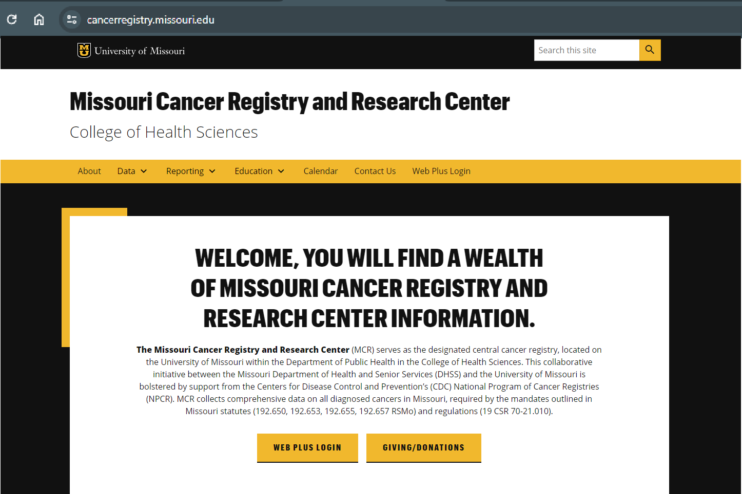
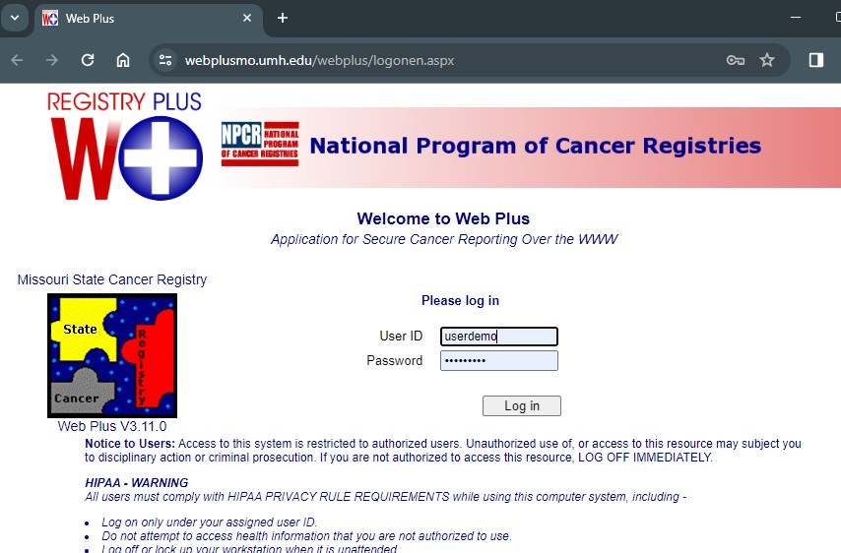
III. WEB PLUS

There are two ways to access Web Plus:
- by using the Web Plus login hyperlink on the MCR website or
- by logging on to the URL: https://webplusmo.umh.edu/webplus/logonen.aspx

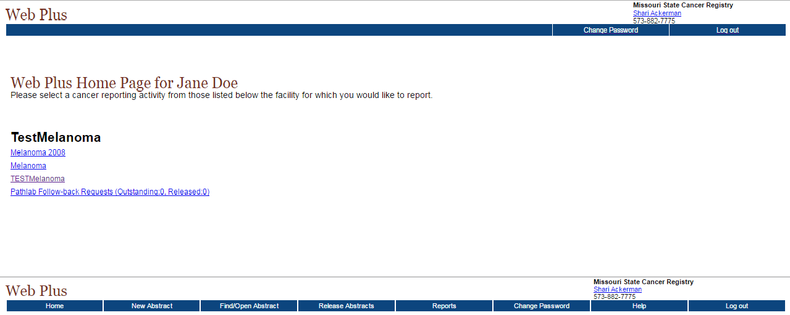
Choose the correct display for your facility and then select “New Abstract” on the menu bar to create a new abstract.
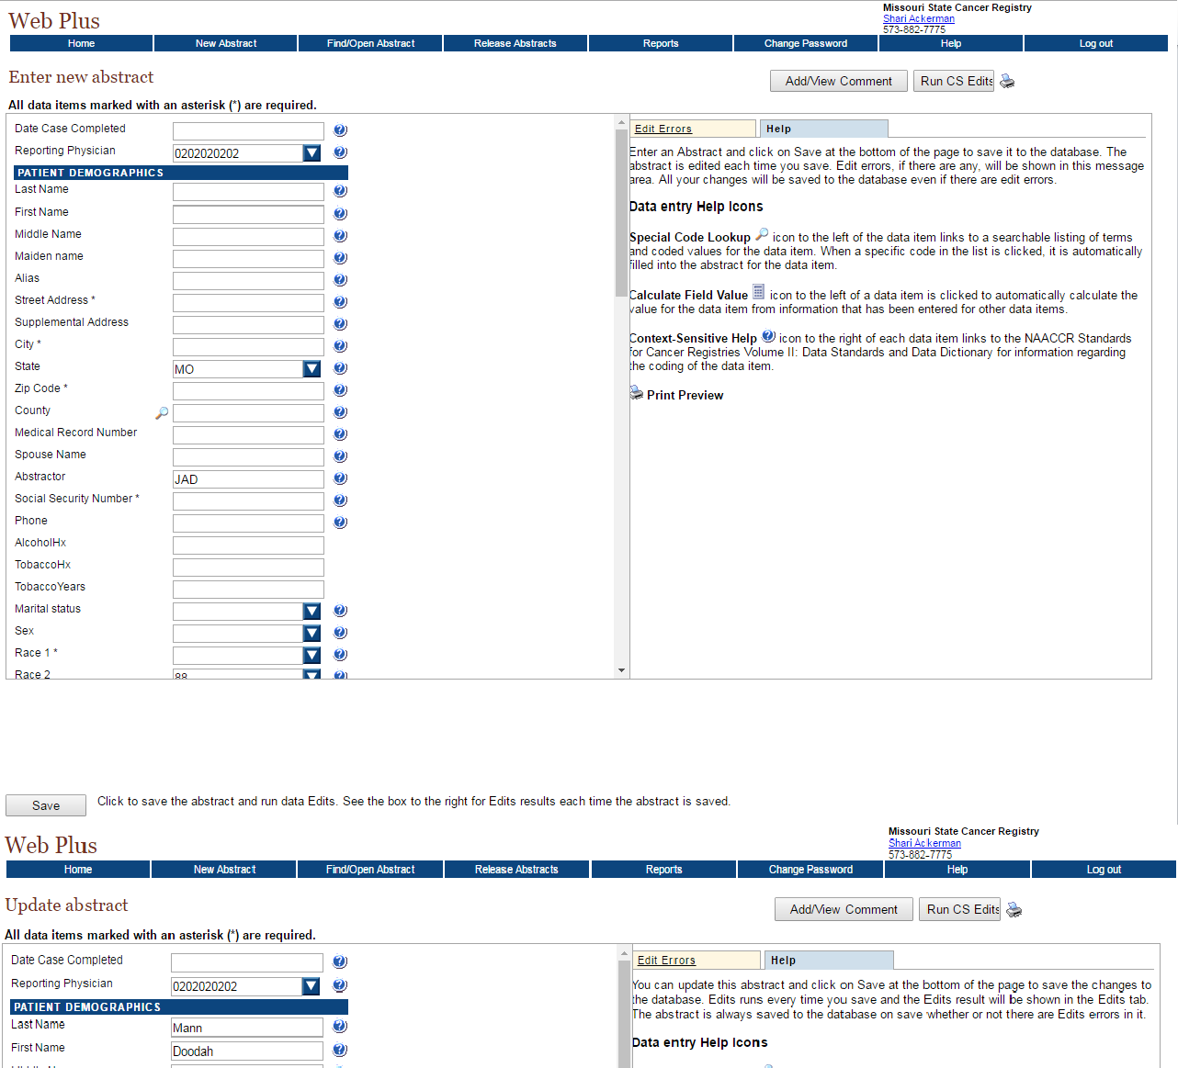

Create the new abstract by completing the data entry fields with the patients’ name and other demographic information. (Note: Data items with * are required elements). You may choose to save at this point and return later or you can enter other relevant medical information in fields using codes provided by Web Plus.
IMPORTANT: In order to prevent loss of work, please be sure to save work often as Web Plus is configured with an automatic timeout feature and will time-out after 5-7 minutes of inactivity.
The “Reporting Physician” field is linked to your sign-on data and should be automatically displayed.

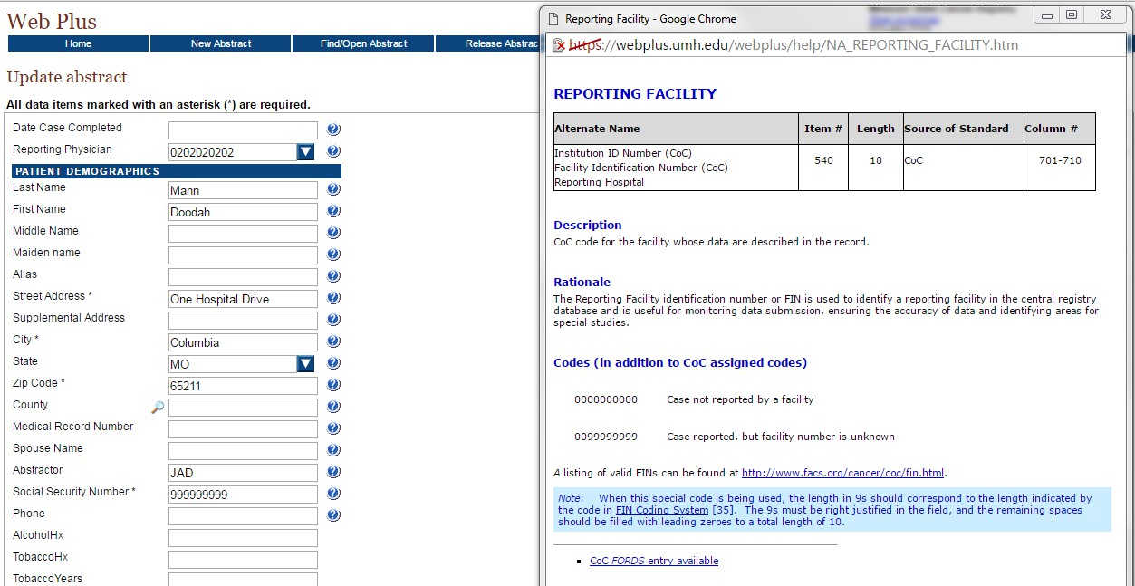
By clicking on the Help icon () a help screen will appear that provides information for that field or data item.
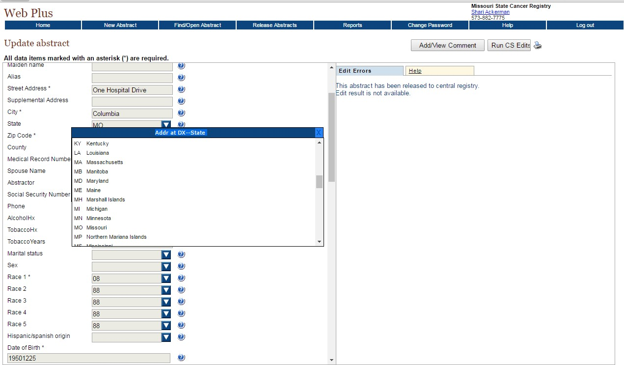

The drop-down arrow may be used to display a list of items that correspond with the selected data entry field.
Click on the drop-down arrow, scroll, then click the desired item, which will populate the field.
You may also enter the correct code in the field rather than using the drop-down feature.

Helpful text prompts will also pop out to the right when your cursor is placed in each field. Please read these as they explain what we are looking for in each field and have examples!
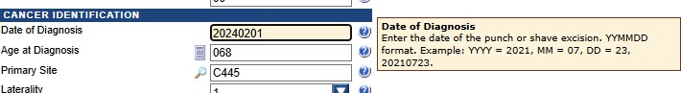

2
The magnifying glass icon ( ) is also used to open a list of codes and terms for a specific field.

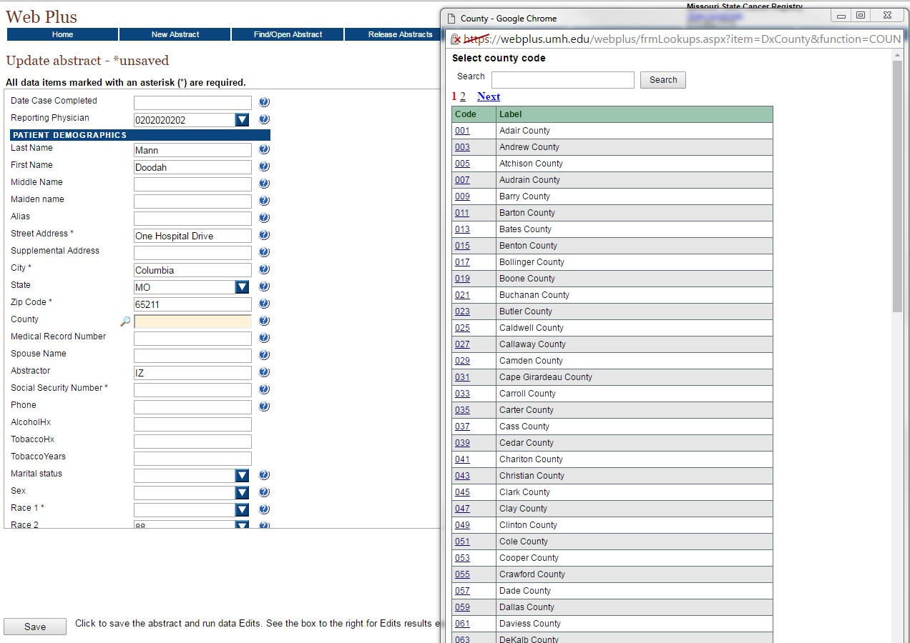
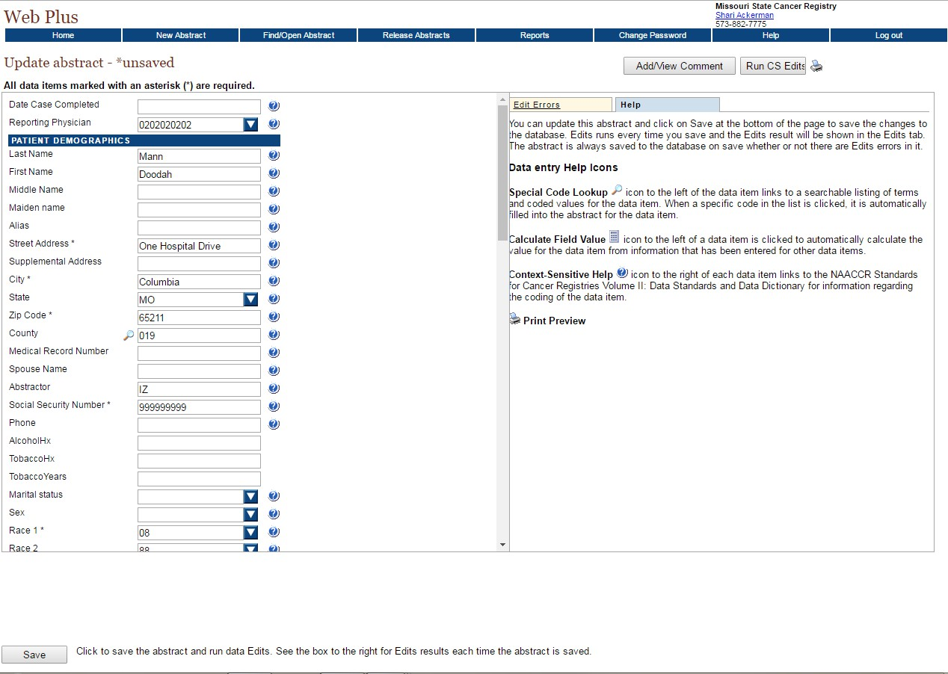
3
- Click on the magnifying glass to open the pull-down menu.
- Search by entering a term in the search field or by scrolling and selecting the proper term.
- Click on the code to populate the corresponding field.
- You may also enter the correct code in the field if known.
1

4

.

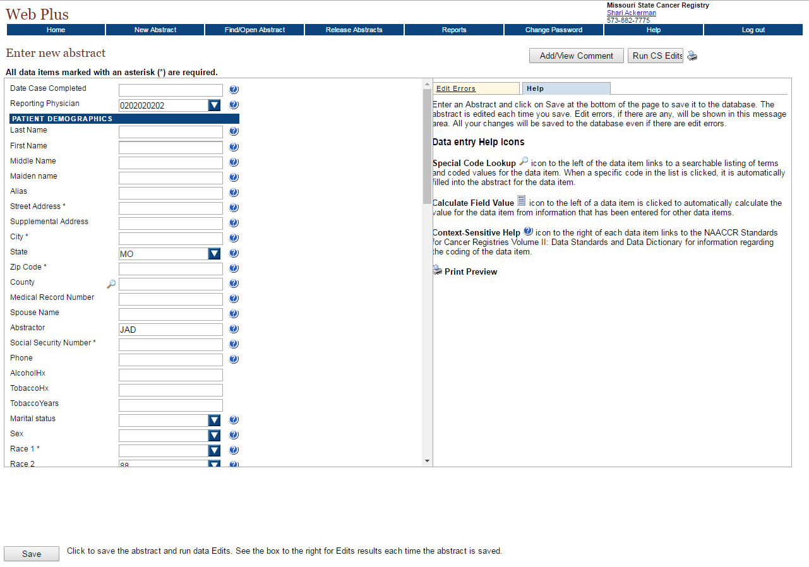
Click on the “Save” button to retain your work and to allow the system to edit the abstract and display errors.
IMPORTANT: In order to prevent loss of work, please be sure to save work often as Web Plus is configured with an automatic timeout feature and will time-out after 5-7 minutes of inactivity.
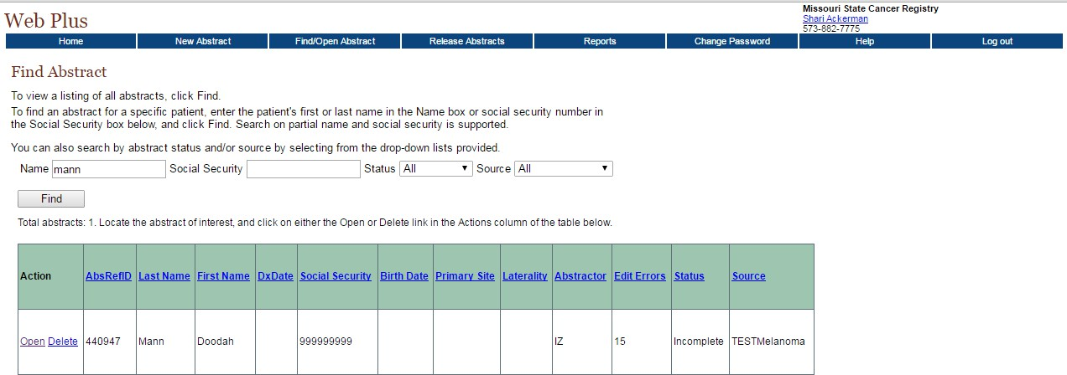
To retrieve a saved abstract, click on “Find/Open Abstract” from the menu bar, type in the name and click “Find”. Select the desired abstract by clicking “Open”.

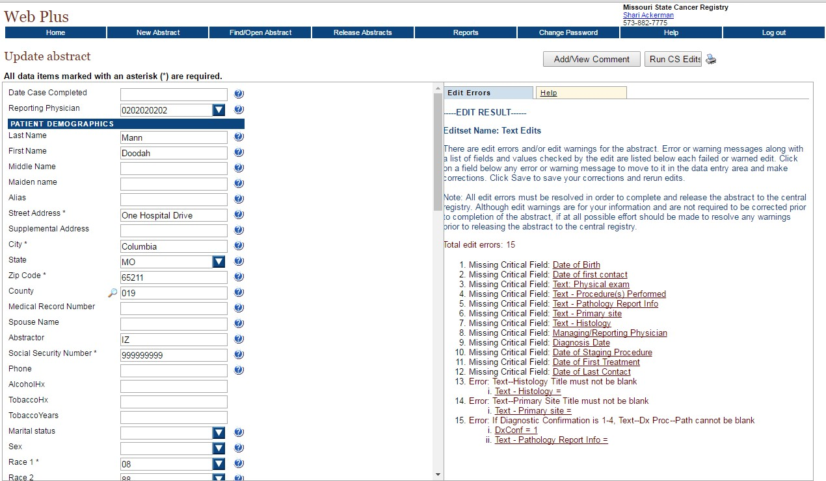
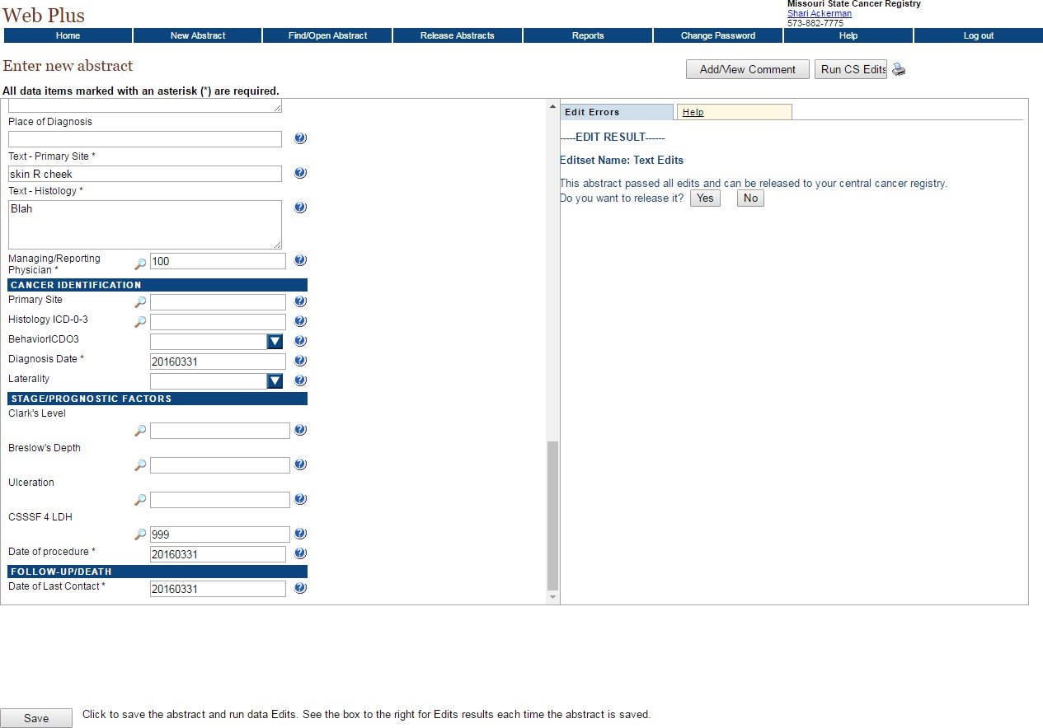
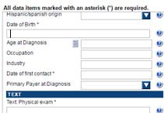


When a saved abstract is re-opened, any errors that need to be corrected are displayed on the “Edit Errors” tab in the information pane.

Click on the underlined “Edit Error” that you wish to correct. This will take you to the corresponding field in the abstract, where the correction can be made. Repeat this process until all errors are resolved.

After all edit errors are resolved, click “Save” to save the abstract and run data edits again.
Once all edit errors are corrected and the form is completed, the abstract may be released to the Central Registry.
To release the abstract individually, click on the “Yes” button in the “Edit/Errors” field.
To batch release the abstract with other abstracts, click the “No” button.

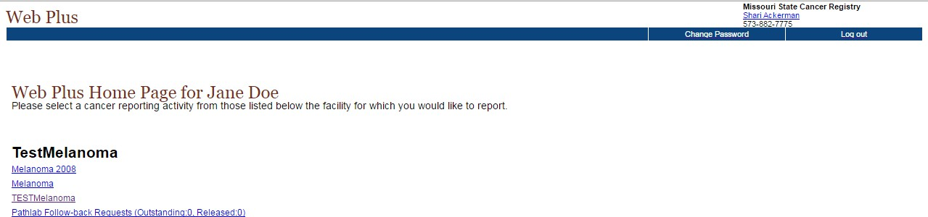
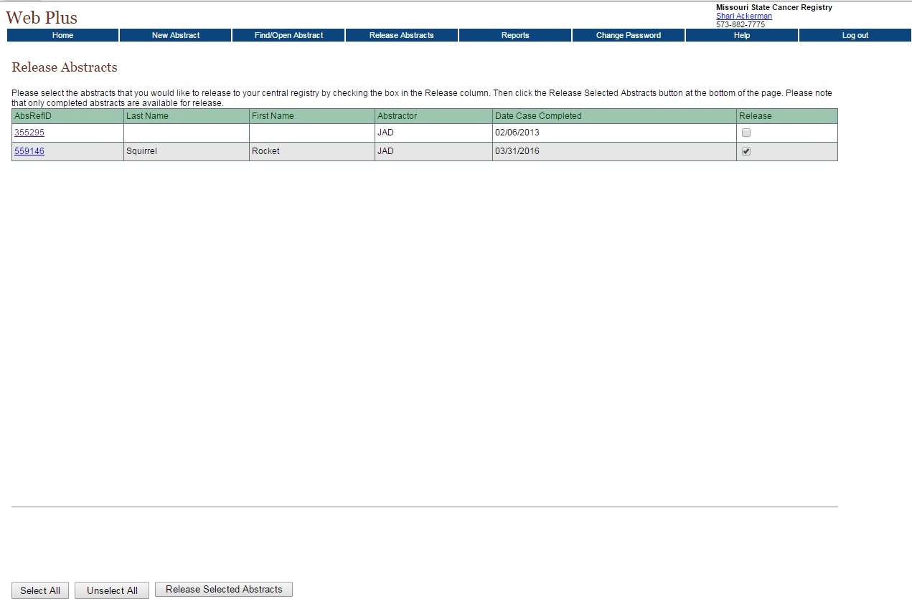
There may be instances when MCR receives information about a patient of yours from a Pathology Lab report that was submitted to us. These reports will generally have some of the data that would normally be submitted by you, but not all of it.

We may send this incomplete information to you to complete as a Follow-back request. You will receive an email from us stating that we have sent an abstract to you to complete.

To access the Follow-back abstract, login in to Web Plus and click on the Pathlab Follow-back Requests reporting activity.
Select the abstracts to be released by clicking on the corresponding box in the “Release” column. Once all the abstracts are selected, click the “Release Selected Abstracts” box.
To batch release one or more completed abstracts to the Central Registry, click “Release Abstracts” on the menu bar.

After the abstracts have been released (or anytime you are finished with Web Plus), click on “Log out” to close out of Web Plus.

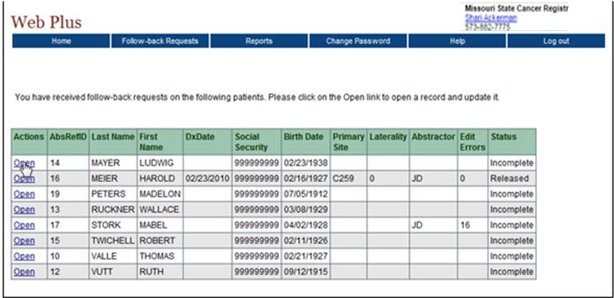
The next screen will list follow-back reports that have been sent to you to complete.
To update a record, click “Open” and update the corresponding record.
Complete the missing data and release to MCR as you would for a newly created abstract (pages 23-27).
The data entry page for the selected abstract will open.

Quick Reference Guide for Using Web Plus
Log on to Web Plus: https://webplusmo.umh.edu/webplus/logonen.aspx

- Log on to application by using the MCR assigned User ID and Password.
- Select ‘New Abstract’ or ‘Find/Open Abstract’.
- Begin by thoroughly reviewing the medical report/records and/or pathology report before entering any patient information.
- If choosing ‘New Abstract’ begin entering the patient information. Your abstract will require a set of field entries specific to the type of tumors your facility treats. By clicking on the special help icon a help screen will appear that provides information such as the size of the field, what information to input and who requires the field. There are also drop-down boxes for a number of fields which will auto-populate the field if clicked.* For
some fields, you will also see a which allows you to search for the proper codes. Certain other fields have a tan ’pop-up’ box which will automatically appear upon entering the corresponding field, which provides additional help (e.g. how to show an unknown social security number, the use of punctuation, etc.). For further information regarding icons and their uses, please refer to pages 24-25 of this manual.
- Cancer Identification: If the user has not reviewed the medical report and/or pathology report, please do so before attempting to enter any further information. Use information from the medical and/or pathology report to complete these items.
- A. Histology field: This field is for the tissue diagnosis made by the pathologist. For melanoma cases, it will almost always be ‘malignant melanoma, nos.’ histology code of “8720/3.” Use the search option and type ‘malignant melanoma,’ then hit enter to go to the appropriate code or simply type in the code, if known.
B. Grade: This may also be found on the pathology report (well-differentiated, moderately differentiated, etc.). Use the drop-down box for this field.
- Stage/prognostic factors: The CDC and NPCR are now using a combination of the TNM and SEER summary staging. Use the help buttons to see what type of information needs to be recorded in each field. Scroll past the gray ‘notes’ section in the first part of the help screen to see the actual codes. You will notice some of the codes correspond to the TNM fields.
- Most of the treatment fields are self-explanatory using the help codes. Remember, we are only asking you to report patients who are NOT diagnosed or treated at a hospital.
- Be sure to complete the Text Fields. Use these fields to document specific details from the pathology report, operative note and other patient medical records. The fields are important because here you can use the text fields to document the codes. For example, if you chose “8720/3” for histology, then the text field should say "malignant melanoma, NOS.” This will help MCR staff reviewing the abstracts to know if items are coded correctly. MCR staff will also use information from text fields to fill in a multitude of other codes so as not to burden you with them.
- You may save information at any time without leaving the abstract. Once all information is complete, click on the ‘Save’ button to save information. This function will automatically run edits, displaying any errors in the text area on the right of the screen. Simply correct errors, and re-save.
- Once a case is saved, you may either choose the option of entering a new abstract, find/open an existing case to edit/enter additional information, or you may log off of the system.
- To prevent loss of work, please remember to save data frequently, as Web Plus is configured with an automatic ‘time-out’ after 5-7 minutes of idle time.
* NOTE: If you know the corresponding code for a field, simply type in the code; you do not have to use the drop-down boxes to populate a field. (Example: ‘8720/3 for Histology, - type ‘8720/3 and press enter.)

Example: Completed Melanoma Case
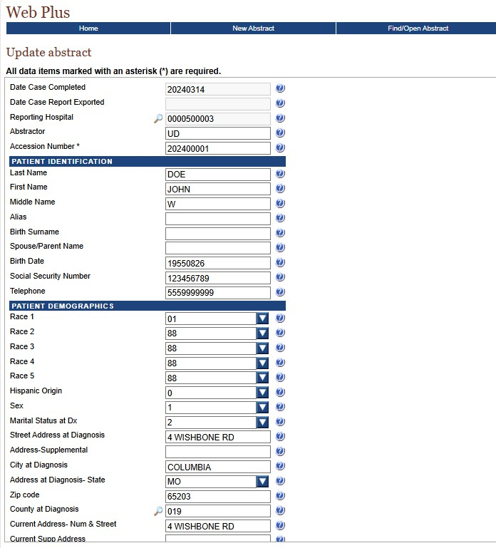
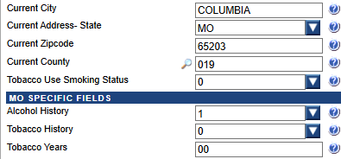

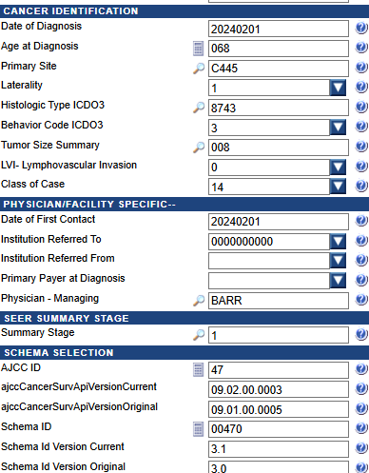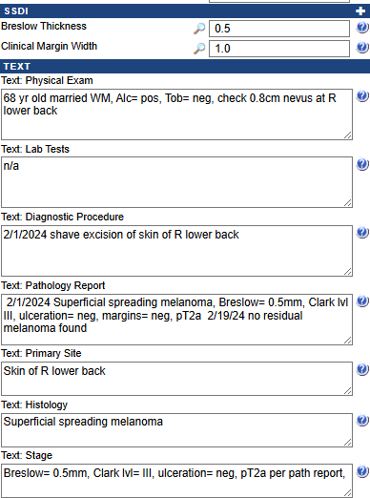

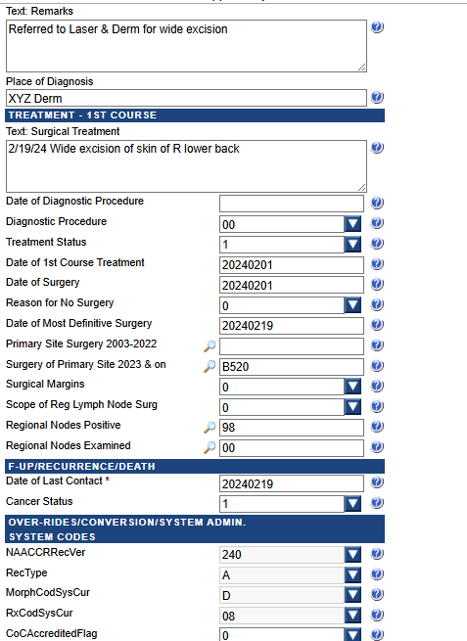

Appendix 1: Quick Guide to Reporting

QUICK GUIDE TO REPORTING
REPORT neoplasms described with the following terms:
- in situ; noninvasive; intraepithelial; noninfiltrating; Stage 0
- malignant; cancer; malignant neoplasm, carcinoma
REPORT benign tumors of the brain and CNS (for diagnoses after January 1, 2004), in any of the following sites:
- The brain, meninges, spinal cord, cranial nerves, and other parts of the central nervous system, pituitary gland, craniopharyngeal duct, and pineal gland
REPORT when the cancer or malignancy is described with terms such as “apparently”,
“compatible with”, “consistent with”, “favors”, “most likely”, “probable”, “suspect”, “suspicious”
REPORT each primary site cancer separately. Any subsequent diagnosis of or treatment for cancer in another primary site should be reported as a separate case
DO NOT REPORT cases described as “possible”, “questionable”, “suggests”, “rule out”, “equivocal”
DO NOT REPORT when a patient has only a history of cancer with no currently active disease
(This applies to all facilities EXCEPT voluntary reporting by Long-term Care Facilities)
DO NOT REPORT:
- Basal cell and squamous cell carcinoma of skin

- In situ carcinoma of the cervix uteri

- Cervical intraepithelial neoplasia (CIN) and

- Prostatic intraepithelial neoplasia (PIN)

Appendix 2: Information Required to Complete Patient Report

INFORMATION REQUIRED TO COMPLETE PATIENT REPORT

PATIENT IDENTIFICATION
Patient Name
Social Security Number Address at Diagnosis Marital Status
Sex Race
Spanish/Hispanic origin Date of Birth

FIRST COURSE OF TREATMENT
Watchful waiting
Patient refused treatment Surgery
Radiation Chemotherapy Other therapy

FOLLOW-UP
Vital status/tumor status
Date of last contact or date of death

DIAGNOSIS
Date/place of initial diagnosis PE/scans/scopes/lab Operative/pathology findings Residual tumor
Diagnostic confirmation
Hospital referred from/to (LTCFs, SNFs, NHs)

CANCER INFORMATION
Primary site/Histology/Grade (differentiation)
Tumor Size
Extent of Disease/lymph node involvement
Staging information

Appendix 3: General Staging and TNM Staging

The following staging information was taken from the website of the National Cancer Institute: https://www.cancer.gov/about-cancer/diagnosis-staging/staging

Staging
Stage refers to the extent of your cancer, such as how large the tumor is, and if it has spread. Knowing the stage of cancer helps the doctor:
- Understand how serious a cancer is and chances of survival
- Plan the best treatment
- Identify clinical trials that may be treatment options

How Stage Is Determined
To learn the stage of a disease, a doctor may order x-rays, lab tests, and other tests or procedures. See the section on Diagnosis to learn more about these tests.

Systems that Describe Stage
There are many staging systems. Some, such as the TNM staging system, are used for many types of cancer. Others are specific to a particular type of cancer. Staging systems may include information about:
- Where the tumor is located in the body
- The cell type (such as, adenocarcinoma or squamous cell carcinoma)
- The size of the tumor
- Whether the cancer has spread to nearby lymph nodes
- Whether the cancer has spread to a different part of the body
- Tumor grade, which refers to how abnormal the cancer cells look and how likely the tumor is to grow and spread

The TNM Staging System
The TNM system is the most widely used cancer staging system. Most hospitals and medical centers use the TNM system as their main method for cancer reporting. You are likely to see cancers described by this staging system in a pathology report, unless a patient has a cancer

for which a different staging system is used. Examples of cancers with different staging systems include brain and spinal cord tumors and blood cancers.

In the TNM system:

- The T refers to the size and extent of the main tumor. The main tumor is usually called the primary tumor.
- The N refers to the the number of nearby lymph nodes that have cancer.
- The M refers to whether the cancer has metastasized. This means that the cancer has spread from the primary tumor to other parts of the body.
When a cancer is described by the TNM system, there will be numbers after each letter that give more details about the cancer—for example, T1N0MX or T3N1M0. The following explains what the letters and numbers mean:

Primary tumor (T)

- TX: Main tumor cannot be measured.
- T0: Main tumor cannot be found.
- T1, T2, T3, T4: Refers to the size and/or extent of the main tumor. The higher the number after the T, the larger the tumor or the more it has grown into nearby tissues. T's may be further divided to provide more detail, such as T3a and T3b.

Regional lymph nodes (N)

- NX: Cancer in nearby lymph nodes cannot be measured.
- N0: There is no cancer in nearby lymph nodes.
- N1, N2, N3: Refers to the number and location of lymph nodes that contain cancer. The higher the number after the N, the more lymph nodes that contain cancer.

Distant metastasis (M)

- MX: Metastasis cannot be measured.
- M0: Cancer has not spread to other parts of the body.
- M1: Cancer has spread to other parts of the body.

Other Ways to Describe Stage
The TNM system helps describe cancer in great detail. But, for many cancers, the TNM combinations are grouped into five less-detailed stages. When talking about a cancer, a doctor or nurse may describe it as one of these stage groups:

Stage | What it means
Stage 0 | Abnormal cells are present but have not spread to nearby tissue. Also called
 | carcinoma in situ, or CIS. CIS is not cancer, but it may become cancer
Stage I, Stage II, | Cancer is present. The higher the number, the larger the cancer tumor and the
and Stage III | more it has spread into nearby tissues
Stage IV | The cancer has spread to distant parts of the body

Another staging system that is used for all types of cancer groups the cancer into one of five main categories. This SEER staging system is more often used by cancer registries than by doctors. But, you may still hear a doctor or nurse describe a cancer in one of the following ways:
  - In situ — Abnormal cells are present but have not spread to nearby tissue
  - Localized — Cancer is limited to the place where it started, with no sign that it has spread
  - Regional — Cancer has spread to nearby lymph nodes, tissues, or organs
  - Distant — Cancer has spread to distant parts of the body
  - Unknown — There is not enough information to figure out the stage

Appendix 4: ICD-10-CM Reporting Codes List
For reportability, MCR utilizes ICD-10 codes as required by the National Program of Cancer Registries (NPCR) and the North American Association of Central Cancer Registries (NAACCR). These are the codes used by central registries throughout the US and Canada.

The ICD-10 list may change annually, so please refer to the MCR website for the 'SEER Casefinding List' link. https://cancerregistry.missouri.edu/reporting/cancer-reporting-hospital/.

Appendix 5: Resources/References

MCR STAFF RESOURCES
For information regarding:
  - Cancer reporting using Web Plus
  - Forms or reprints of MCR materials

Contact:
Stacy Barr, Non-hospital Reporting Coordinator
573-771-6368
barrs@missouri.edu

GENERAL CANCER RESOURCES
Missouri Cancer Registry (https://cancerregistry.missouri.edu/). This site was created to help facilities who are required to submit cancer reports with information to the central cancer registry.
Surveillance Epidemiology and End Results (http://seer.cancer.gov/). This site provides information on cancer statistics and survival of cancer in the U.S., information which may help reduce the burden of disease on the U.S. population.

Steve Dunn’s Cancer Guide (https://cancerguide2.com/). Informative website created by a cancer survivor dedicated to educating non-medical people about cancer. Includes a simple, yet helpful section about understanding cancer types and staging.

American Cancer Society (http://www.cancer.org/). Select cancer by site for diagnostic and treatment information.
National Cancer Institute (http://www.cancer.gov/). Select cancer by site for diagnostic and treatment information.

A cancer dictionary from the National Cancer Institute’s comprehensive cancer information website:https://www.cancer.gov/publications/dictionaries/cancer-terms.
Hormone Treatment for Prostate Cancer: https://www.webmd.com/prostate-cancer/features/ hormone-therapy-for-prostate-cancer#1

Breslow’s information - for melanoma cases information on understanding your pathology report: https://www.oncolink.org/cancers/skin/melanoma/treatments/understanding-your-pathology-report-melanoma

SEER Staging of Disease: https://training.seer.cancer.gov/ss2k/

TNM Staging: https://www.cancer.org/cancer/melanoma-skin-cancer/detection-diagnosis-staging/melanoma-skin-cancer-stages.html

RESOURCES FOR COMMON CHEMOTHERAPY DRUGS
National Cancer Institute: https://www.cancer.gov/about-cancer/treatment/drugs/cancer-type
Cancer.Net: http://www.cancer.net/navigating-cancer-care/how-cancer-treated/drug-information-resources

Navigating Care: https://www.navigatingcare.com/library/all/chemotherapy_drugs

Oncology Nurse Advisor: http://www.oncologynurseadvisor.com/chemotherapy-regimens/section/2171/
Chemocare.com: http://www.chemocare.com/

ONLINE RESOURCE FOR CANCER TERMS

National Cancer Institute: https://www.cancer.gov/publications/dictionaries/cancer-terms

.

Appendix 6. Frequently Asked Questions (FAQS) Regarding the Missouri Cancer Registry (MCR)

What is a cancer registry? Why is it needed?
A cancer registry is a system for collection, storage, analysis and interpretation of data on cancer patients. Cancer registries may be hospital-based or population-based.
Hospital-based registries use information abstracted from medical records to assess the number of diagnoses per year and frequencies by sites. The information collected consists of demographics, site of cancer, type of cancer, type of treatments, stage of disease at diagnosis and vital status. Hospital registry data are used to evaluate diagnostic and treatment practices; assess quality of patient care and hospital programs; and track outcomes. Registry data are also used to develop standards of care; develop strategic plans and measure progress; and assist hospital administrators and physicians in setting up screening programs.

Central cancer registries depend on the information obtained from hospital-based registries and from other sources (e.g., pathology laboratories, freestanding cancer clinics and treatment centers, physician offices, non-hospital facilities, other state central registries, etc.). Data submitted by hospitals and other reporting facilities is edited, and then it is consolidated to remove duplicate cases. Data are then analyzed so that crude, age-adjusted and age-specific annual cancer incidence rates can be produced and trends in incidence for all cancers and for specific types/sites of cancer by age, sex and race can be assessed. These data are necessary to conduct epidemiological studies and evaluate the effectiveness or appropriateness of cancer prevention and control measures.

What is the goal of the Missouri Cancer Registry?
The ultimate goal is a true population-based cancer registry. In recent years, the patterns of health care have changed, and a shift to outpatient diagnosis and treatment has been recognized. This shift has resulted in underreporting of cancer cases. Sites that are known to be underreported include melanomas of the skin (white females and males); Non-Hodgkin’s lymphoma (African-American males; cancers of the oral cavity and pharynx (African-American females) and prostate cancer (all males). Without a complete data set, the Missouri Department of Health cannot conduct accurate epidemiological studies or develop a comprehensive cancer prevention and control strategy.
The Centers for Disease Control and Prevention (CDC) also recognized this trend when they established the National Program of Cancer Registries (NPCR) by enacting The Cancer Registries Amendment Act (Public Law 102-515). This legislation authorizes the CDC to provide funds to states to improve existing registries or to establish registries where they do not exist. The Missouri Cancer Registry applied for and received a grant from CDC to enhance the state registry. Stipulations of this grant require that at least 95% of new cancer cases will be reported to MCR. This goal can only be accomplished if Non-hospital facilities report cancer cases to the Missouri Cancer Registry.

What information is required to be submitted by reporting facilities?

Hospitals are required to submit 223 NPCR or Missouri-required data elements. The information required for Non-hospital facilities is minimal and includes, but is not limited to:

patient’s name, address, social security number, sex, race, Hispanic origin, date of birth, date of diagnosis, site, histology, stage and treatment.

Will the patient’s right to confidentiality be breached if this information is reported to the Missouri Cancer Registry?
All cancer cases submitted to MCR will be covered by the regulations within this legislation protecting the identity of the patient, hospital, physician, health care provider, pathology laboratory, ambulatory surgical center, free-standing cancer clinic or treatment center. (See also Chapters 192.067 and 192.655 of the Missouri Revised Statutes)

Will physicians and other health care professionals be liable for breach of confidentiality?
Physicians and other health care professionals cannot be liable if state law requires reporting of cancer cases.

Are there any federal mandates associated with a state’s central cancer registry?
Congress established the National Program of Cancer Registries (NPCR) in 1992 by enacting The Cancer Registries Amendment Act (Public Law 102-515). Public Law 102-515 authorizes The Centers for Disease Control and Prevention (CDC) to provide funds to states to improve existing cancer registries; to plan and implement registries where they do not exist; to develop model legislation and regulations for states to enhance viability of registry operations; to set standards for completeness, timeliness, and quality; and to provide training.

One requirement for retention of federal funding is that “The State has a law authorizing formation of a statewide registry and legislation or regulation in support of all 8 criteria outlined in Public Law 102-515”. One criterion is completeness, defined as collection of data on at least 95% of cancer cases diagnosed or treated in the state each year.

When Missouri’s existing legislation was enacted in 1984, the completeness criterion could be met with collection of hospital inpatient data. With advances in medical technology and changes in health care delivery, the completeness criterion can no longer be met solely by relying on hospital inpatient data. To maintain a population-based registry, information must also now be gathered from hospital outpatient departments, physicians’ offices, freestanding treatment centers, ambulatory surgery centers, Non-hospital facilities and pathology laboratories.

In addition to meeting federal funding agency requirements, the state health department has the responsibility of maintaining a surveillance system that can produce accurate and complete reports on cancer incidence and trends in incidence. Therefore, the department strives not only to meet the minimum completeness requirement (95%) but also to achieve a 100% population-based central cancer registry.

What is the penalty for failure to report a case?
The penalty for failing to report is an infraction (192.657.3 RSMO). An infraction is not a crime as opposed to a felony or misdemeanor but may be punished by a fine. Chapter 556.021 RSMO defines an infraction as:

  - An offense defined by this code or by any other statute of this state constitutes an “infraction” if it is so designated or if no other sentence than a fine, or fine and forfeiture or other civil penalty is authorized upon conviction.

  - An infraction does not constitute a crime and conviction of an infraction shall not give rise to any disability or legal disadvantage based on conviction of a crime.

How often will I be required to report cases?
Reporting frequency will depend on reporting category and number of cases. Hospitals are required to submit at least quarterly with larger hospitals (greater than 500 cases annually) required to report monthly. Larger pathology laboratories may be requested to submit data on a monthly basis; small laboratories on a quarterly basis. Other Non-hospital facilities will be required to report at least quarterly. Physicians will be contacted on an as needed basis regarding additional data not available from other facilities (i.e., pathology labs will not have treatment information).

What patients are required to be reported?

Any patient that is diagnosed and/or treated at your facility for cancer is to be reported. This may include patients that are clinically diagnosed or patients diagnosed or treated for a recurrence as well as newly diagnosed patients. Further information can be obtained by calling the number listed below.

Can I request data from the Missouri Cancer Registry?
Yes, aggregate data can be requested by calling the number listed below. No patient, reporting facility, physician or healthcare provider information will be released without permission of the same.

Who do I call if I have questions after reading the FAQ Sheet?
For questions regarding Non-hospital reporting, please call 573-882-7775 ext 06.

Appendix 7: Disease Process Information for LTCF Reporters

INTRODUCTION
The information in this section is to assist you when you are reviewing patients’ charts and would like to have a better understanding of certain types of cancer, their diagnosis and their treatment. It is not appropriate to use this information for the average person diagnosed with cancer. It was written with Non-hospital facility patients in mind.

Although there are more than one hundred types of cancer, we have included only some of the more common types of cancer. We do not expect you to become experts on cancer, but hope to familiarize you with some of the basics.

Colon Cancer
Symptoms: Bright red or black blood in the stool, weight loss, unexplained anemia or a change in bowel habits.
Diagnosis: Colonoscopy, digital rectal exam, sigmoidoscopy, biopsy or lower GI series.

Treatment: Treatment depends on the stage of the disease, surgery being the most common. Common surgical terminology seen in documentation is: polypectomy, wedge or bowel resection and colostomy. Non-surgical treatments may include: radiation and/or chemotherapy. Radiation is delivered by an external beam therapy (ERBT. Chemotherapy treatments involve a regimen of drugs. You may see drug names such as: Fluorouracil (5-FU, Capecitabine
(Xeloda, Irinotecan (Camptosar, Oxaliplatin (Eloxatin, Cetuximab (Erbitux, Bevacizumab (Avastin or combination treatments called FOLFOX (FOLic acid,5-FU, OXaliplatin.
Staging: You may see colon cancer staging refered to as: “Duke” or “TNM”.

Bladder Cancer
Symptoms: Blood or blood clots in the urine are the most common urinary symptoms.
Diagnosis: Urinalysis to check for blood in urine (hematuria. Washing of the bladder to examine the cells (cytology. Intravenous pyelogram (IVP, abdominal CT, and chest x-ray may be useful. Cystoscopy – visual examination of the bladder using a lighted tubular instrument.

Treatment: Depends on the stage of the disease. For tumors that do not invade muscle, tumors may be removed with surgery (transurethral resection of the bladder or TURB, with lasers (YAG or CO2 or with chemotherapy drugs placed into the bladder. BCG (a biological therapy is frequently used. It is given by catheter inside the bladder weekly for six consecutive weeks.
More advanced disease requires more extensive surgery or radiation therapy, depending on the general health of the patient.
Staging: May be stated using any of the staging systems described in the manual, page 18 or Appendix 3.

Brain Tumors (benign and malignant)
All brain tumors whether benign or malignant must be reported. There are several types of brain tumors; distinguished from one another by the way the cancer cells look under the microscope. This section only covers brain tumors that start in the brain. (Sometimes cancer in the brain has spread from another part of the body.

Malignant Histologies include:
Astrocytoma Ependymoma
Glioblastoma Multiforme Glioma
Malignant Meningioma (may be benign or malignant) Medulloblastoma
Oligodendroglioma
Benign Histologies include:
Chordoma
Neurocytoma, Central Neurofibromas Neurofibromatosis Nuerothekeoma
Neuroma
Perineurioma, NOS
Symptoms: Frequent headaches, vomiting, difficulty walking or speaking.

Diagnosis: CT scan, or MRI may be used to visualize a tumor. A biopsy helps to determine the tumor type and the aggressiveness of the tumor. Brain tumors may be diagnosed by radiology tests alone.
Treatment: Surgery is the most common treatment. Depending on the patient’s general health, age, etc. this may not be an option. In that case, radiation may be used to shrink the tumor.

Staging: There is no staging system for this disease.

Breast cancer
Symptoms: Lump or thickening in/near the breast or underarm area. A change in the size or shape of the breast, discharge from the nipple, change in the color or the breast may become dimpled, puckered, or scaly.

Diagnosis: Occasionally physicians find Non-hospital facility patients with breast masses or neglected breast cancer (based on the appearance of a lesion with obvious tissue death.

Treatment: Depending on the patient’s general condition, there may be no treatment other than hormones. It is possible this patient will never enter a hospital for diagnosis or treatment of this cancer. For patients in generally good health, a variety of surgery types could be recommended.

Staging: May be stated using any of the staging systems described in the manual, page 18 or Appendix 3.

Leukemia
Leukemia is a disease of the blood. The classification system for leukemia can be confusing, so for our purposes, we will only discuss the two main forms: Acute and chronic.
Symptoms: Patients may have symptoms including: enlarged lymph nodes, swollen gums, bruises or small pinpoint red rash on the skin.

Diagnosis: Diagnosis will include blood tests (to look for abnormal white blood cells. Bone marrow examination may also be performed (usually in a hospital setting.

Treatment:
ACUTE: Chemotherapy for these patients is intensive and almost always completed in a hospital setting. Physicians are often reluctant to offer treatment for elderly patients. In many cases, the patient or family refuses treatment. Without treatment, length of survival averages 3-5 months after diagnosis.
CHRONIC: Treatment for patients with early stage disease may consist of “observation only.” Chemotherapy for those with more advanced disease might include: fludarabine, hydrea, busulfan (myerlan. Chronic leukemias sometimes convert to an acute phase. Average survival is measured in years rather than months (for all age groups. It is possible this patient will never enter a hospital for diagnosis or treatment of this cancer.

Staging: There is no staging system for this disease.

Liver cancer
Also known as hepatocellular carcinoma or hepatoma. Rare type of cancer. Most cancers in the liver spread there from another organ and are identified by the organ from which they spread (e.g. colon, breast, etc. This section refers only to cancers originating in the liver.
Symptoms: Like pancreatic cancer, this cancer is generally diagnosed at an advanced stage. Symptoms may include bloating, abdominal pain, weight loss, decreased appetite and nausea. Jaundice is frequently present.

Diagnosis: Diagnostic work-up may include blood tests, liver function studies, Alpha Feta Protein (AFP. Imaging tests may be useful to establish the stage of disease (CT, ultrasound, MRI. Diagnosis almost always includes a liver biopsy. This will help determine if the cancer actually started in the liver.

Treatment: Treatments generally consist of relieving symptoms of the disease. It is possible this patient will never enter a hospital for diagnosis or treatment of this cancer.
Survival often is measured in months.

Staging: May be stated using any of the staging systems described in the manual, page 18 or Appendix 3.

Lung Cancer
Symptoms: Cough that won’t go away. Coughing up blood. Hoarseness, shortness of breath. Increased amount of sputum. Lung infection that won’t clear up. Fatigue.
Diagnosis: Lung sounds may indicate the presence of fluid in the lungs.
Sputum (mucus coughed up from the lungs may be examined for malignant cells. Chest x-ray or CT scans are helpful.
Treatment: Surgical removal of the tumor is the best treatment option. This usually is recommended only if the tumor is thought to be contained within the lung. Radiation is often used for older patients, or patients whose health is compromised due to other conditions (emphysema, etc.. There may be a role for chemotherapy, probably palliative (oral etoposide, platinum drugs, taxol, taxotere, camptosar or CPT-11, Gemzar or navelbine. Survival is dependent on extent of disease and the overall health of the patient.

Staging: May be stated using any of the staging systems described in the manual, page 18 or Appendix 3.

Lymphomas
Cancers that develop in the lymphatic system are known as lymphomas. Lymphomas are divided into two types: Hodgkin’s disease and non-Hodgkin’s lymphomas. The treatment varies according to the type diagnosed.
Symptoms: One or more enlarged lymph nodes, usually neck, under the arms or in the groin. Sometimes fatigue, fever, chills, night sweats, decreased appetite, weight loss.

Diagnosis: Blood tests may show abnormalities.
Imaging studies may show masses, or enlarged areas of lymph nodes. Biopsies are performed and may include the bone marrow.

Treatment:
HODGKIN’S: Usually depends on extent of disease. Combined chemotherapy and radiation therapy often used. Chemotherapy regimens include: MOPP or ABVD.
NON-HODGKIN’S: Treatment depends on the grade (low, intermediate, high. Close observation may the treatment of choice for older patients. Radiation therapy alone. Chemotherapy alone (cytoxan, chlorambucil, CVP, CMOPP, CHOP. Combination chemotherapy and radiation therapy.
Staging: Uses the Ann Arbor staging system, Stages 1-4. This staging systems is not used for any other cancer.

Multiple myeloma
Most often a disease of the bone marrow, also known as plasma cell myeloma. This disease is treatable but rarely curable. This cancer is underreported in Missouri.

Symptoms: Bone pain is the most common symptom, often accompanied by weakness and fatigue.
Diagnosis: Blood tests often reveal anemia.
99% of patients will have an M-protein in the blood or urine.
Bone marrow examination must reveal at least 10 percent abnormal plasma cells.

rays show skeletal abnormalities in 75% of patients at diagnosis.
Treatment: Since the disease it not curable, physicians may choose not to treat patients due to potential side effects, costs, etc.
Possible drugs: melphalan (Alkeran) with or w/o prednisone, BCNU with or without prednisone Bone pain may be treated with analgesics (aspirin, acetaminophen, and ibuprofen), narcotics or radiation therapy
Staging: There is no staging system for this disease.

Myeloproliferative Disorders
  - Symptoms: Shortness of breath during exertion.
  - Weakness and fatigue.
  - Pale skin.
  - Loss of appetite.
  - Prolonged bleeding from minor cuts due to low platelet counts.
  - Purpura, a condition in which the skin bleeds, causing black and blue or pin-sized spots on the skin.
This is a group of diseases in which too many certain types of blood cells are made in the bone marrow. These include:
  - Polycythemia vera
  - Chronic myeloproliferative disease, NOS
  - Essential thrombocythemia
  - Chronic neutrophilic leukemia
  - Hypereosinophilic leukemia

Symptoms/Diagnosis: Usually diagnosed with blood tests. Bone marrow biopsy
Treatment: The treatments for these disorders are used to control symptoms. They are usually not curable conditions. If there are no symptoms, no treatment is necessary.
  - Treatment depends on the type of disorder.
  - Treatments may lower the amount of blood in the body (phlebotomy).
  - Treatments may filter platelets from the blood (plateletpheresis).
  - Chemotherapy (hydroxurea, chlorambucil)
  - Radiation – external beam radiation or using a radioactive drug, P32
  - Splenectomy (removal of the spleen)

Staging: There is no staging system for these diseases.

Myelodysplastic Syndromes
This is a group of diseases in which the bone marrow does not function normally and not enough normal blood cells are made. These include:
  - Refractory anemia
  - Refractory anemia w/sideroblasts
  - Refractory anemia w/excess blasts
  - Refractory anemia w/excess blasts in transformation
  - Myelodysplastic syndromes w/5q deletion (5q-) syndrome
  - Therapy-related myelodysplastic syndrome, NOS
  - Myelodysplastic syndrome, NOS

Symptoms: Most common sign is anemia. Patient may bleed without any reason, bruise more easily than normal, feel tired all of the time, or have an infection that won’t go away.
Diagnosis: Blood tests may reveal abnormalities such as the number white blood cells (WBC may be too low or the platelets may be low.
Bone marrow biopsies would be used to determine exact kind of disease.
Treatment: Main treatment is giving red blood cells or platelets to relieve symptoms of the disease.

Staging: There is no staging system for these diseases.

Pancreatic cancer

This cancer is underreported by Missouri hospital cancer registries, most likely due to the fact these patients may only be seen for ERCP.
Symptoms: Usually there are no symptoms until the cancer is already at an advanced stage. Symptoms may include jaundice, abdominal masses/pain, enlarged liver, abdominal fluid (ascites and sometimes swollen legs.

Diagnosis: Several blood tests are helpful in diagnosis this cancer (CA 19-9, CEA, serum bilirubin. Imaging tests may be useful to establish the stage of disease. Endoscopic retrograde cholangiopancreatography (ERCP is frequently the only procedure used and is not considered cancer-directed treatment. During this procedure a tube is inserted into the opening of the pancreatic duct. If the patient’s biliary duct is obstructed by tumor, a stent may be inserted which actually bypasses the obstructed. This procedure is done on an outpatient basis at hospitals or GI clinics.
Treatment: Even if diagnosed at an early stage, this cancer is rarely curable. Surgery is usually used only for palliation (relief from symptoms). Occasionally patients have surgery to relieve an obstruction, but not sure how often this would be used on patients already in generally poor health. Life expectancy for these patients is generally measured in months. It is possible this patient will never enter a hospital for diagnosis or treatment of this cancer.

Staging: May be stated using any of the staging systems described in the manual, page 18 or Appendix 3.

Prostate cancer

This cancer is underreported in Missouri.
Symptoms: Patient could be having urinary symptoms such as blood in the urine or difficulty urinating.
Diagnosis: May be diagnosed by elevated prostate-specific antigen (PSA. Digital rectal exam (DRE could detect an abnormality of the prostate. Bone scan might be used to determine extent of disease if PSA extremely high.
Treatment: If surgery is not possible, treatment could be one of several hormonal therapies (either oral or shots. Hormonal therapies include:

- Luteinizing hormone-releasing hormone agonists (LHRH agonists.) These are chemicals that stop the production of testosterone in the testicles. Essentially, they provide the benefits of an orchiectomy for men with advanced prostate cancer without surgery. This approach is sometimes called "chemical castration." However, the effects are fully reversible if you stop taking the medication.
Most LHRH agonists are injected every one to four months. Some examples are Lupron, Trelstar, Vantas, and Zoladex. A new drug, Viadur, is an implant placed in the arm just once a year. Plenaxis is a drug that's similar to LHRH agonists. However, because it can cause serious allergic reactions, it's not used that often.

- Anti-androgens. LHRH agonists and orchiectomies only affect the androgens that are made in the testicles. Thus they have no effect on the 5% to 10% of a man's "male" hormones that are made in the adrenal glands. Anti-androgens are designed to affect the hormones made in the adrenal glands. They don't stop the hormones from being made, but they stop them from having an effect on the cancer cells.

The advantage of anti-androgens is that they have fewer side effects than LHRH agonists. Many men prefer them because they are less likely to diminish libido. Side effects include tenderness of the breasts, diarrhea, and nausea. These drugs are also taken as pills each day, which may be more convenient than injections. Examples
are Casodex, Eulexin, and Nilandron.

- Combined Androgen Blockade. This approach combines anti-androgens with LHRH agonists or an orchiectomy. By using both approaches, you can cut off or block the effects of hormones made by both the adrenal glands and the testicles. However, using both treatments can also increase the side effects. An orchiectomy or an LHRH agonist on its own can cause significant side effects like a loss of libido, impotence, and hot flashes. Adding an anti-androgen can cause diarrhea, and less often, nausea, fatigue, and liver problems.

- Estrogens. Some synthetic versions of female hormones are used for prostate cancer. In fact, they were one of the early treatments used for the disease. However, because of their serious cardiovascular side effects, they're not used as often anymore. J. Brantley Thrasher, MD, a spokesman for the American Urological Association and chairman of urology at the University of Kansas Medical Center, says they're usually used only after initial hormone treatments have failed. Examples of estrogens are DES (diethylstilbes-trol), Premarin, and Estradiol.

- Other Drugs. Proscar (finasteride) is another drug that indirectly blocks an androgen that helps prostate cancer cells grow. Depending on the case, doctors sometimes use other anticancer drugs like Nizoral (ketoconazole) and Cytadren (aminoglutethimide.)

- Orchiectomy. The surgical removal of the testicles was the earliest form of hormone therapy for prostate cancer. However, the procedure is permanent. As with LHRH agonists, side effects can be significant. They include: Loss of sex drive, hot flashes, development of breasts (gynecomastia) or painful breasts, loss of muscle, weight gain, fatigue, and decrease in levels of "good" cholesterol.

It is possible this patient will never enter a hospital for diagnosis or treatment of this cancer.
Staging: May be stated using any of the staging systems described in the manual, page 18 or Appendix 3.

Unknown primary
Sometimes a patient develops cancer cells that cannot be traced to the site where they first started growing (primary site. When this happens, physicians to try to find the most likely source of the cancer because this will determine the best type of treatment, as well as the chances for recovery. Unknown primary cancers account for approximately 3% of all cancer patients.

Symptoms/Diagnosis: A biopsy is the best way to determine a cancer’s beginnings. If tissue is not available, radiology tests (CT scan, chest x-ray, etc. may be helpful.

Treatment: Surgery is a common treatment to remove the cancer, especially if only one area of cancer is detected in the body. If the cancer is widespread, or found in several areas of the body, treatment options are more limited. Chemotherapy may be an option depending on the overall health and age of the patients. Hormonal therapies may be used if breast or prostate cancers are suspected.

Staging: There is no staging system for this disease. The prognosis for these patients is generally poor. Survival is most frequently measured in months.

Bibliography
Dollinger, M., Rosenbaum, E., & Cable, G. (1997. Everyone’s Guide to Cancer Therapy (4th ed. Kansas City: Andrews McMeel Publishing.

