
Missouri Cancer Registry
September 2025
Fellow Registrars,
We are enjoying the cooler temperatures! We are actively preparing for the upcoming MOODS Conference at Boone Health on September 26th.
We hope to see you there!
This month we would like to share three more one-pagers on Uterine, Ovarian and Lymphoid cancers.
Due Dates
To be on track, large hospitals (>500 cases/yr.) typically are expected to have abstracted February 2025 diagnosis cases by September 15, 2025. Smaller facilities (<300 cases /yr.) were expected to report the 4th Quarter of 2024 by July 15, 2025.
Education
MCR Helpline
Reach us at 1-800-392-2829 during regular office hours or leave a message; a member of our QA team will return your call within one business day.

NAACCR Webinars:
NAACCR Webinars are now available on the MCR website at https://cancerregistry.missouri.edu/education/educational-webinars-and-recordings/ Contact Lucinda Ham at lahf5p@health.missouri.edu for the password. After gaining access to the webinars, click on the file folder for the month. The webinar materials are readily accessible and can be downloaded.
NAACCR Webinar: Solid Tumor Rules 2025, August 2025

Upcoming NAACCR Webinar: Coding Pitfalls 2025, September 4, 2025, 8-11 a.m. This webinar will review the cores concepts used to determine multiple primaries and assign histology. Examples, quizzes and case scenarios are included. To attend the live broadcast in Columbia, MO, sign up here:
https://www.signupgenius.com/go/10C054CACAE28A0F8C25-58191311-naaccr

Missouri Oncology Data Specialist Educational Conference – September 26th
Registration remains open for the second Annual Missouri Oncology Data Specialist (MOODS) Educational Conference to be held on September 26, 2025, at Boone Health. We are excited to provide this free in-person educational conference! The conference has been approved for 6.5 CEIP hours through NCRA. We hope to see you there! An agenda is attached for your review. Register for the conference by completing the form in this link: Missouri Oncology Data Specialist Educational Conference 2025 Registration form

YouTube – Casefinding Audits: Reducing Missed Cases and Strengthening Clinical Accuray
Check out our newest YouTube on Casefinding Audits created by Deborah Carey. This video shows how to easily find cancer cases in your disease index – provided it is in Excel format. https://www.youtube.com/channel/UCsm_Eu4-pqIdZibqeyOecUQ

MCR Training and Online Courses
The MO Oncology Data Specialist Study Guide and Fundamentals of Abstracting courses have been recently updated. We have also added additional courses to the MCR Course Catalog. Click on the following link to enroll in any of these courses.
https://cancerregistry.missouri.edu/education/educational-webinars-and-recordings/

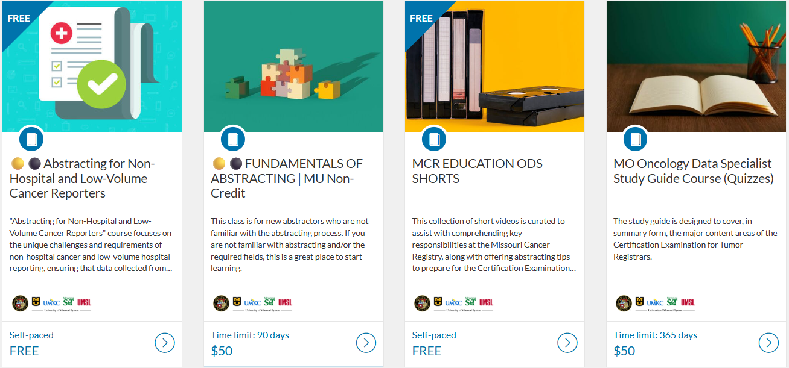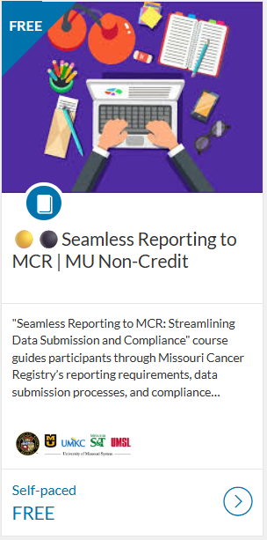

Student Highlights

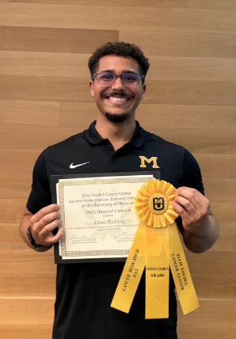
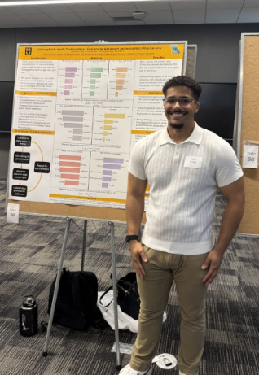
We are so proud of our student, Steven Richburg, who attended the Summer SURF Program at EFCC and won an award for his presentation on “Utilizing Public Health Dashboards as a Resource for Adolescent and Young Adult (AYA) Cancers!” The full dashboard can be found on our website at https://cancerregistry.missouri.edu/ Click on the AYA report on the home page.

Death Clearance
Death Clearance (DC) follow back for the reporting year 2023 is underway! If you have changes in staffing, or a different person in charge of Death Clearance reporting, please let Stacy Barr know. barrs@health.missouri.edu
Check Web Plus to see if you have any cases follow back cases listed. If you are new to the process or would like a refresher, please refer to the instructions and You Tube video that can be accessed from this page of our website under ‘DC Follow-Back Requests’ https://cancerregistry.missouri.edu/reporting/cancer-reporting-hospital/

We truly appreciate your contributions to making this project successful; the information you provide is an essential part of MCR in meeting our annual goals!

In Kind Letter Responses Needed ASAP!
We are asking for a statement of the actual cost required for your facility to report data to MCR for the period June 30, 2024, to June 29, 2025. Please return your responses to Stacy Barr. Your response provides us with an idea of the amount of support your facility provided by the Central Registry. barrs@health.missouri.edu

Ready for 2025 Cases!
MCR updated its Registry Plus Suite of software programs to V25B. We are now ready to accept 2025 cases. Reach out if you run across any issues with this upgrade. The V25B metafile can be found on the NAACCR Clearinghouse for your vendors or the zip file can be downloaded from the MCR website at this link https://cancerregistry.missouri.edu/reporting/cancer-reporting-hospital/

Missouri Health Maps now Missouri Cancer Dashboard
Missouri Cancer Registry recently added Missouri Health Maps to its website. The maps can be found by clicking on the Missouri Cancer Dashboards button on the MCR home page task bar.

The Missouri Health maps display 2018-2022 data. This information may be helpful to you and your facility to see cancer incidence in your area. The map of Missouri is divided into zones based on population.

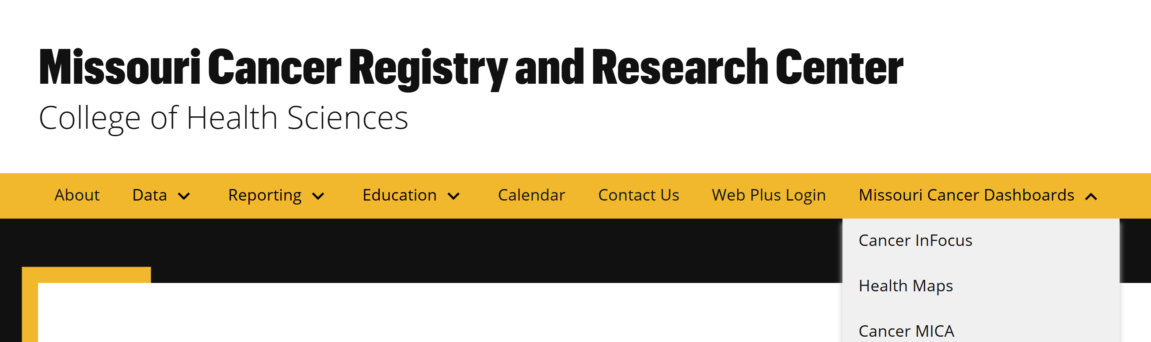

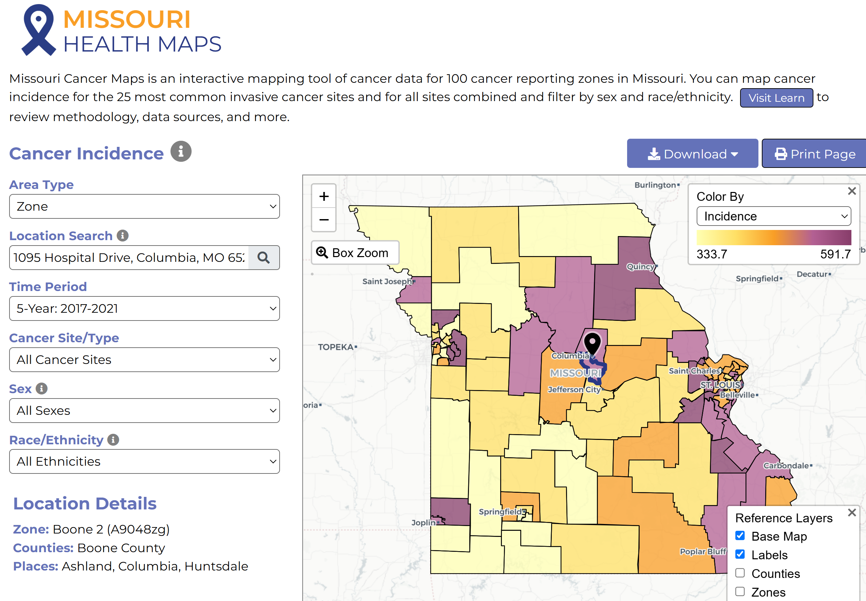

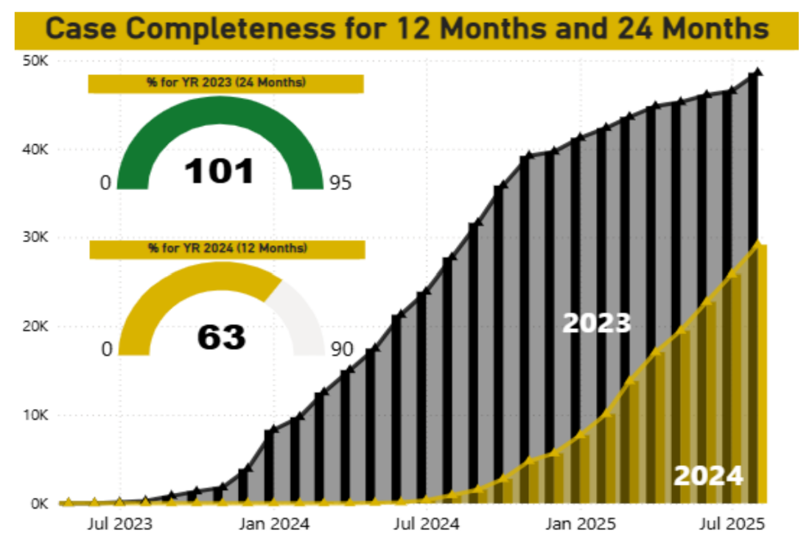

MCR is required by NPCR to submit 90% of 2024 data during the Call for Data this November. We need your cases and support to meet this goal! This graph shows our status toward reaching the 2023 and 2024 goals.

Radiation Exposure Compensation Act (RECA)
The Radiation Exposure Compensation Act (RECA), 42 U.S.C. § 2210 note, is a federal law that provides partial restitution to individuals who developed certain serious illnesses following exposure to radiation from the U.S. nuclear weapons program, or their survivors. This became effective for Missouri on July 4, 2025. New claims may be filed through December 31, 2027. Please see this link for guidelines on requesting information from Missouri Cancer Registry https://cancerregistry.missouri.edu/radiation-exposure-compensation-act-reca/

NEWS FROM THE STANDARD SETTERS
SEER Educate News
July/August 2025 Updates
In Training, ODS Prep - No CEs, there is a group module called Coding Drill - Dx 2025 Surgery (SEER Coding Guidelines). These coding drills focus on surgery related data items, with surgery primary site as a critical field. It is weighted as 2 points. Breast and Colon are available. In Training, Disease Information, there is a General section and as of August 2025, there are site-specific sections for Breast and Prostate. Each site-specific section is broken into Stats, Anatomy, Diagnostic Procedures, Staging, and Treatment.

Log in or sign up at SEER*Educate today by visiting https://educate.fredhutch.org/ and Learn by Doing!
Help Desk will be CLOSED or Limited (in addition to weekends)
- August 29-September 1 (Labor Day weekend)
- September 22-26 (Staff vacations)
- November 11 (Veterans Day)
- November 27-29 (Thanksgiving)
- December 24-26 (Christmas)
- January 1 (New Years Day)

NAACCR
The NAACCR Data Standards, Data Dictionary v26, and 2026 Implementation Guidelines are now available on the NAACCR website. https://www.naaccr.org/

NAACCR Fall 2025 ODS Exam Prep Course
First session is Tuesday, September 2, 2025
Course highlights include:
- 8 live webinars
- Full access to recorded sessions
- Weekly online quizzes to test your knowledge
- Time practice exam
- Active discussion board for peer and instructor support
Register today at https://education.naaccr.org/CTR

NCRA Fall Webinar Series
NCRA’s fall 2025 three-part Abstracting & Coding webinar series will focus on rectal, testicular, and pancreatic cancers. Webinars start at 2:00 PM ET. Register for the three-part series by September 26th. https://www.cancerregistryeducation.org/live-webinars

NCRA Virtual Fundamentals of Abstracting Workshop Beginning in September
The virtual Fundamentals of Abstracting (FOA) Workshop includes four three-hour sessions scheduled over four days from 12:00 PM to 3:00 PM ET. The faculty will provide a theoretical basis for the tasks and activities associated with abstracting and a review of the topics most important to abstractors, including Solid Tumor Rules, ICD-O, AJCC TNM Staging, Summary Stage, and Site-Specific Data Items. The workshop is designed for cancer registry employees with between six months to two years of experience. Attendees should have knowledge of anatomy, physiology, medical terminology, and cancer registry resources. The workshop is foundational and is not eligible for CE credits. Deadline to register is Friday, September 5, 2025.
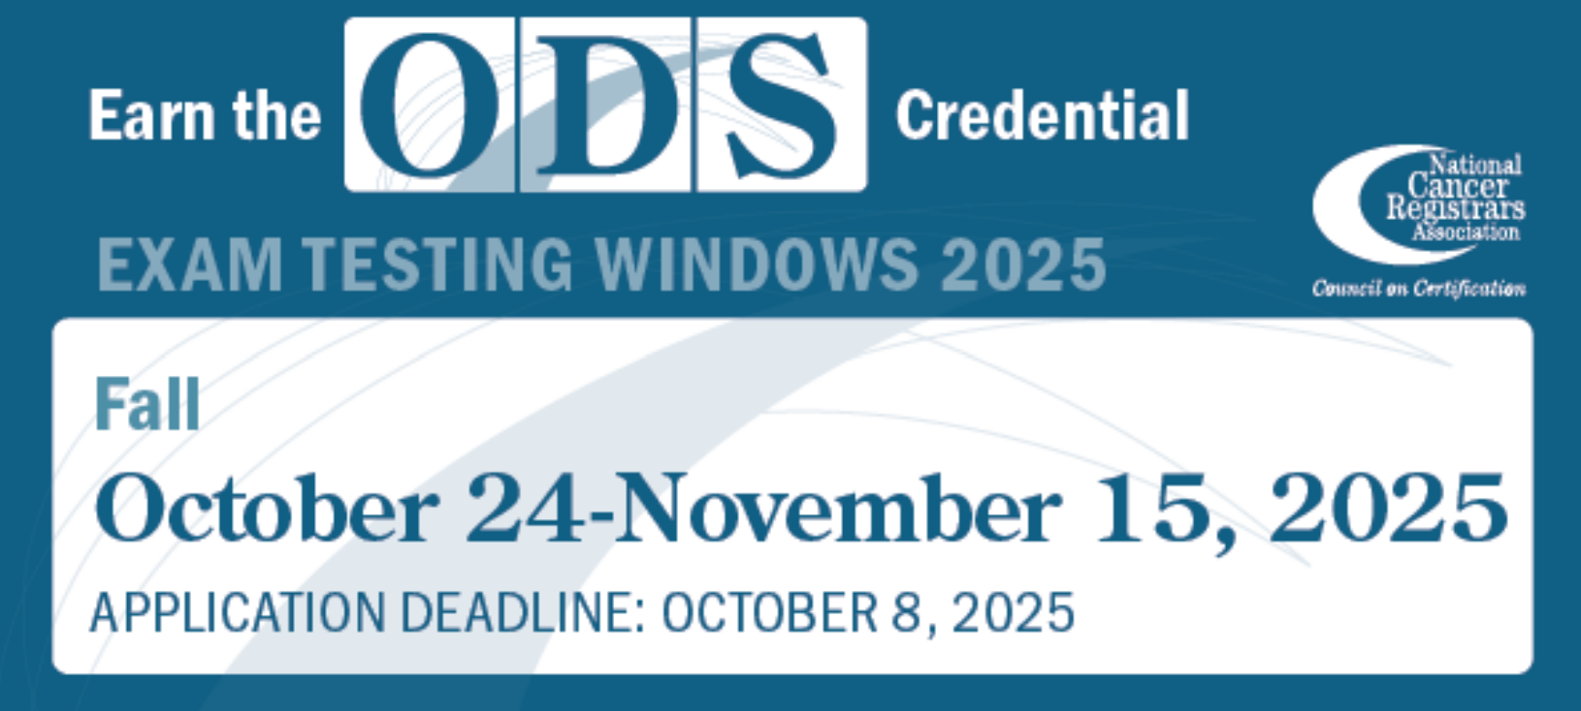

Warm regards,
Lucinda Ham, RHIA, ODS-C  Operations/QA Manager, Missouri Cancer Registry  Department of Public Health  1095 Hospital Drive | Columbia MO 65211  O: 573-882-7775 | C: 573-220-2438  F: 573-884-9655 | E: lahf5p@health.missouri.edu  W: https://cancerregistry.missouri.edu/ | “Alone we can do so little, together we can do so much” – Helen Keller
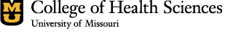

Missouri Cancer Registry and Research Center is supported in part by a cooperative agreement between the Centers for Disease Control and Prevention (CDC) and the Missouri Department of Health and Senior Services (DHSS) (DP2202-22-04) and a Surveillance Contract between DHSS and the University of Missouri.

