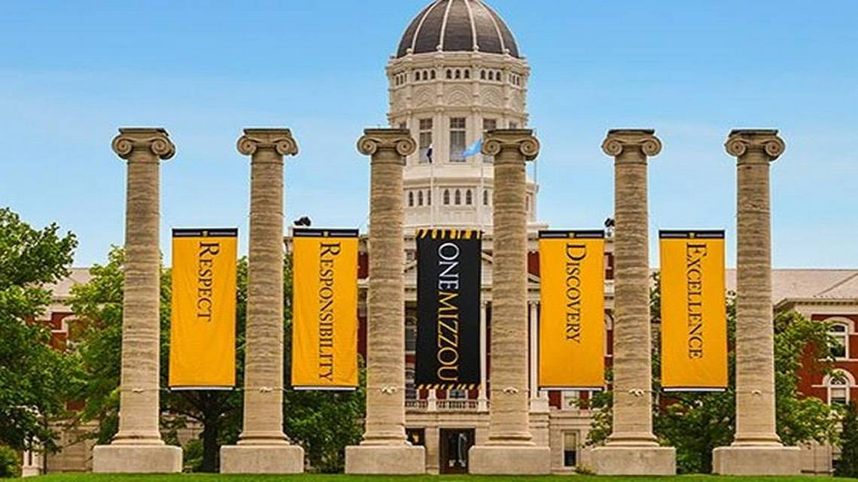
Missouri Cancer Registry
October 2025
Fellow Registrars,
We had a great turnout at the MOODS Conference held on September 26th at Boone Health. It was great to see so many of you there! We are looking forward to seeing you again next year!
October is Breast Cancer Awareness month! Be sure to get your annual screening done. The attached one-pager provides Missouri Breast Cancer Stats from 2018-2022. I have also included the statistical one-pager for Liver and IHBD cancers.
Due Dates
To be on track, large hospitals (>500 cases/yr.) typically are expected to have abstracted March 2025 diagnosis cases by October 15, 2025. Smaller facilities (<300 cases /yr.) were expected to report the 1st Quarter of 2025 by October 15, 2025.
Education
MCR Helpline
Reach us at 1-800-392-2829 during regular office hours or leave a message; a member of our QA team will return your call within one business day.

NAACCR Webinars:
NAACCR Webinars are now available on the MCR website at https://cancerregistry.missouri.edu/education/educational-webinars-and-recordings/ Contact Lucinda Ham at lahf5p@health.missouri.edu for the password. After gaining access to the webinars, click on the file folder for the month. The webinar materials are readily accessible and can be downloaded.
NAACCR Webinar: Coding Pitfalls 2025, September 2025

Upcoming NAACCR Webinar: Oral Cavity & Minor Salivary Glands 2025, October 2, 2025, 8-11 a.m. The webinar will cover the anatomy, solid tumor rules, staging and treatment of oral cavity and salivary glands. Examples, quizzes and case scenarios are included. To attend the live broadcast in Columbia, MO, sign up here:
https://www.signupgenius.com/go/10C054CACAE28A0F8C25-59092551-oral

YouTube – Casefinding Audits: Reducing Missed Cases and Strengthening Clinical Accuray
Check out our newest YouTube on Casefinding Audits created by Deborah Carey. This video shows how to easily find cancer cases in your disease index – provided it is in Excel format. https://www.youtube.com/channel/UCsm_Eu4-pqIdZibqeyOecUQ
Show Me Tip
Deborah Carey, ODS-C, created the attached Show Me Tip on Breast Cancers. This edition is full of great tips on how to properly code and abstract breast cancers. Be sure to check it out!

Missouri Oncology Data Specialist Educational Conference – September 26th
We had a wonderful day at the MOODS Conference! Attendees learned about Cancer Statistics in Missouri, Advances in Technical & Surgical Treatment of Breast Cancer; Death Clearance; Hematopoietic Neoplasm Coding, Current Staging, Treatment & Outcome in Hematopoietic Diseases; Surgical Management of Liver & Peritoneal Metastasis from Colorectal Cancer, and a roundtable discussion on How Information is Used in the Registry and lastly. The day ended with a rousing game of MCR Jeopardy!

Special thanks to our presenters, Jeanie Shaneberger at Boone Health, for providing the location, and the MCR team for their contributions and assistance with the conference.

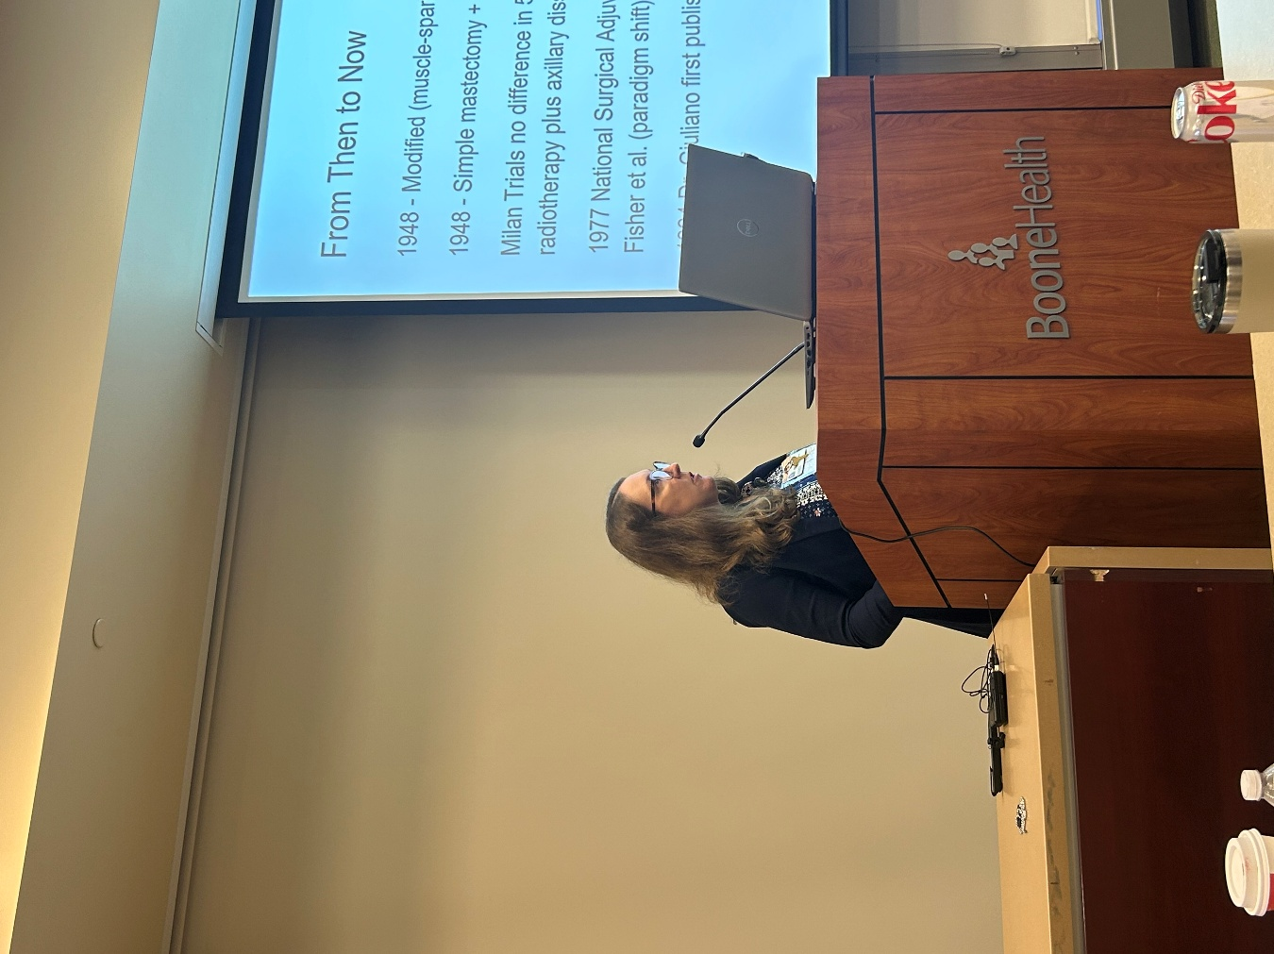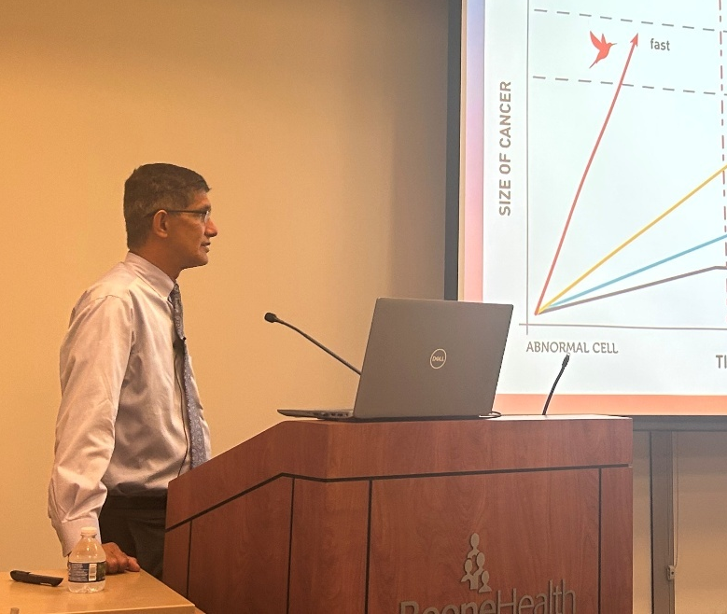
Dr. Ashley Wilbers Dr. Cherian Verghese
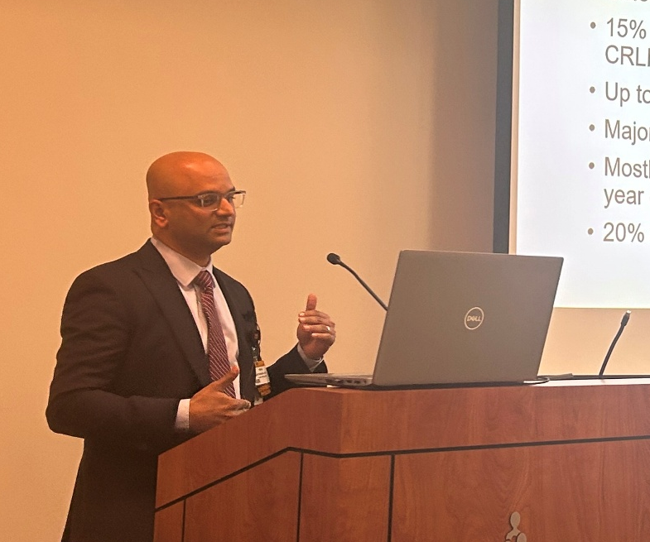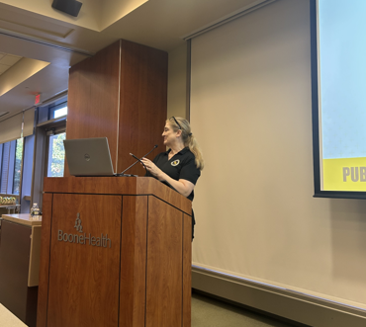
Dr. Vikas Satyananda Dr. Iris Zachary
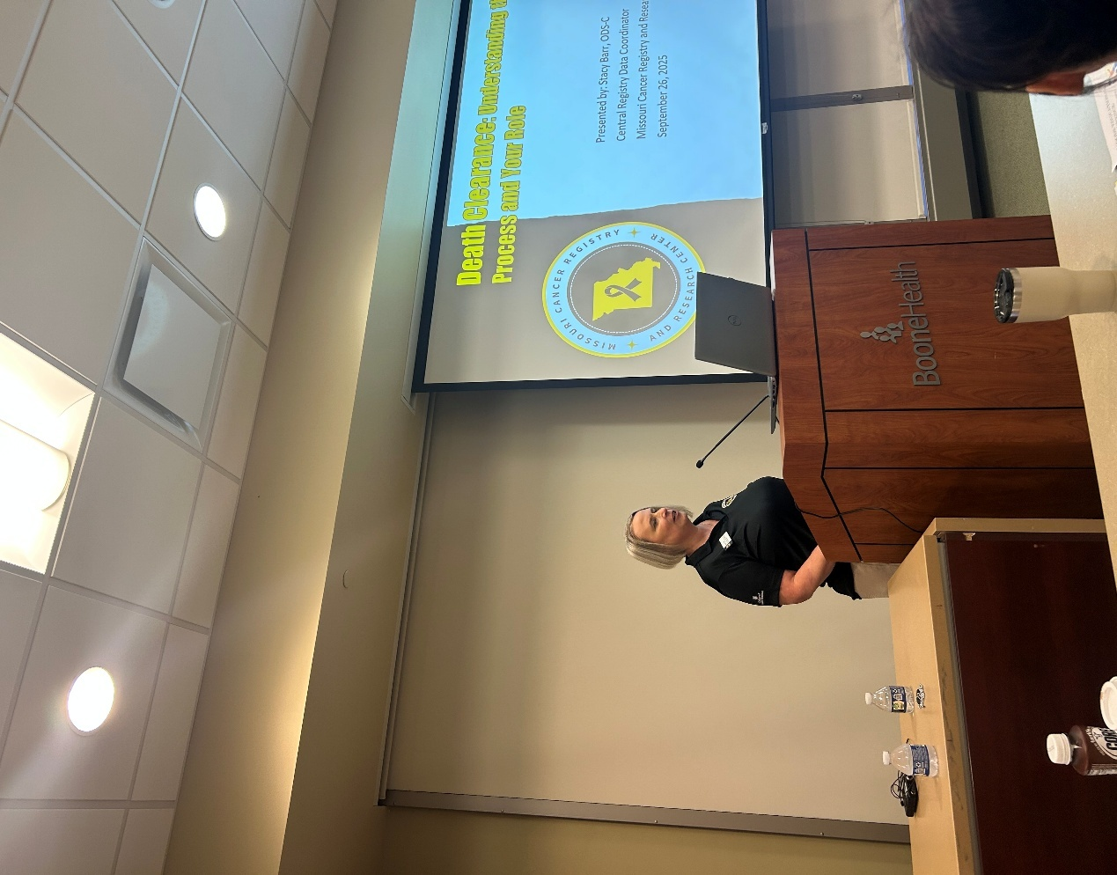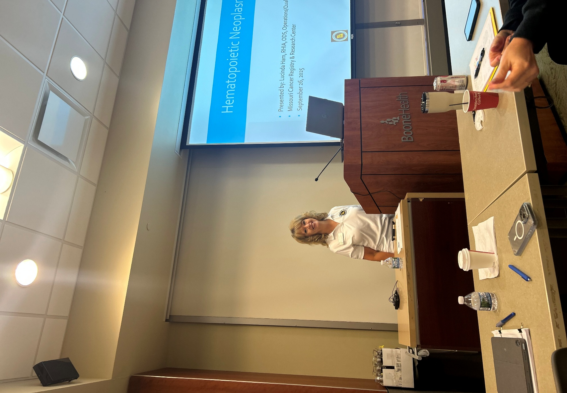
Stacy Barr, BS, ODS-C Lucinda Ham, RHIA, ODS-C
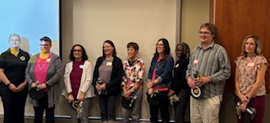

This group of individuals were recipients of Shining Star awards for meeting the Gold Certificate criteria three years in a row.

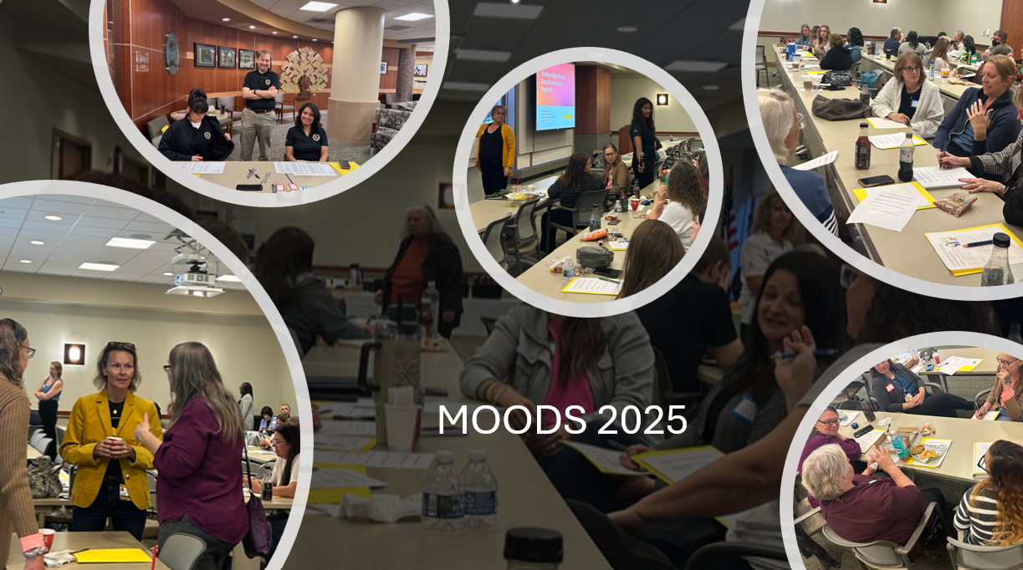

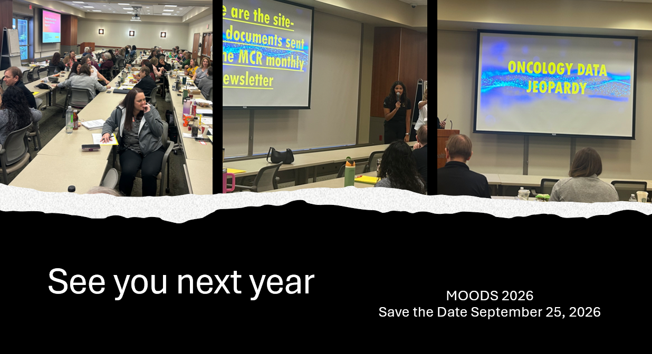

YouTube – Casefinding Audits: Reducing Missed Cases and Strengthening Clinical Accuray
Check out our newest YouTube on Casefinding Audits created by Deborah Carey. This video shows how to easily find cancer cases in your disease index – provided it is in Excel format. https://www.youtube.com/channel/UCsm_Eu4-pqIdZibqeyOecUQ

MCR Training and Online Courses
The MO Oncology Data Specialist Study Guide and Fundamentals of Abstracting courses have been recently updated. We have also added additional courses to the MCR Course Catalog. Click on the following link to enroll in any of these courses.
https://cancerregistry.missouri.edu/education/educational-webinars-and-recordings/

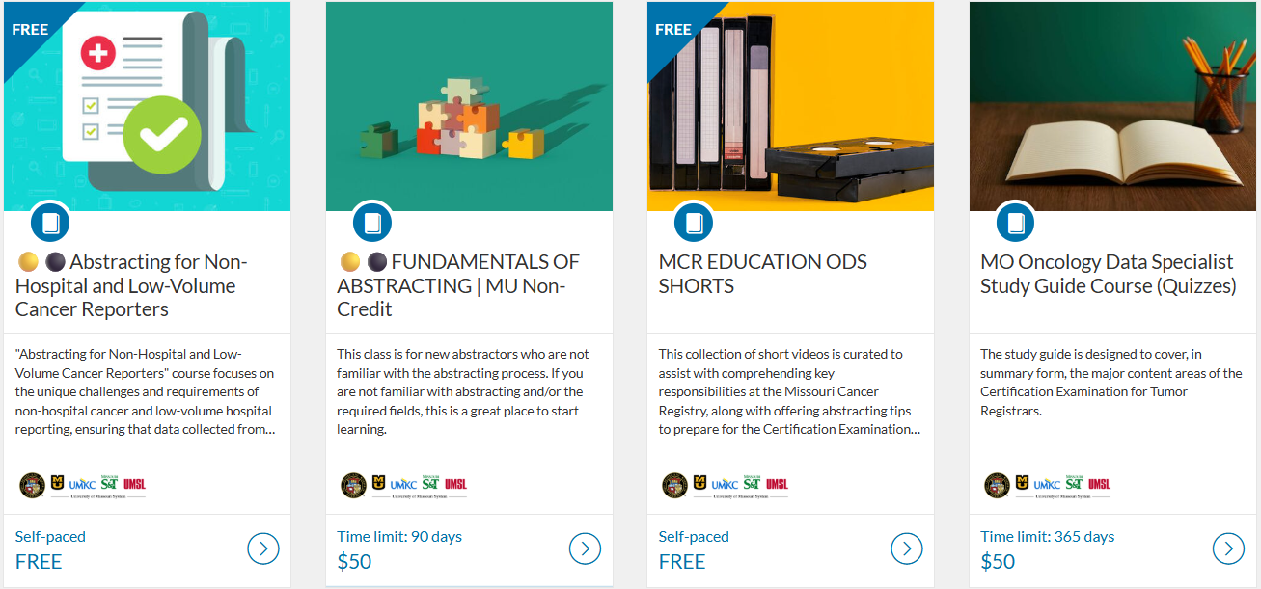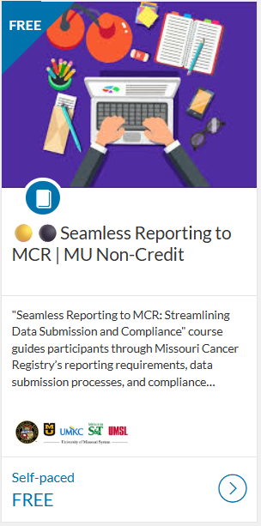

Death Clearance
If you indicated that you have missed cases, please submit them as soon as possible to MCR.

Ready for 2025 Cases!
MCR updated its Registry Plus Suite of software programs to V25B. We are now ready to accept 2025 cases. Reach out if you run across any issues with this upgrade. The V25B metafile can be found on the NAACCR Clearinghouse for your vendors or the zip file can be downloaded from the MCR website at this link https://cancerregistry.missouri.edu/reporting/cancer-reporting-hospital/

Missouri Cancer Dashboards
Missouri Cancer Registry recently added Missouri Health Maps to its website. The maps can be found by clicking on the Missouri Cancer Dashboards button on the MCR home page task bar.

The Missouri Health maps display 2018-2022 data. This information may be helpful to you and your facility to see cancer incidence in your area. The map of Missouri is divided into zones based on population.

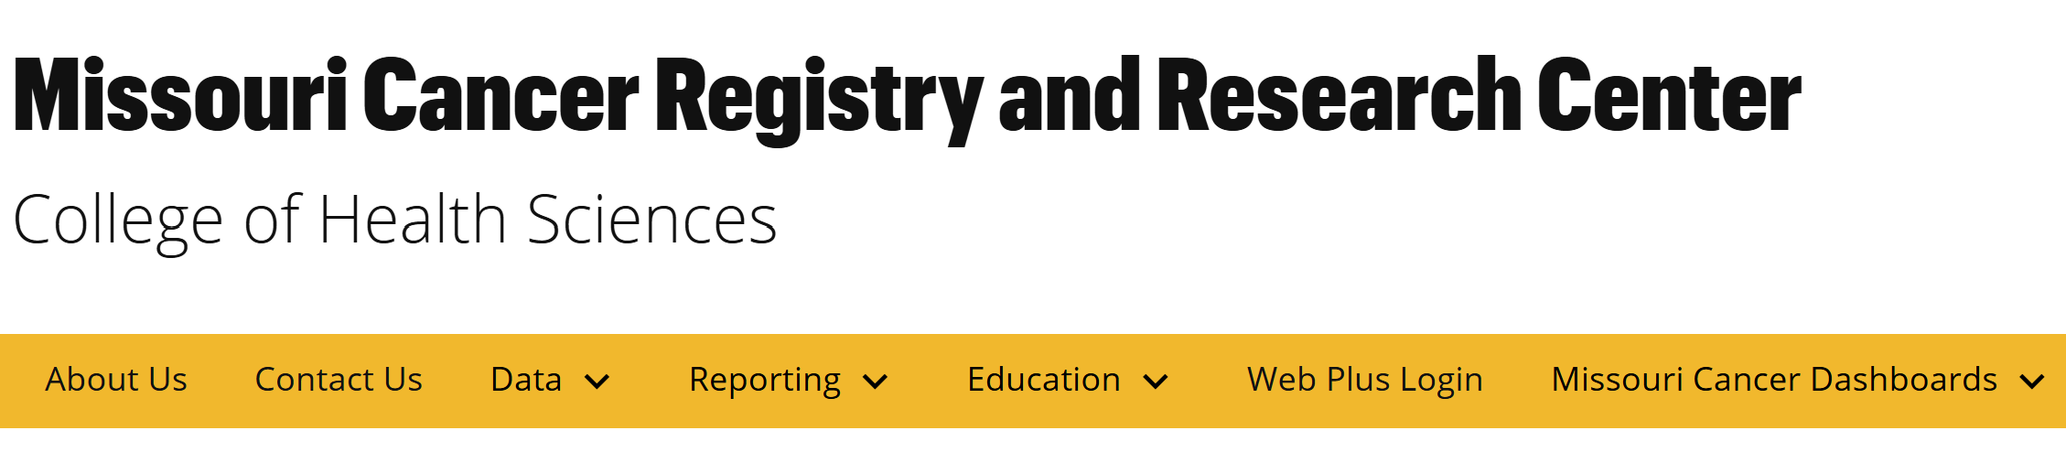

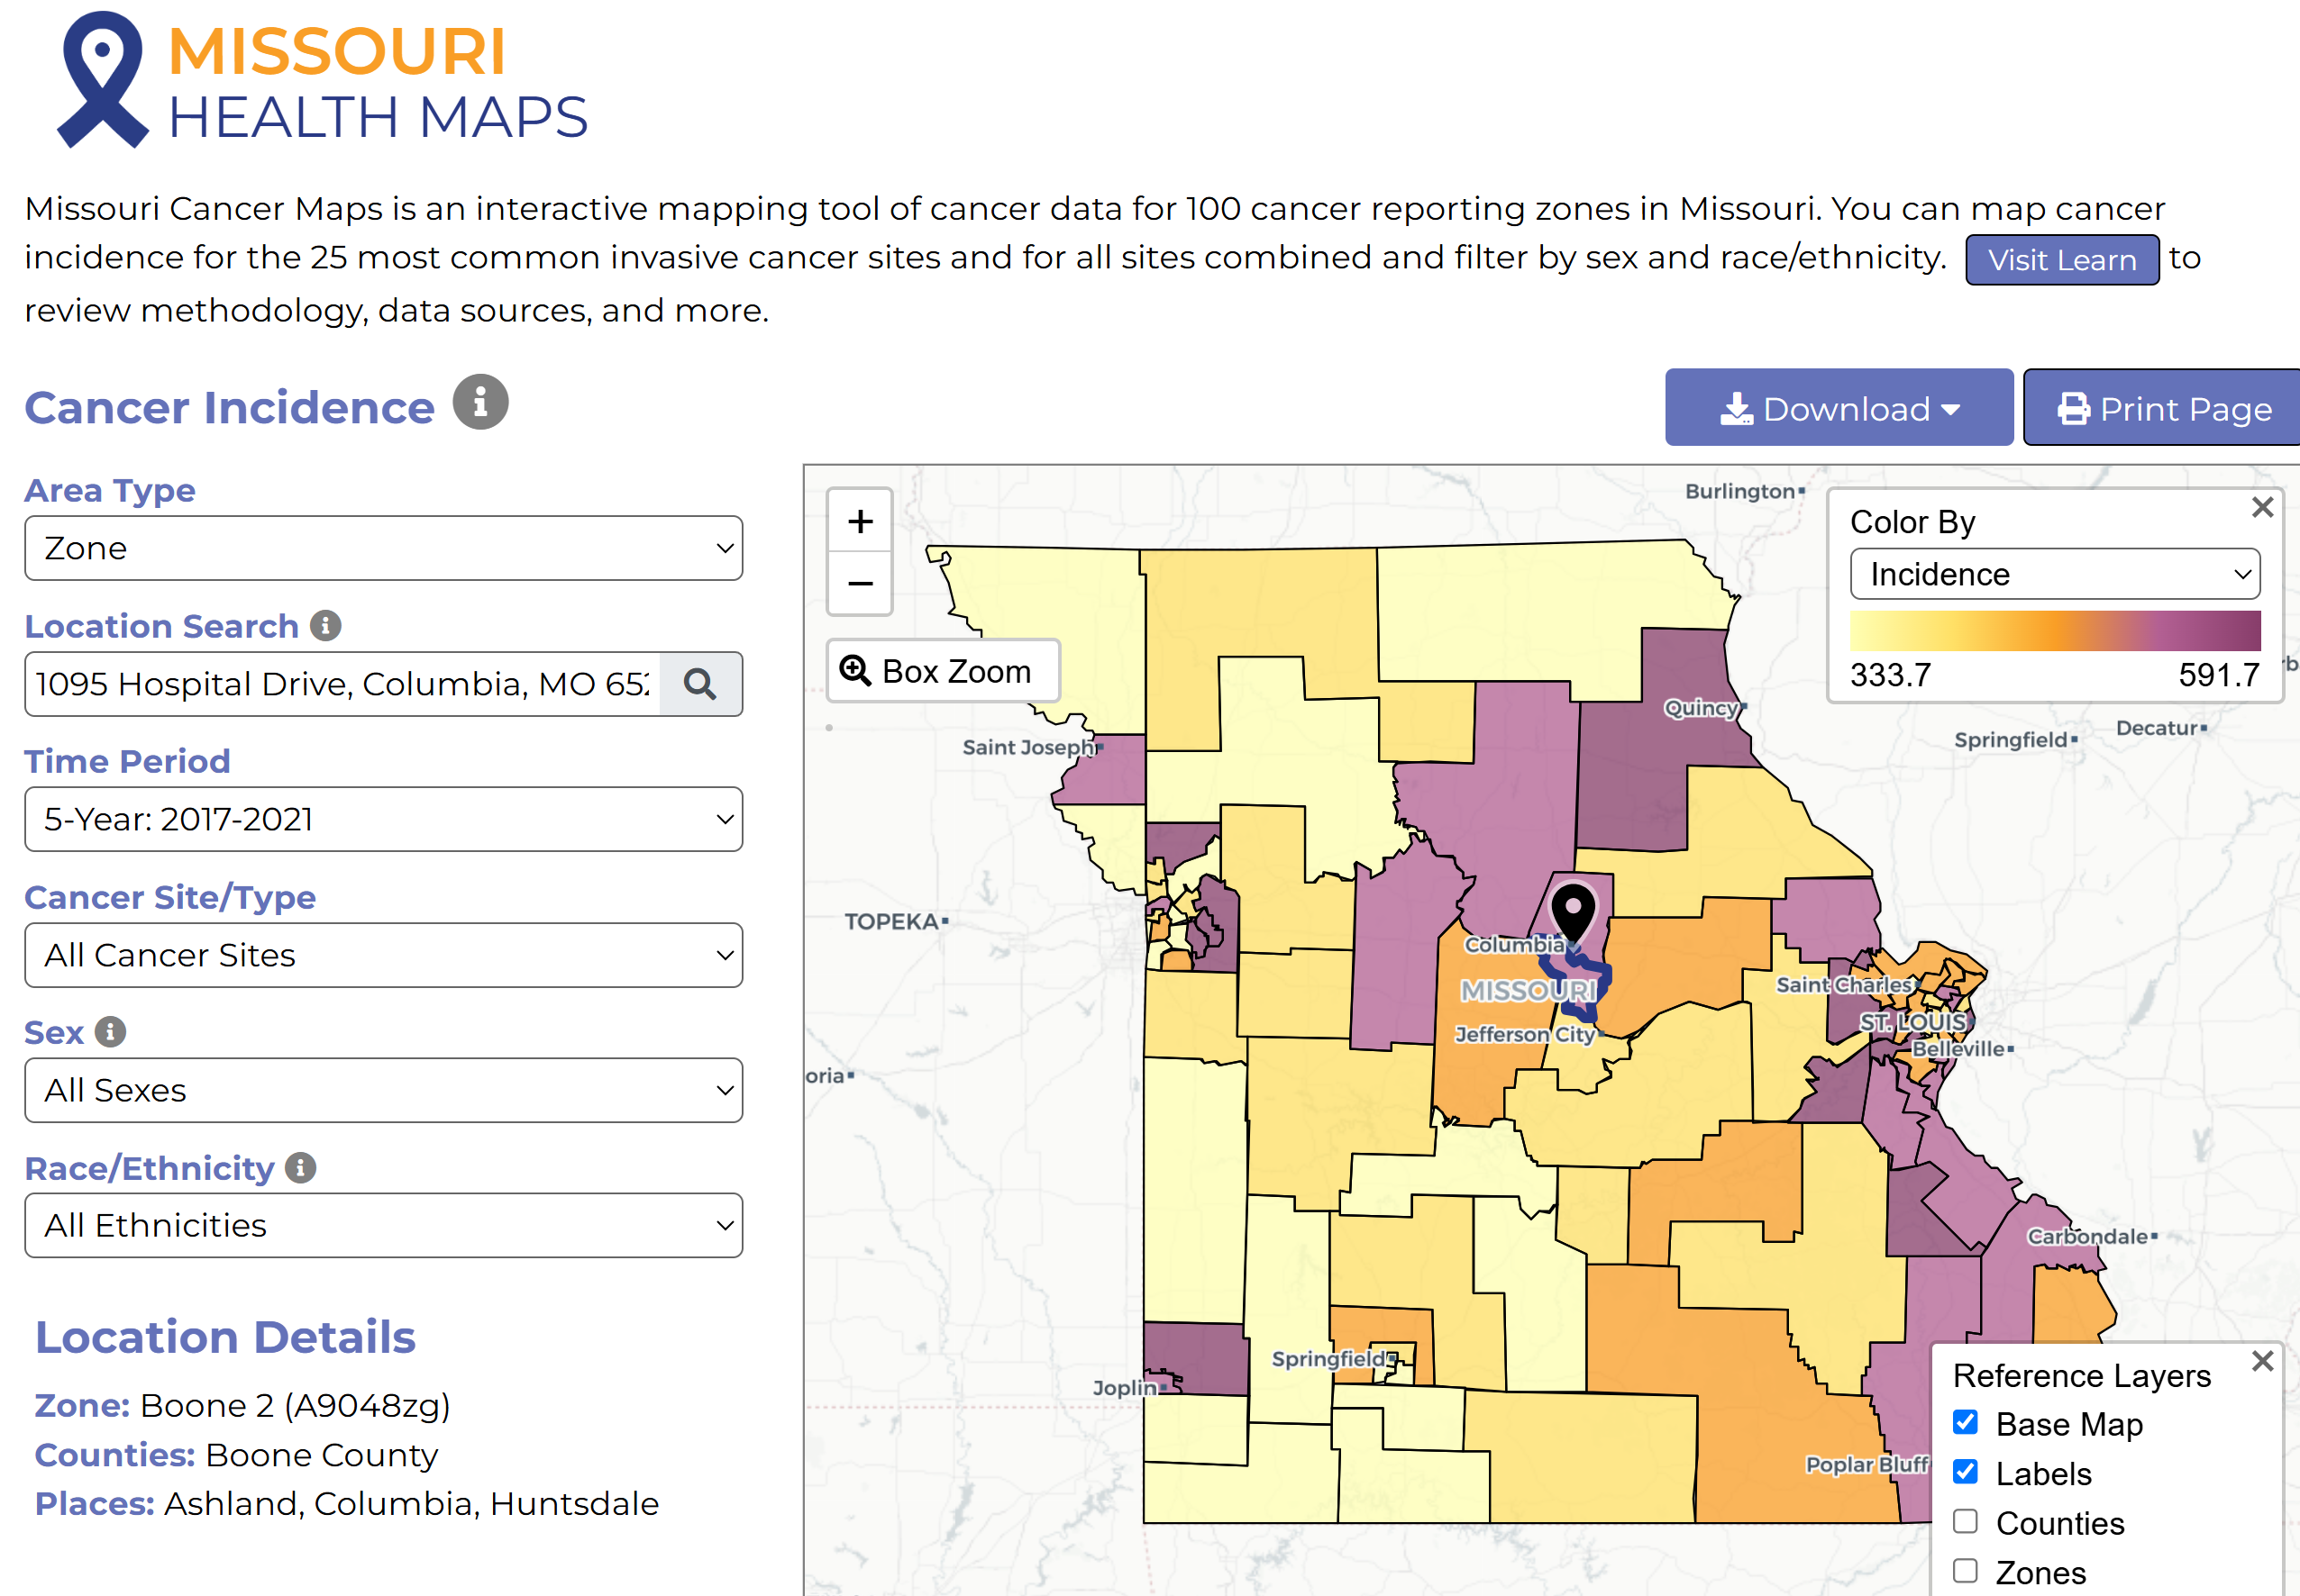

Cancer InFocus Maps
Cancer In Focus Maps provide a variety of information at the county level. Under Other Dashboards, select CIF Hot Spots to see which counties are potential cancer hotspots in Missouri. These are interactive maps produced in collaboration between the National Cancer Institute and Centers for Disease Control and Prevention. The graphs provide a geographic profile of cancer burden in Missouri and reveal sociodemographic disparities in cancer incidence, mortality, risk factors for cancer, and cancer screening, across different population subgroups.

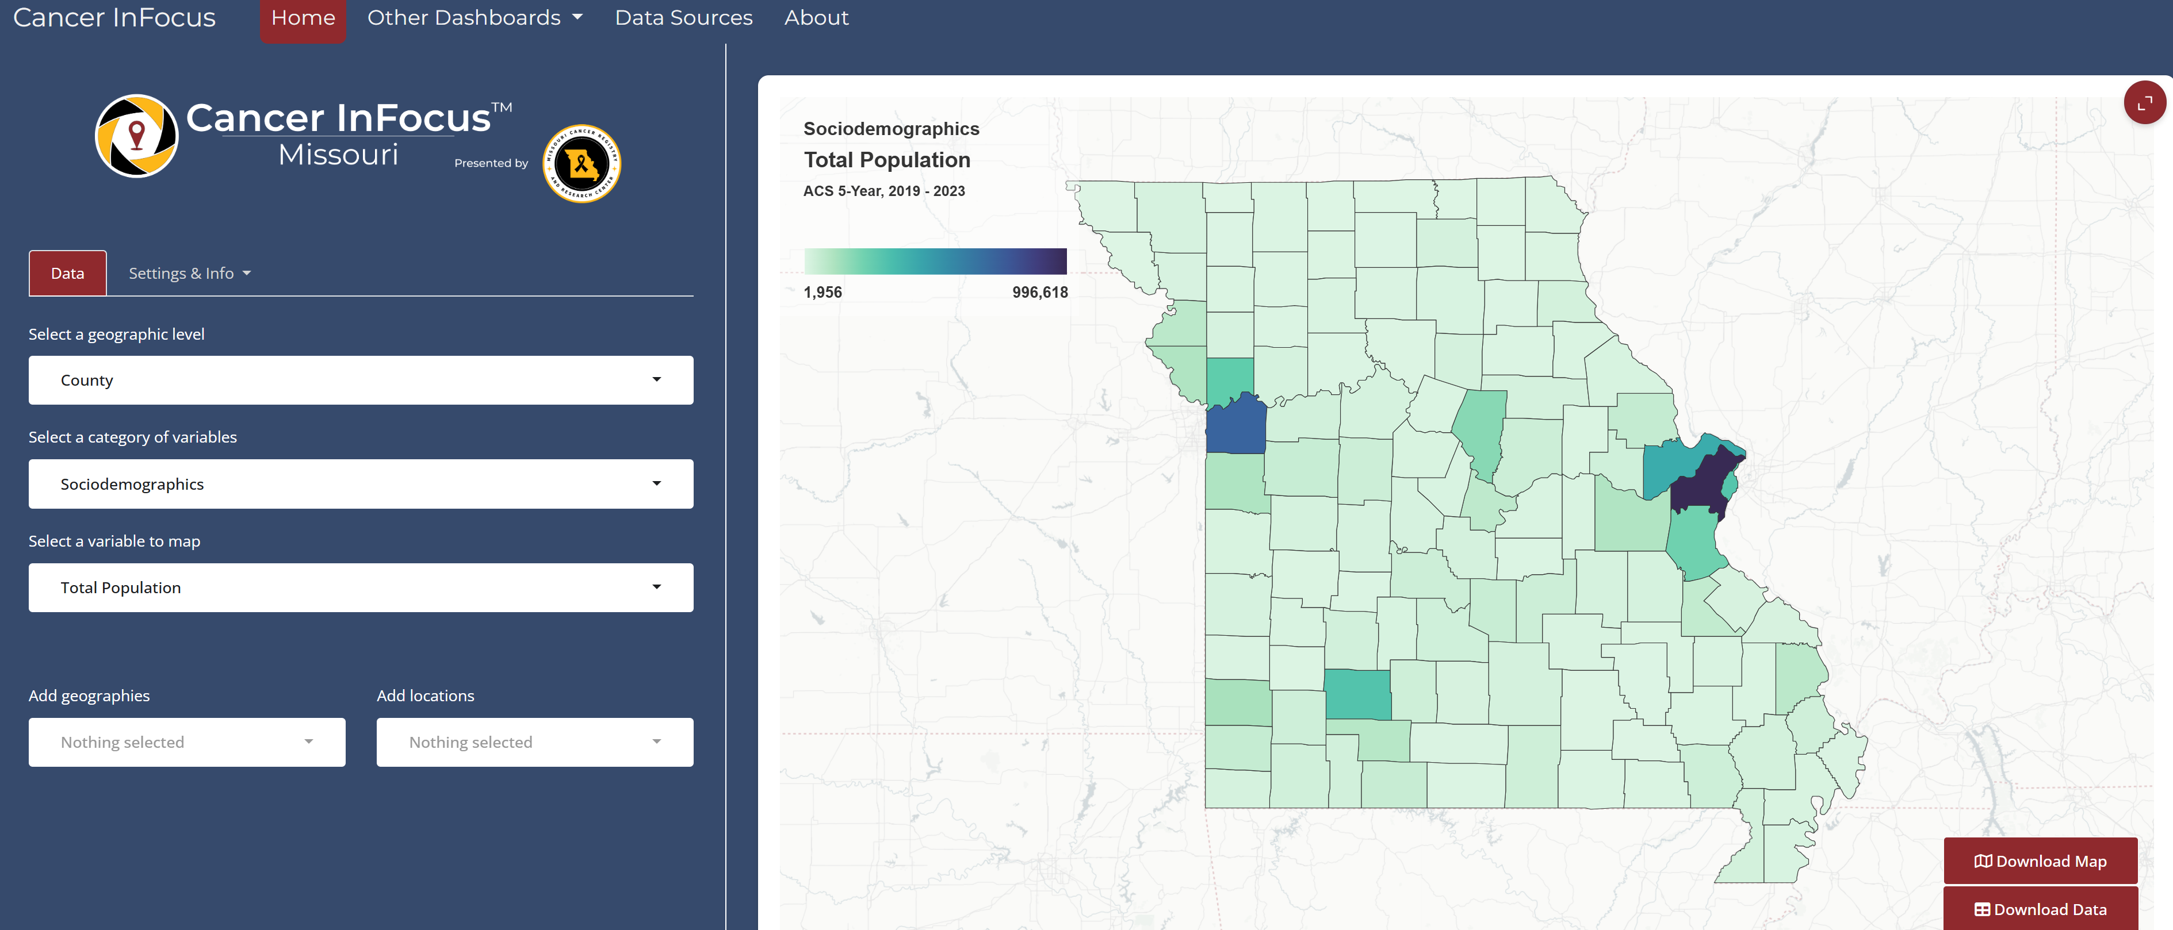

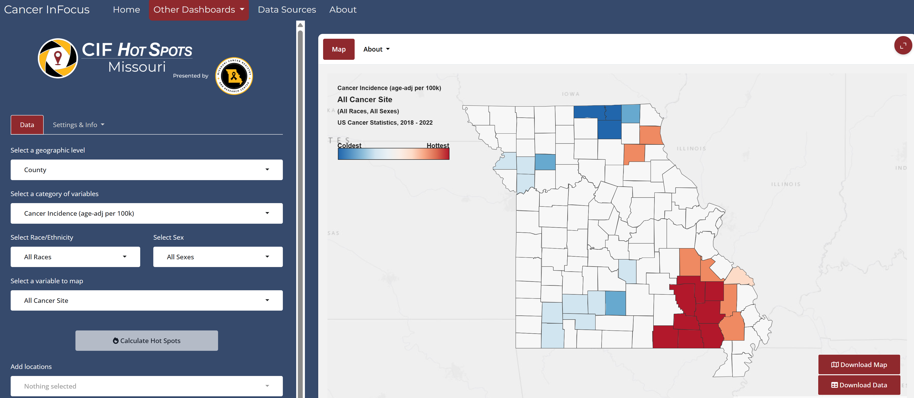

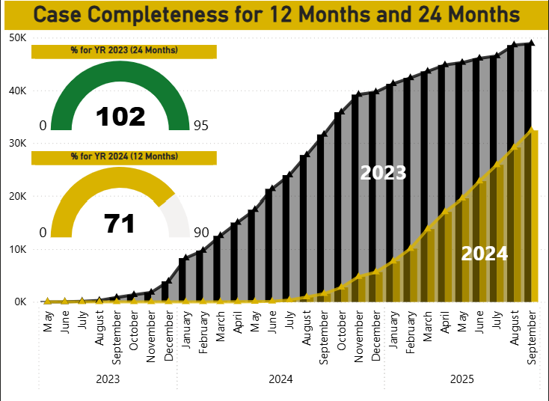

MCR is required by NPCR to submit 90% of 2024 data during the Call for Data this November. We have made great strides in the past month toward reaching 90% goal for 2024 cases.

Radiation Exposure Compensation Act (RECA)
The Radiation Exposure Compensation Act (RECA), 42 U.S.C. § 2210 note, is a federal law that provides partial restitution to individuals who developed certain serious illnesses following exposure to radiation from the U.S. nuclear weapons program, or their survivors. This became effective for Missouri on July 4, 2025. New claims may be filed through December 31, 2027. Please see this link for guidelines on requesting information from Missouri Cancer Registry https://cancerregistry.missouri.edu/reca/

NEWS FROM THE STANDARD SETTERS
SEER Educate News
September 2025 News – SEER Registration Workshop
Register now at NCRA to secure your online seat for the virtual meeting. On the NCRA homepage, click on Conference and then on 2025 SEER Workshop. Registration deadline is November 21, 2025, or until meeting capacity is reached.

The virtual meeting will be held December 8, 10, and 12, 2025, from 12:00 to 5:00 pm ET each day.

If you encounter an issue with the meeting registration, contact Nancy Allen at nallen@ncra-usa.org.
Log in or sign up at SEER*Educate today by visiting https://educate.fredhutch.org/ and Learn by Doing!
Help Desk will be CLOSED or Limited (in addition to weekends)
- November 11 (Veterans Day)
- November 27-29 (Thanksgiving)
- December 24-26 (Christmas) - January 1 (New Years Day)

NAACCR
The NAACCR Data Standards, Data Dictionary v26, and 2026 Implementation Guidelines are now available on the NAACCR website. https://www.naaccr.org/

Warm regards,
Lucinda Ham, RHIA, ODS-C  Operations/QA Manager, Missouri Cancer Registry  Department of Public Health  1095 Hospital Drive | Columbia MO 65211  O: 573-882-7775 | C: 573-220-2438  F: 573-884-9655 | E: lahf5p@health.missouri.edu  W: https://cancerregistry.missouri.edu/ | “Alone we can do so little, together we can do so much” – Helen Keller
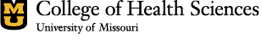

Missouri Cancer Registry and Research Center is supported in part by a cooperative agreement between the Centers for Disease Control and Prevention (CDC) and the Missouri Department of Health and Senior Services (DHSS) (DP2202-22-04) and a Surveillance Contract between DHSS and the University of Missouri.
