
Missouri Cancer Registry
November 2025
Fellow Registrars,
Thanksgiving is quickly approaching. We at MCR wish you a wonderful holiday season! We are actively preparing for the Annual Call for Data. We have reached all 2023 goals and could not have done it without your case submissions.
November is Lung Cancer Awareness month. Please see the attached one-pager for Missouri stats.
Although statistically fewer, November is also Pancreatic and Stomach Cancer awareness month. Those one-pagers are attached as well.
Due Dates
To be on track, large hospitals (>500 cases/yr.) typically are expected to have abstracted March 2025 diagnosis cases by October 15, 2025. Smaller facilities (<300 cases /yr.) were expected to report the 1st Quarter of 2025 by October 15, 2025.
Education
MCR Helpline
Reach us at 1-800-392-2829 during regular office hours or leave a message; a member of our QA team will return your call within one business day.

NAACCR Webinars:
NAACCR Webinars are now available on the MCR website at https://cancerregistry.missouri.edu/education/educational-webinars-and-recordings/ Contact Lucinda Ham at lahf5p@health.missouri.edu for the password. After gaining access to the webinars, click on the file folder for the month. The webinar materials are readily accessible and can be downloaded.
NAACCR Webinar: Oral Cavity & Minor Salivary Glands 2025, October

Upcoming NAACCR Webinar: Melanoma 2025, November 6, 2025, 8-11 a.m. The webinar will cover the anatomy, solid tumor rules, staging and treatment of melanoma malignancies. Examples, quizzes and case scenarios are included. To attend the live broadcast in Columbia, MO, sign up here: https://www.signupgenius.com/go/10C054CACAE28A0F8C25-59972500-naaccr

Abstracting Tip: Understand Ambiguous Terms – SEER Vs. NCDB/STORE

Death Clearance
Please submit any cases you noted as missed during death clearance as soon as possible. Reminder: Death clearance for your facility is not considered complete until all missed cases have been submitted.

YouTube – Casefinding Audits: Reducing Missed Cases and Strengthening Clinical Accuray
Check out our newest YouTube on Casefinding Audits created by Deborah Carey. This video shows how to easily find cancer cases in your disease index – provided it is in Excel format. https://www.youtube.com/channel/UCsm_Eu4-pqIdZibqeyOecUQ

MCR Training and Online Courses
The MO Oncology Data Specialist Study Guide and Fundamentals of Abstracting courses have been recently updated. We have also added additional courses to the MCR Course Catalog. Click on the following link to enroll in any of these courses.
https://cancerregistry.missouri.edu/education/educational-webinars-and-recordings/

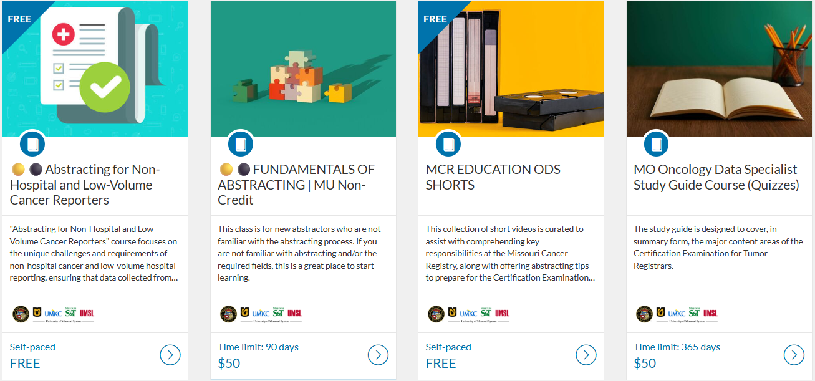

V26 metafile
The Missouri V26 metafile will be posted to the NAACCR Clearinghouse the week of November 3, 2025, for your vendors to review. It does contain some new SSDIs and a new field for documenting patient sex.

Missouri Cancer Dashboards
Missouri Cancer Registry recently added Missouri Health Maps to its website. The maps can be found by clicking on the Missouri Cancer Dashboards button on the MCR home page task bar.

The Missouri Health maps display 2018-2022 data. This information may be helpful to you and your facility to see cancer incidence in your area. The map of Missouri is divided into zones based on population.

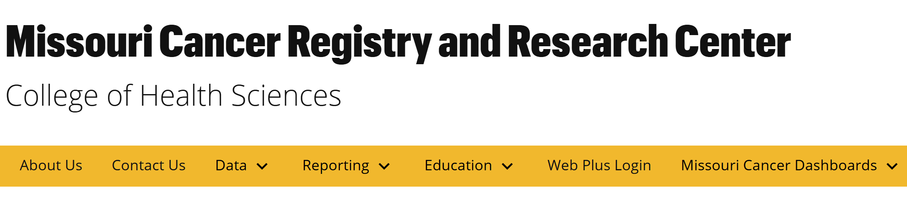

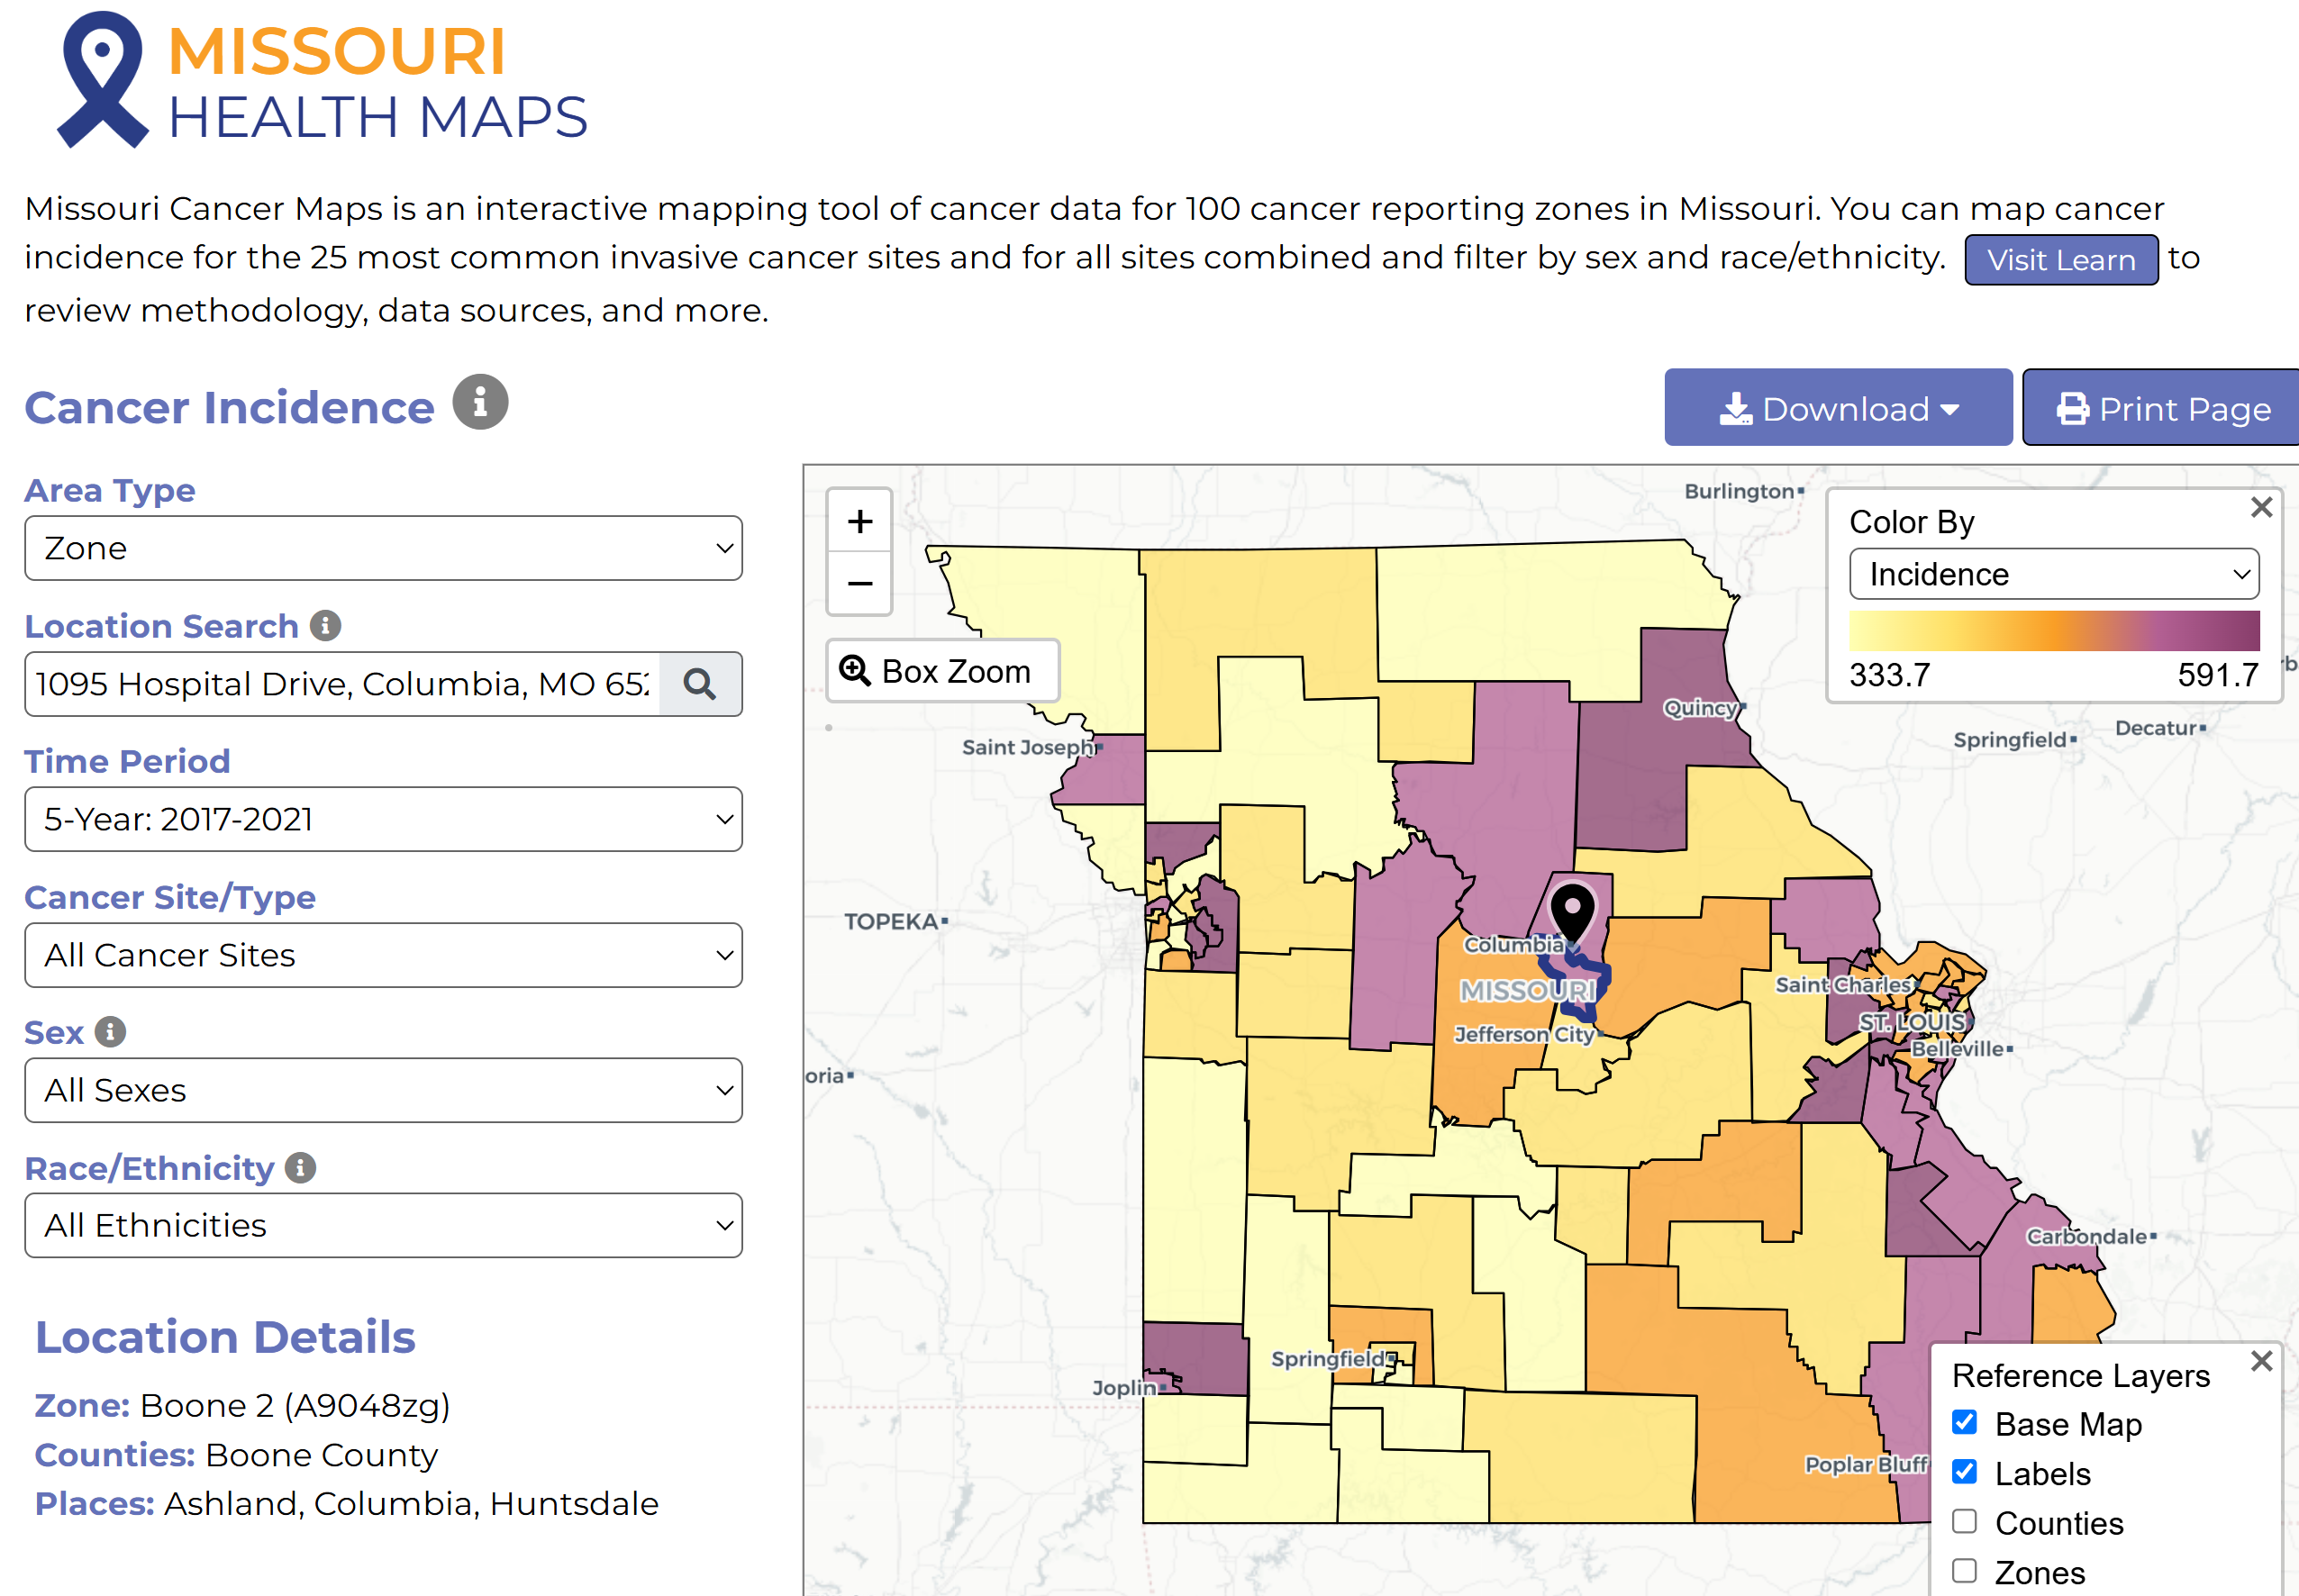

Cancer InFocus Maps
Cancer In Focus Maps provide a variety of information at the county level. Under Other Dashboards, select CIF Hot Spots to see which counties are potential cancer hotspots in Missouri. These are interactive maps produced in collaboration between the National Cancer Institute and Centers for Disease Control and Prevention. The graphs provide a geographic profile of cancer burden in Missouri and reveal sociodemographic disparities in cancer incidence, mortality, risk factors for cancer, and cancer screening, across different population subgroups.

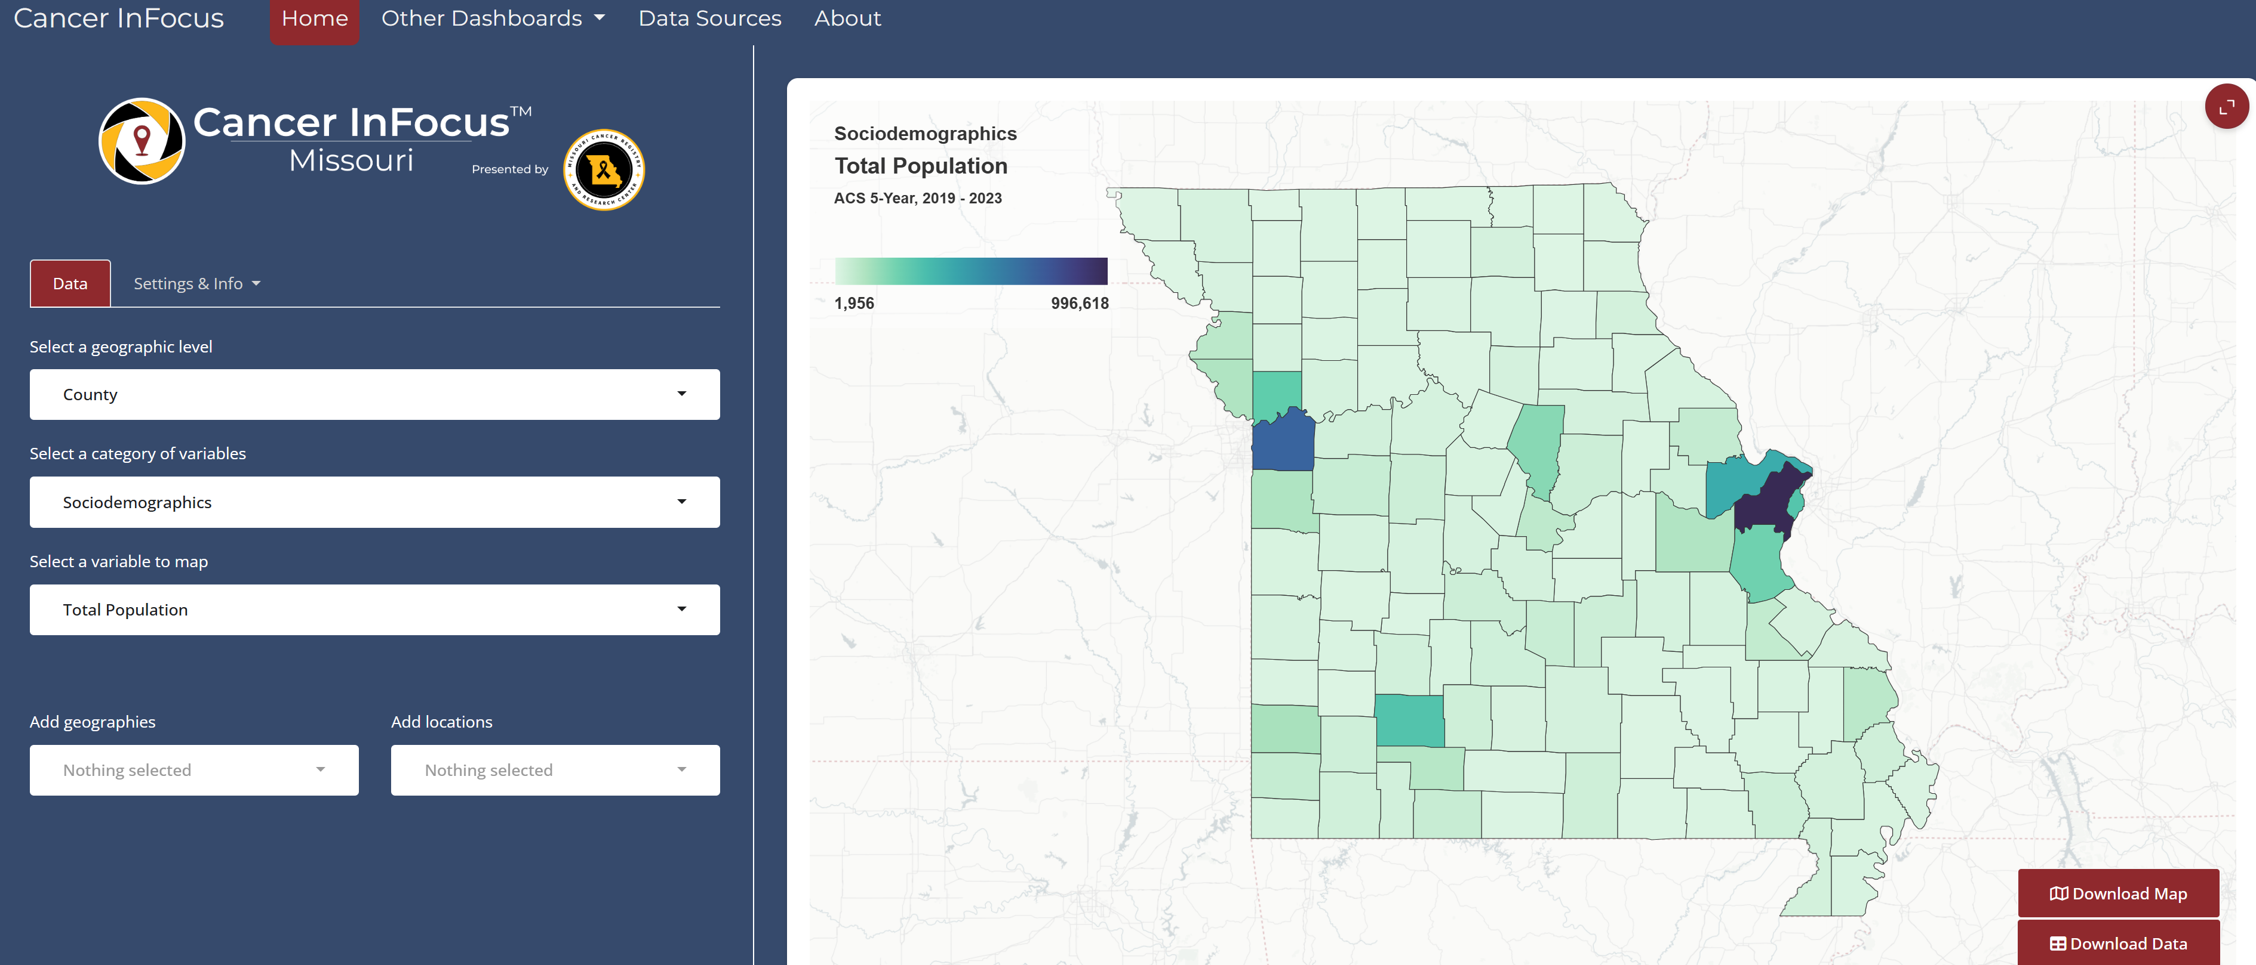

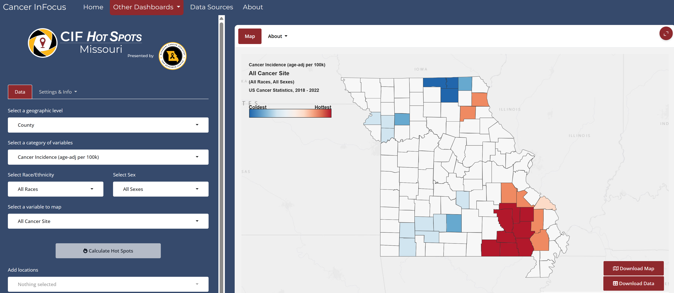

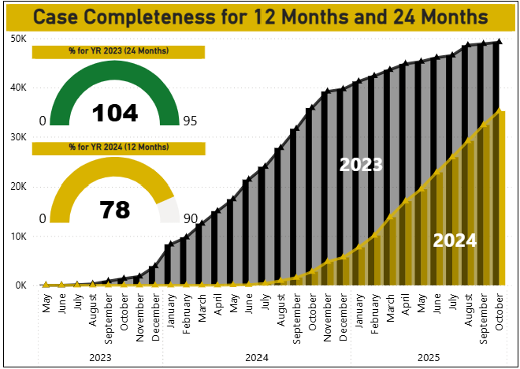

MCR is required by NPCR to submit 90% of 2024 data during the Call for Data this November. We have made great strides in the past month toward reaching 90% goal for 2024 cases.

Radiation Exposure Compensation Act (RECA)
The Radiation Exposure Compensation Act (RECA), 42 U.S.C. § 2210 note, is a federal law that provides partial restitution to individuals who developed certain serious illnesses following exposure to radiation from the U.S. nuclear weapons program, or their survivors. This became effective for Missouri on July 4, 2025. New claims may be filed through December 31, 2027. Please see this link for guidelines on requesting information from Missouri Cancer Registry https://cancerregistry.missouri.edu/reca/

NEWS FROM THE STANDARD SETTERS
SEER Educate News
Log in or sign up at SEER*Educate today by visiting https://educate.fredhutch.org/ and Learn by Doing!
Help Desk will be CLOSED or Limited (in addition to weekends)
- November 9-11 (Veterans Day long weekend)
- November 27-29 (Thanksgiving)
- December 24-28 (Christmas long weekend)
- January 1-4 (New Years long weekend)
- January 19th

NAACCR
The NAACCR Data Standards, Data Dictionary v26, and 2026 Implementation Guidelines have recently been updated and are now available on the NAACCR website. https://www.naaccr.org/

Warm regards,
Lucinda Ham, RHIA, ODS-C  Operations/QA Manager, Missouri Cancer Registry  Department of Public Health  1095 Hospital Drive | Columbia MO 65211  O: 573-882-7775 | C: 573-220-2438  F: 573-884-9655 | E: lahf5p@health.missouri.edu  W: https://cancerregistry.missouri.edu/ | “Alone we can do so little, together we can do so much” – Helen Keller
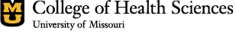
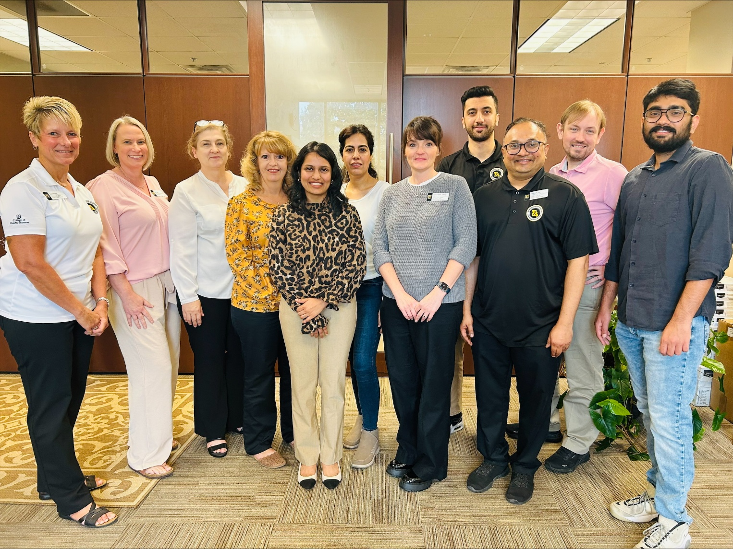

Missouri Cancer Registry and Research Center is supported in part by a cooperative agreement between the Centers for Disease Control and Prevention (CDC) and the Missouri Department of Health and Senior Services (DHSS) (DP2202-22-04) and a Surveillance Contract between DHSS and the University of Missouri.

