
Missouri Cancer Registry
August 2025
Fellow Registrars,
Summer is flying by! We have been working on Call for Data preparations, educational presentations, and Death Clearance.
This month we have three one-pagers to share. We hope you find this information useful in your work.
Due Dates
To be on track, large hospitals (>500 cases/yr.) typically are expected to have abstracted January 2025 diagnosis cases by August 15, 2025. Smaller facilities (<300 cases /yr.) were expected to report the 4th Quarter of 2024 by July 15, 2025.
Education
MCR Helpline
Reach us at 1-800-392-2829 during regular office hours or leave a message; a member of our QA team will return your call within one business day.

Abstracting Tips
- Breast cancer: In situ breast cancer GRADE is categorized by Low (L), Intermediate (M) or High (H). A 9 can be used if the information is unknown or not available. Numeric grades 1-3 should not be used for in-situ breast cancers.
- Lymphoma: If a lymph node is biopsied or removed to diagnose or state lymphoma, and that node is NOT the only node involved with Lymphoma, use code 02 - diagnostic/staging procedure. If there is only a single node involved with lymphoma, use the data item RX-Summ Surg 2023 [1291] to code these procedures.

NAACCR Webinars:
NAACCR Webinars are now available on the MCR website at https://cancerregistry.missouri.edu/education/educational-webinars-and-recordings/ Contact Lucinda Ham at lahf5p@health.missouri.edu for the password. After gaining access to the webinars, click on the file folder for the month. The webinar materials are readily accessible and can be downloaded.
NAACCR Webinar: Leveraging Technology to Improve Efficiency in a Hospital Registry, July 10, 2025

Upcoming NAACCR Webinar: Solid Tumor Rules 2025, 8-11 a.m. This webinar will review the cores concepts used to determine multiple primaries and assign histology. Examples, quizzes and case scenarios are included. To attend the live broadcast in Columbia, MO, sign up here:
https://www.signupgenius.com/go/10C054CACAE28A0F8C25-57591453-solid
SEER Educate News
2025 Updates
As of May 27th, 2025, the EOD exercise for most sites has been updated for 2025. New lung exercises will be released in January 2026 to include the new lung SSDI. The Heme, Histology, and Solid Tumor Rules Coding Exercises have been updated to the manuals released for 2025. Please note, the diagnosis years for these cases are prior to 2025, so data items that are specific to a diagnosis year will still conform to the appropriate SEER manual. There will be notes in the rationale explaining differences in coding effective with diagnosis year 2025.
Log in or sign up at SEER*Educate today by visiting https://educate.fredhutch.org/ and Learn by Doing!
Help Desk will be CLOSED or Limited (in addition to weekends)
- September 1 Labor Day
- November 11 (Veterans Day)
- November 27-29 (Thanksgiving)
- December 24-26 (Christmas)
- January 1 (New Years Day)

MCR Training and Online Courses
The MO Oncology Data Specialist Study Guide and Fundamentals of Abstracting courses have been recently updated. We have also added additional courses to the MCR Course Catalog. Click on the following link to enroll in any of these courses.
https://cancerregistry.missouri.edu/education/educational-webinars-and-recordings/

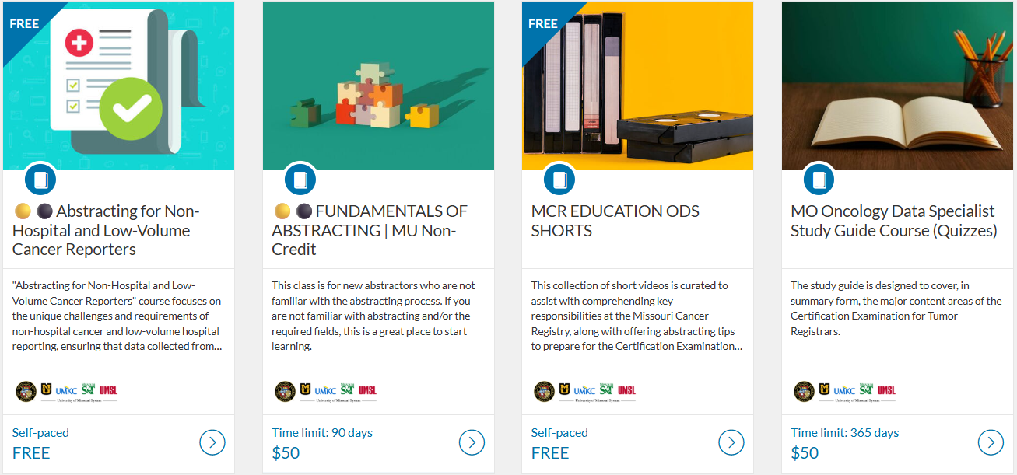

Death Clearance
Death Clearance (DC) follow back for the reporting year 2023 is underway! If you have changes in staffing, or a different person in charge of Death Clearance reporting, please let Stacy Barr know. barrs@health.missouri.edu
Please be on the lookout for a separate notification email regarding the official start of the death clearance follow back process. The DC process will essentially be the same as last year. If you are new to the process or would like a refresher, please refer to the instructions and You Tube video that can be accessed from this page of our website under ‘DC Follow-Back Requests’ https://cancerregistry.missouri.edu/reporting/cancer-reporting-hospital/

We truly appreciate your contributions to making this project successful; the information you provide is an essential part of MCR in meeting our annual goals!

In Kind letters
In Kind letters will be sent out very soon. We are asking for a statement of the actual cost required for your facility to report data to MCR for the period June 30, 2024, to June 29, 2025. Please return your responses by August 15, 2025, to Stacy Barr. Your response provides us with an idea of the amount of support your facility provided by the Central Registry. barrs@health.missouri.edu

Missouri Oncology Data Specialist Educational Conference – Registration Now Open!!

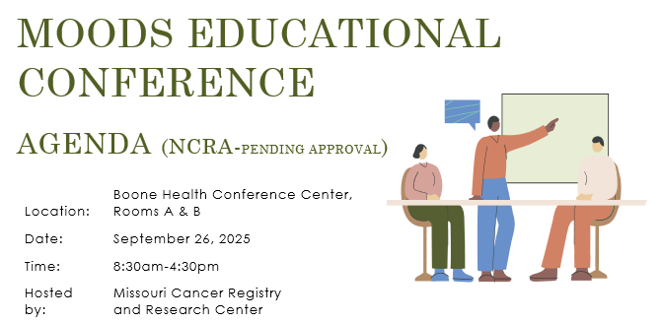
Registration is now open for the second Annual Missouri Oncology Data Specialist (MOODS) Educational Conference to be held on September 26, 2025, at Boone Health. We are excited to provide this free in-person educational conference!
Register for the conference by completing the form in this link: Missouri Oncology Data Specialist Educational Conference 2025 Registration form

Ready for 2025 Cases!
MCR updated its Registry Plus Suite of software programs to V25B. We are now ready to accept 2025 cases. Reach out if you run across any issues with this upgrade. The V25B metafile can be found on the NAACCR Clearinghouse for your vendors or the zip file can be downloaded from the MCR website at this link https://cancerregistry.missouri.edu/reporting/cancer-reporting-hospital/

Missouri Health Maps now Missouri Cancer Dashboard
Missouri Cancer Registry recently added Missouri Health Maps to its website. The maps can be found by clicking on the Missouri Cancer Dashboards button on the MCR home page task bar.

The Missouri Health maps display 2018-2022 data. This information may be helpful to you and your facility to see cancer incidence in your area. The map of Missouri is divided into zones based on population.

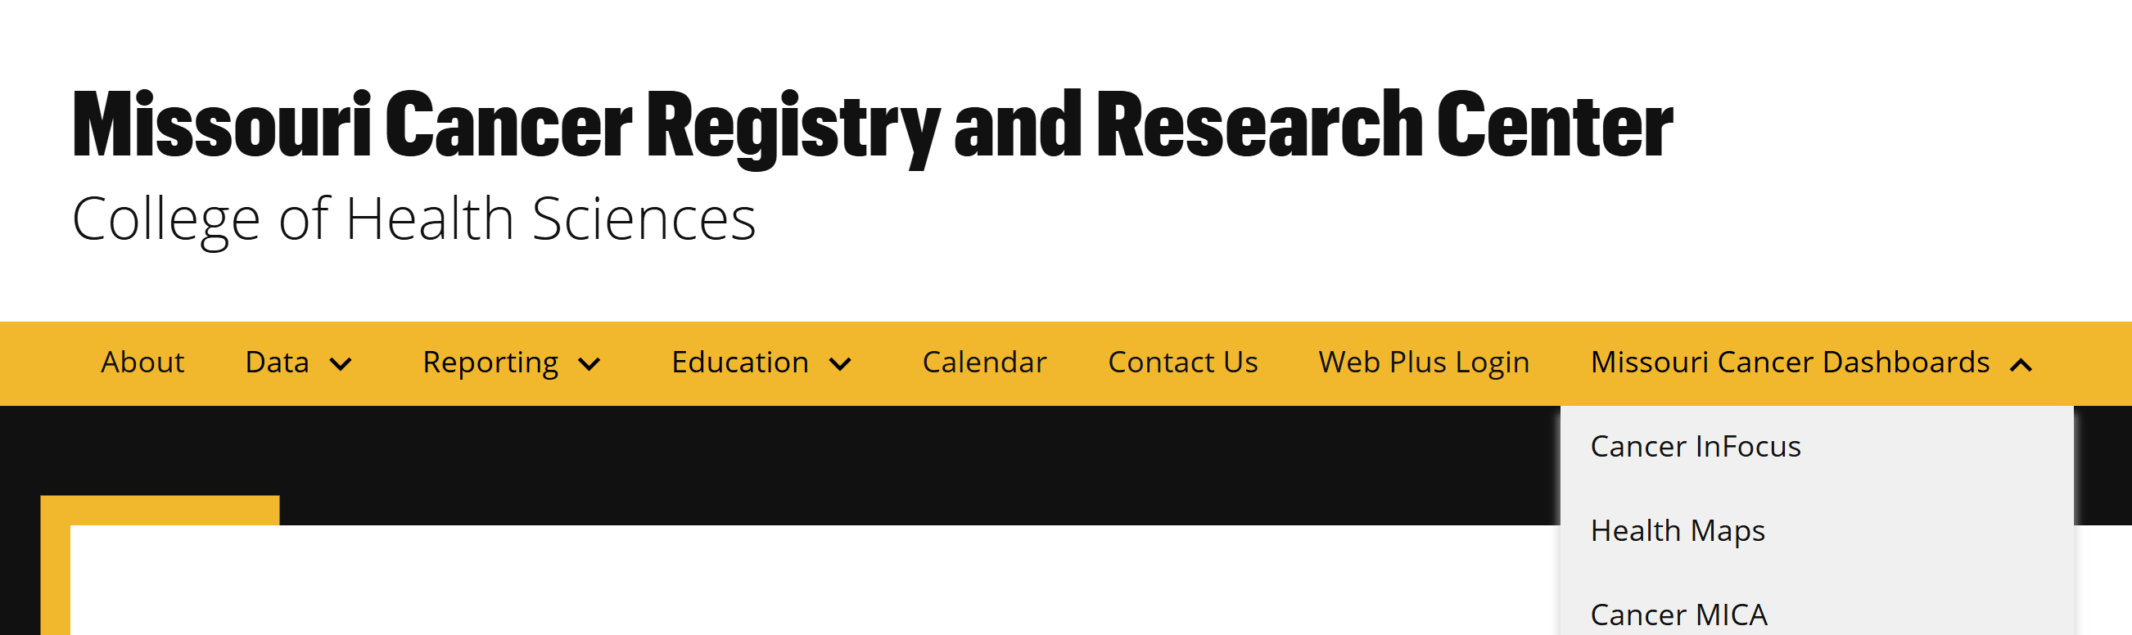
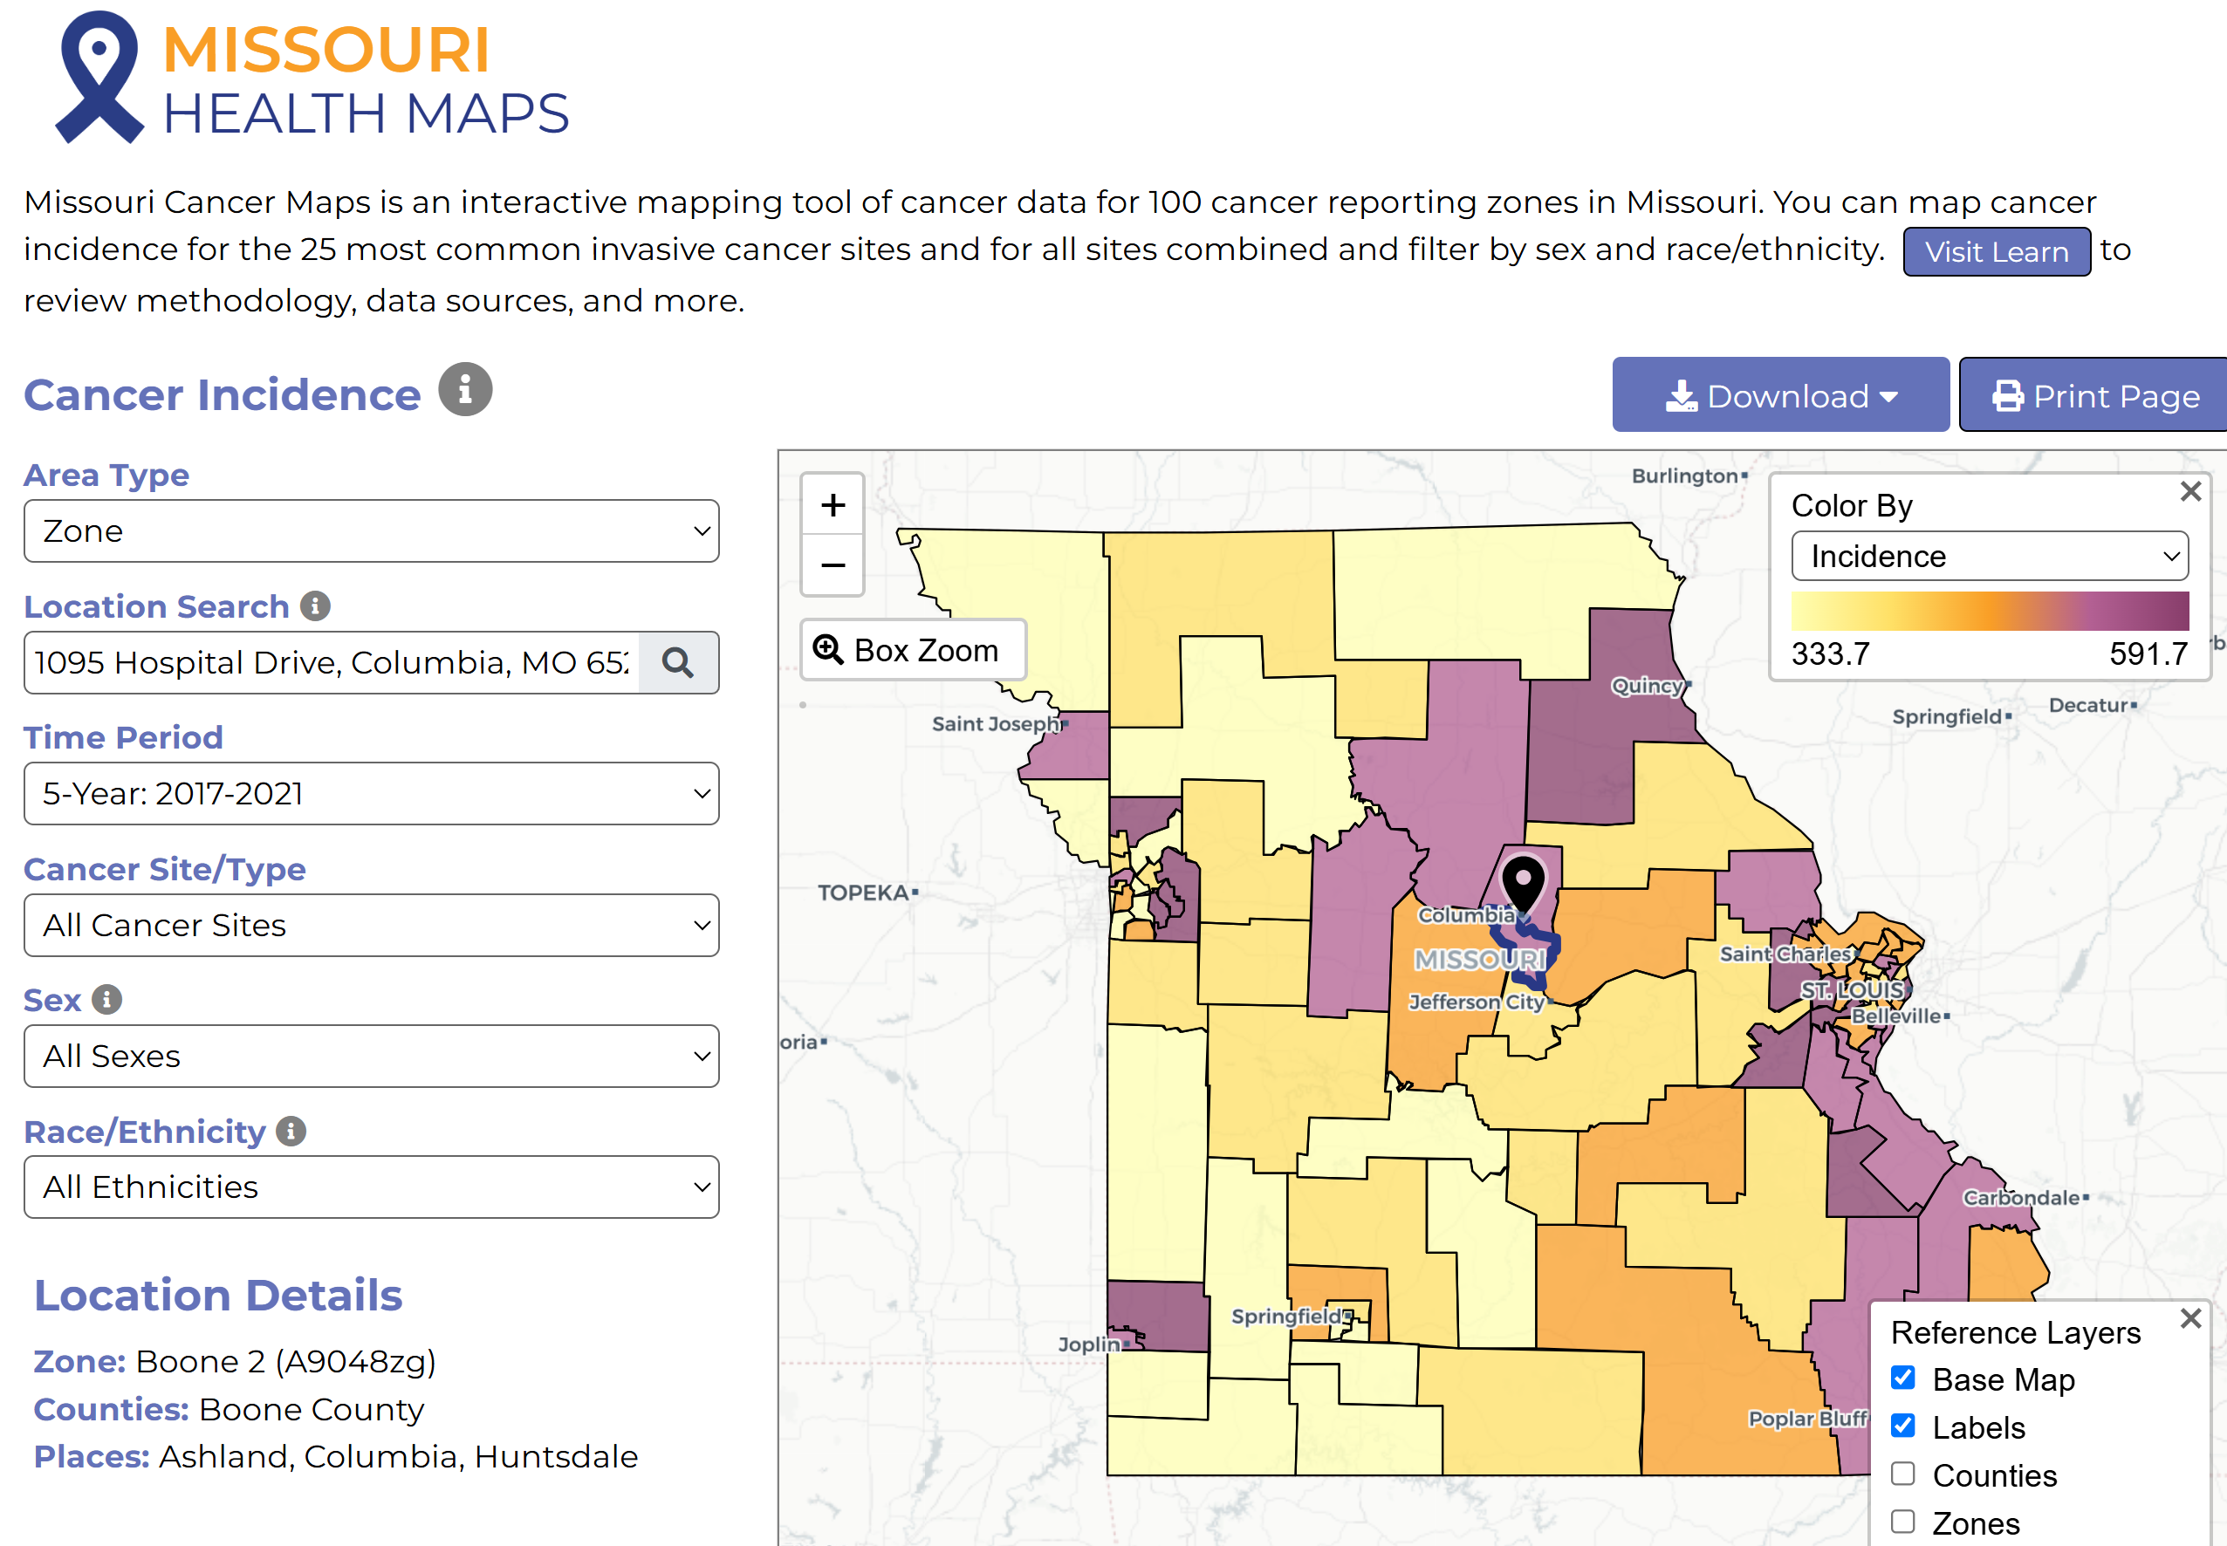

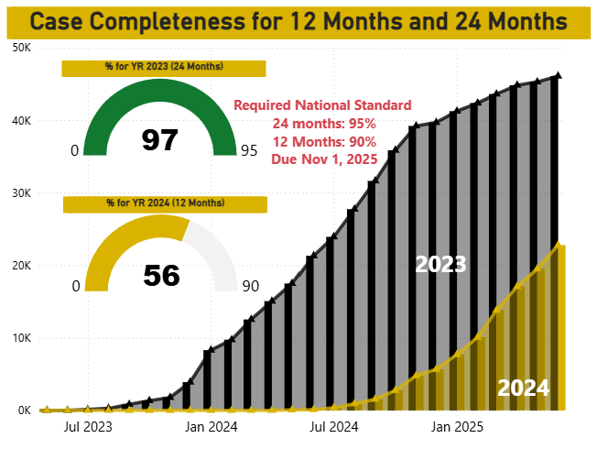

MCR is required by NPCR to submit 90% of 2024 data during the Call for Data this November. We need your cases and support to meet this goal! This graph shows our status toward reaching the 2023 and 2024 goals.
As you can see, we need your 2024 cases.

NEWS FROM THE STANDARD SETTERS
NAACCR
The NAACCR Data Standards and Data Dictionary v26 are now available on the NAACCR website. https://www.naaccr.org/

NAACCR Fall 2025 ODS Exam Prep Course
First session is Tuesday, September 2, 2025
Course highlights include:
- 8 live webinars
- Full access to recorded sessions
- Weekly online quizzes to test your knowledge
- Time practice exam
- Active discussion board for peer and instructor support
Register today at https://education.naaccr.org/CTR

NCRA Virtual Fundamentals of Abstracting Workshop Beginning in September
The virtual Fundamentals of Abstracting (FOA) Workshop includes four three-hour sessions scheduled over four days from 12:00 PM to 3:00 PM ET. The faculty will provide a theoretical basis for the tasks and activities associated with abstracting and a review of the topics most important to abstractors, including Solid Tumor Rules, ICD-O, AJCC TNM Staging, Summary Stage, and Site-Specific Data Items. The workshop is designed for cancer registry employees with between six months to two years of experience. Attendees should have knowledge of anatomy, physiology, medical terminology, and cancer registry resources. The workshop is foundational and is not eligible for CE credits. Deadline to register is Friday, September 5, 2025.
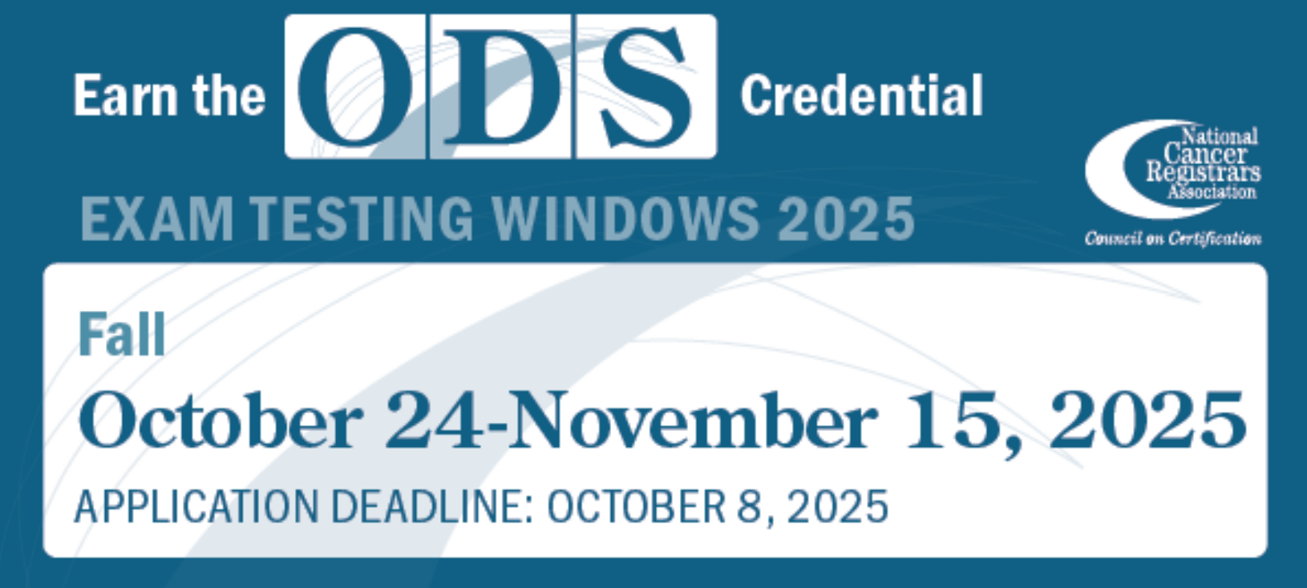

Warm regards,
Lucinda Ham, RHIA, ODS-C  Operations/QA Manager, Missouri Cancer Registry  Department of Public Health  1095 Hospital Drive | Columbia MO 65211  O: 573-882-7775 | C: 573-220-2438  F: 573-884-9655 | E: lahf5p@health.missouri.edu  W: https://cancerregistry.missouri.edu/ | “Alone we can do so little, together we can do so much” – Helen Keller
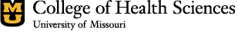
Missouri Cancer Registry and Research Center is supported in part by a cooperative agreement between the Centers for Disease Control and Prevention (CDC) and the Missouri Department of Health and Senior Services (DHSS) (DP2202-22-03) and a Surveillance Contract between DHSS and the University of Missouri.

