**Missouri Cancer Registry**

June 2025

***Fellow Registrars,***

***We have been very busy at MCR! We have upgraded to V25 and can now accept 2025 cases. This month we have two one-pagers for your review on bladder and brain cancers. Deborah Carey created a Show Me Tip on Bladder Cancers. We hope you find this information useful.***



**DUE DATES**

To be on track, large hospitals (>500 cases/yr.) typically are expected to have abstracted November 2024 diagnosis cases by June 15, 2025. Smaller facilities (<300 cases /yr.) are expected to report the 4th Quarter of 2024 by July 15, 2025.

**EDUCATION**

**MCR Helpline**

Reach us at 1-800-392-2829 during regular office hours or leave a message; a member of our QA team will return your call within one business day.

**NAACCR Webinars:**

**NAACCR Webinars are now available on the MCR website** at [**https://cancerregistry.missouri.edu/education/educational-webinars-and-recordings/**](https://cancerregistry.missouri.edu/education/educational-webinars-and-recordings/)Contact Lucinda Ham at[**lahf5p@health.missouri.edu**](mailto:lahf5p@health.missouri.edu) for the password. After gaining access to the webinars, click on the file folder for the month. The webinar materials are readily accessible and can be downloaded.

**NAACCR Webinar: Prostate 2025, May 15, 2025**

**Upcoming NAACCR Webinar: Uterus 2025, June 12, 2025,** 8-11 a.m. This webinar will cover anatomy, solid tumor rules, staging and treatment of uterine primary malignancies. Examples, quizzes and case scenarios are included. **To attend the live broadcast in Columbia, Mo,** sign up here:[**https://www.signupgenius.com/go/10C054CACAE28A0F8C25-57000938-uterus**](https://www.signupgenius.com/go/10C054CACAE28A0F8C25-57000938-uterus)

**MCR YouTube**

Need a general overview of cancer registry and how the data is used? Visit our YouTube channel to watch the presentation on Quality Cancer Data. [**https://www.youtube.com/channel/UCsm_Eu4-pqIdZibqeyOecUQ**](https://www.youtube.com/channel/UCsm_Eu4-pqIdZibqeyOecUQ)

**Show Me Tip on Bladder Cancers**

Deborah Carey created the attached Show Me Tip on **Bladder cancers**. This tip provides clarification of bladder histology codes, bladder anatomy and key multiple primary coding rules.



**SEER Educate April 15th News**

**2025 Updates**

As of March 31st, 2025, the Heme, Histology, and Solid Tumor Rules Coding Exercises have been updated to the manuals released for 2025. Please note, the diagnosis years for these cases are prior to 2025, so data items that are specific to a diagnosis year will still conform to the appropriate SEER manual. There will be notes in the rationale explaining differences in coding effective with diagnosis year 2025.

**ODS Prep Release – 2025 SEER Manual**

**The 2025 ODS exam covers the 2025 STORE Manual. There is a new group of tests - More STORE – that covers data items not included in the SEER Manual.**

**Commission on Cancer (CoC) – Full Replacement**

On November 19th, NEW Commission on Cancer multiple choice tests were moved to public view in the Training Menu. The content is divided into three groups: Standards, Synoptic Reports, and Quality Measures.

Log in or sign up at SEER*Educate today by visiting [**https://educate.fredhutch.org/**](https://educate.fredhutch.org/) and Learn by Doing!

**Help Desk will be CLOSED or Limited (in addition to weekends)**

* June 2-6 Limited during NAACCR
* Jun 19 (Juneteenth)
* July 4-6 (July 4th weekend)

**NCRA Genetics and Cancer Registrar Webinar series**

Two webinars focusing on genetics and the role played by genetics in cancer surveillance will be held on June 4th and June 18th. Visit [**LIVE Webinars**](https://www.cancerregistryeducation.org/live-webinars)for more information.

**MCR Training and Online Courses**

The MO Oncology Data Specialist Study Guide and Fundamentals of Abstracting courses have been recently updated. We have also added additional courses to the MCR Course Catalog. Click on the following link to enroll in any of these courses

[**https://cancerregistry.missouri.edu/education/educational-webinars-and-recordings/**](https://cancerregistry.missouri.edu/education/educational-webinars-and-recordings/)

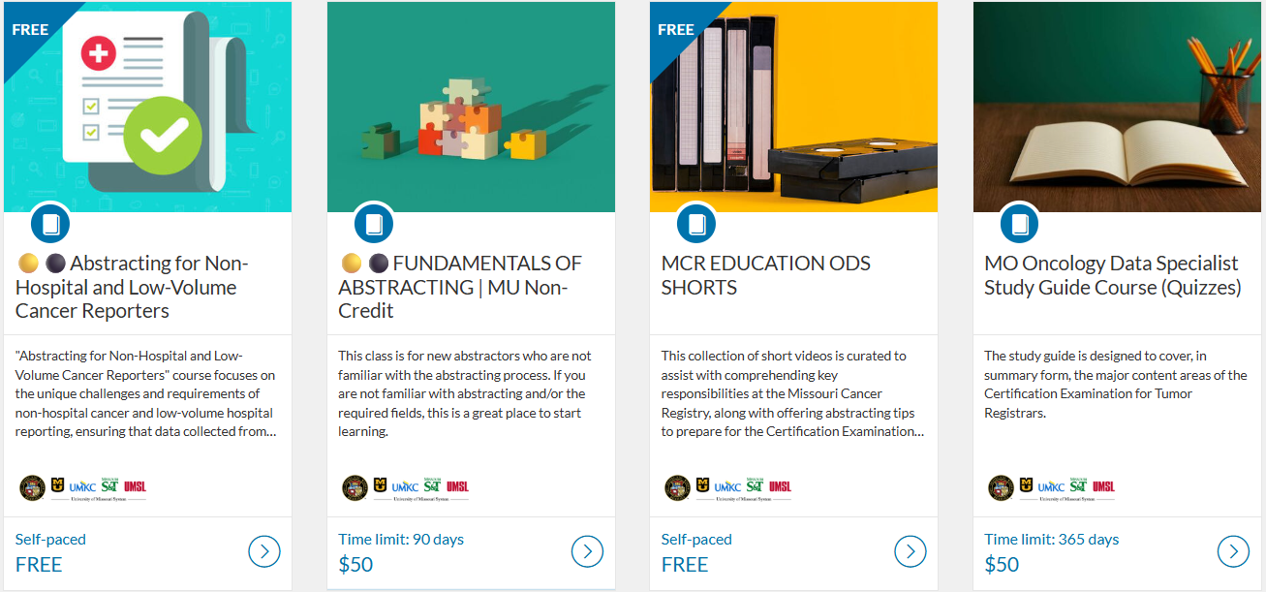

**MCR NEWS**

**Save the Date! The second Annual MOODS Educational Conference will be held on September 26, 2025, at Boone Hospital Center. We are excited to provide this free in-person educational conference!**

**Ready for 2025 Cases!**

MCR updated its Registry Plus Suite of software programs to V25B. We are now ready to accept 2025 cases. Reach out if you run across any issues with this upgrade. The V25B metafile has been placed on the NAACCR Clearinghouse for your vendors to pick up.

**Missouri Cancer Registry Annual Report and Data Analytics**

The Missouri Cancer Registry Annual Report is now available online. Access the report by visiting the Missouri Cancer Registry, scrolling down to the Missouri Cancer Stats & Facts section. To view the latest report, click on "View Annual Report" on that page. The reports provide key insights, trends, and analyses to help understand the prevalence and impact of cancer across Missouri. This year's report was prepared by **Vishwa Bhayani, Informatics Specialist**. [**https://cancerregistry.missouri.edu/**](https://cancerregistry.missouri.edu/)

**MCR is required by NPCR to submit 90% of 2024 data during the Call for Data this November. We need your cases and support to meet this goal! The above graph shows our status toward reaching the 2023 and 2024 goals.**

**NEWS FROM THE STANDARD SETTERS**

**NAACCR 2025 Implementation Guidelines**

The 2025 Implementation Guidelines and Recommendations are also available on the NAACCR website at [**https://www.naaccr.org/implementation-guidelines/**](https://www.naaccr.org/implementation-guidelines/)The NAACCR Implementation Guidelines and Recommendations provide cancer registries and software vendors with a plan to assist with the implementation of the NAACCR Data Standards and Data Dictionary (DS&DD) in a timely manner. It is advised to review the new data items and changes pages so you will know what is expected in V25.

**2026 ICD-O-3.2 Updates**

The 2026 Guidelines for ICD-O-3 Histology Code and Behavior Update for cases diagnosed 1/1/2026 forward have been released and are now available on the NAACCR website. The update includes tables listing new terminology in both alpha and numeric format. The updated 2026 annotated ICD-O-3.2. Excel document will be posted at a later date. The guidelines, alpha, and numeric tables are available on the NAACCR website.[**https://www.naaccr.org/icdo3/**](https://www.naaccr.org/icdo3/)

Warm regards,

|  |  |  |
| --- | --- | --- |
| *Lucinda Ham, RHIA, ODS-C*  *Operations/QA Manager, Missouri Cancer Registry*   |  | | --- | |  |   Department of Public Health  **1095 Hospital Drive** | Columbia MO 65211  **O:**573-882-7775 | **C:**573-220-2438 **F:**573-884-9655 | **E:**[**lahf5p@health.missouri.edu**](mailto:lahf5p@health.missouri.edu) **W:** **<https://cancerregistry.missouri.edu/>** | *“Great things are done by a series of small things brought together” – Vincent Van Gough* |

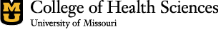

Missouri Cancer Registry and Research Center is supported in part by a cooperative agreement between the Centers for Disease Control and Prevention (CDC) and the Missouri Department of Health and Senior Services (DHSS) (DP2202-22-03) and a Surveillance Contract between DHSS and the University of Missouri.