**Missouri Cancer Registry**

July 2025

***Fellow Registrars,***

***Summer is definitely heating up! I hope you have taken the time to enjoy all the things you like about summer!***

***We are pleased to announce MCR received the NAACCR Gold Certification, 2023 Registry of Distinction Award for data timeliness and completeness based on 2022 case submissions and Registry of Surveillance designation! We could not have accomplished this goal without you! Thank you for your efforts in submitting quality, timely data!***

***We are once again blessed with several students this summer to assist with projects. The students have been tremendous help!***

**Due Dates**

To be on track, large hospitals (>500 cases/yr.) typically are expected to have abstracted December 2024 diagnosis cases by July 15, 2025. Smaller facilities (<300 cases /yr.) are expected to report the 4th Quarter of 2024 by July 15, 2025.

**Education**

**MCR Helpline**

Reach us at 1-800-392-2829 during regular office hours or leave a message; a member of our QA team will return your call within one business day.

**NAACCR Webinars:**

**NAACCR Webinars are now available on the MCR website** at [**https://cancerregistry.missouri.edu/education/educational-webinars-and-recordings/**](https://cancerregistry.missouri.edu/education/educational-webinars-and-recordings/)Contact Lucinda Ham at[**lahf5p@health.missouri.edu**](mailto:lahf5p@health.missouri.edu) for the password. After gaining access to the webinars, click on the file folder for the month. The webinar materials are readily accessible and can be downloaded.

**NAACCR Webinar: Uterus, June 12, 2025**

**Upcoming NAACCR Webinar: Leveraging Technology to Improve Efficiency in a Hospital Registry, July 10, 2025,** 8-11 a.m. This webinar will review new technologies used to improve efficiency of basic hospital registry operations. The operations include, but are not limited to casefinding, follow-up, and abstracting. **To attend the live broadcast in Columbia, MO,** sign up here:[**https://www.signupgenius.com/go/10C054CACAE28A0F8C25-57379302-naaccr**](https://www.signupgenius.com/go/10C054CACAE28A0F8C25-57379302-naaccr)

**SEER Educate June News**

**2025 Updates**

As of March 31st, 2025, the Heme, Histology, and Solid Tumor Rules Coding Exercises have been updated to the manuals released for 2025. Please note, the diagnosis years for these cases are prior to 2025, so data items that are specific to a diagnosis year will still conform to the appropriate SEER manual. There will be notes in the rationale explaining differences in coding effective with diagnosis year 2025.

Log in or sign up at SEER*Educate today by visiting [**https://educate.fredhutch.org/**](https://educate.fredhutch.org/) and Learn by Doing!

**Help Desk will be CLOSED or Limited (in addition to weekends)**

* July 4-6 (July 4th weekend) and July 7-11 (limited responses)

**MCR Training and Online Courses**

The MO Oncology Data Specialist Study Guide and Fundamentals of Abstracting courses have been recently updated. We have also added additional courses to the MCR Course Catalog. Click on the following link to enroll in any of these courses

[**https://cancerregistry.missouri.edu/education/educational-webinars-and-recordings/**](https://cancerregistry.missouri.edu/education/educational-webinars-and-recordings/)

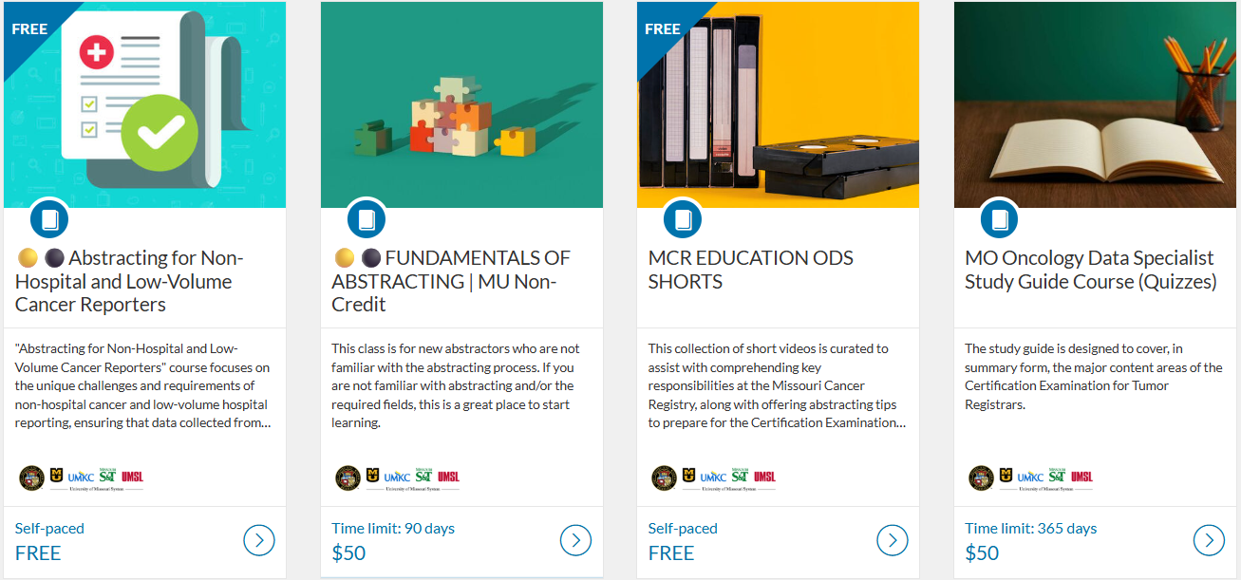

**Death Clearance**

Death Clearance (DC) follow back for the reporting year 2023 is underway! If you have changes in staffing, or a different person in charge of Death Clearance reporting, please let Stacy Barr know. [**barrs@health.missouri.edu**](mailto:barrs@health.missouri.edu)

Please be on the lookout for a separate notification email regarding the official start of the death clearance follow back process. The DC process will essentially be the same as last year. If you are new to the process or would like a refresher, please refer to the instructions and You Tube video that can be accessed from this page of our website under ‘DC Follow-Back Requests’ [**https://cancerregistry.missouri.edu/reporting/cancer-reporting-hospital/**](https://cancerregistry.missouri.edu/reporting/cancer-reporting-hospital/)

We truly appreciate your contributions to making this project successful; the information you provide is an essential part of MCR in meeting our annual goals!

**MCR NEWS**

**Save the Date! The second Annual MOODS Educational Conference will be held on September 26, 2025, at Boone Hospital Center. We are excited to provide this free in-person educational conference!**

**Draft agenda is attached separately.**

**Ready for 2025 Cases!**

MCR updated its Registry Plus Suite of software programs to V25B. We are now ready to accept 2025 cases. Reach out if you run across any issues with this upgrade. The V25B metafile can be found on the NAACCR Clearinghouse for your vendors or the zip file can be downloaded from the MCR website at this link [**https://cancerregistry.missouri.edu/reporting/cancer-reporting-hospital/**](https://cancerregistry.missouri.edu/reporting/cancer-reporting-hospital/)

**Missouri Health Maps**

Missouri Cancer Registry recently added Missouri Health Maps to its website. The maps can be found by clicking on the Missouri Health Maps button on the MCR home page task bar. The maps currently display 2017-2021 data and will be updated to 2018-2022 data very soon. This information may be helpful to you and your facility to see cancer incidence in your area. The map of Missouri is divided into zones based on population.

**Missouri Cancer Registry Annual Report and Data Analytics**

The Missouri Cancer Registry Annual Report is now available online. Access the report by visiting the Missouri Cancer Registry, scrolling down to the Missouri Cancer Stats & Facts section. To view the latest report, click on "View Annual Report" on that page. The reports provide key insights, trends, and analyses to help understand the prevalence and impact of cancer across Missouri. This year's report was prepared by **Vishwa Bhayani, Informatics Specialist**. [**https://cancerregistry.missouri.edu/**](https://cancerregistry.missouri.edu/)

**MCR is required by NPCR to submit 90% of 2024 data during the Call for Data this November. We need your cases and support to meet this goal! This graph shows our status toward reaching the 2023 and 2024 goals.**

**As you can see, we need your 2024 cases.**

**NEWS FROM THE STANDARD SETTERS**

**NAACCR**

The NAACCR Data Standards and Data Dictionary v26 are now available on the NAACCR website. [**https://www.naaccr.org/**](https://www.naaccr.org/)

Warm regards,

|  |  |  |
| --- | --- | --- |
| *Lucinda Ham, RHIA, ODS-C*  *Operations/QA Manager, Missouri Cancer Registry*   |  | | --- | |  |   Department of Public Health  **1095 Hospital Drive** | Columbia MO 65211  **O:**573-882-7775 | **C:**573-220-2438 **F:**573-884-9655 | **E:**[**lahf5p@health.missouri.edu**](mailto:lahf5p@health.missouri.edu) **W:** **<https://cancerregistry.missouri.edu/>** | *“Alone we can do so little, together we can do so much” – Helen Keller* |

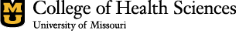

Missouri Cancer Registry and Research Center is supported in part by a cooperative agreement between the Centers for Disease Control and Prevention (CDC) and the Missouri Department of Health and Senior Services (DHSS) (DP2202-22-03) and a Surveillance Contract between DHSS and the University of Missouri.