
Missouri Cancer Registry
March 2025
Fellow Registrars,
Daylight savings time begins March 9th. Don’t forget to Spring forward! We at MCR are ready for Spring! March is colon cancer awareness month. The attached one-pager provides statistical information for Missouri for Colon cancer based on 2017-2021 data. I have also included our recently published one-pager on Pediatric cancers.
DUE DATES
To be on track, large hospitals (>500 cases/yr.) typically are expected to have abstracted August 2024 diagnosis cases by March 15, 2025. Smaller facilities (<300 cases /yr.) are expected to report the 3rd Quarter of 2024 by April 15, 2025.
EDUCATION
MCR Helpline
Reach us at 1-800-392-2829 during regular office hours or leave a message; a member of our QA team will return your call within one business day.

NAACCR Webinars:
NAACCR Webinars are now available on the MCR website at https://cancerregistry.missouri.edu/education/educational-webinars-and-recordings/ Contact Lucinda Ham at lahf5p@health.missouri.edu for the password. After gaining access to the webinars, click on the file folder for the month. The webinar materials are readily accessible and can be downloaded.

NAACCR Webinar: Boot Camp 2025
March 13, 2025, 8-11 a.m. This is one of NAACCR most popular webinars. The lecture is minimal with most of the time being spent reviewing exercises, quizzes, and case scenarios. To attend the live broadcast in Columbia, Mo, sign up here: https://www.signupgenius.com/go/30E0E4BA9A823A6FB6-55347664-naaccr
Show Me Tips
The March 2025 Show Me Tip is “Hematopoietic Neoplasms.” This tip provides clarification of coding guidelines, coding tips and examples for abstracting hematopoietic neoplasms.

YouTube
Hematopoietic Neoplasms 2025
We have a new video on YouTube created by Lucinda Ham, RHA, ODS-S and Babette Langeneckert, ODS-C. This video focuses on anatomy, physiology, genetics, and vocabulary related to hematopoietic neoplasms. An overview of how to use the Hematopoietic and Lymphoid Neoplasm Database and Manual is included. Case scenarios and coding examples are included. Watch the recording on YouTube at: https://cancerregistry.missouri.edu/education/educational-webinars-and-recordings/ and click on the MCR YouTube channel.

Coming soon!! Electronic Change of Information Forms
Based on a recommendation from a large reporting facility, we have created an online Change of Information form for submitting updates/corrections on individual cancer cases. A blast email will be sent out with the new form link when it becomes available. Change of Information forms are needed only for changes in the following data elements:
1. Last name, first name, middle name, 2. Address at diagnosis, includes city, county, state and zip code, 3. Race,
4. Spanish/Hispanic origin, 5. Sex, 6. Birth date, 7. Social security number, 8. Date of diagnosis, 9. Date of 1st Contact,
10. Primary site (and any updates to affected fields: stage, surgery, etc.) 11. Morphology type behavior and grade,
12. Laterality, 13. Diagnostic confirmation, 14. Summary Stage 2018, 15. Type and start date of FIRST course of definitive Tx
Do not report changes in TNM staging or second course treatment.

NEW MCR COURSE CATALOG
MCR now has its own course catalog. Scan the QR code to access available courses or click on the https://umsystem-mcr.catalog.instructure.com/ MCR plans to add more courses to the catalog over the next few months.

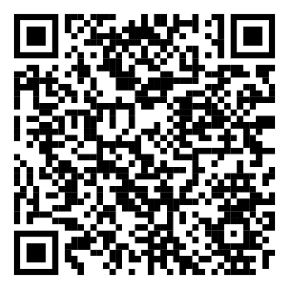


Fundamentals of Abstracting Course Now Available

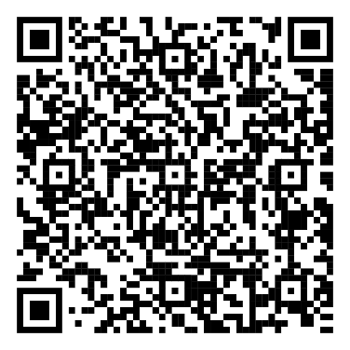
The Missouri Cancer Registry is offering this online course for new abstractors who are not familiar with abstracting cancer cases. This course is a fantastic way to learn the basics of cancer abstraction. The course contains ten modules which follow the Missouri Cancer Registry Abstract Code Manual. When you have completed the modules, five practice cases can be taken to assess your knowledge. Keep in mind that cancer abstraction and coding rules are constantly changing. This course will direct you to the necessary resources used daily by cancer registrars. The fee for the course is $50. A certificate will be available at the end of the course. The course will remain open for 90 days. Contact Lucinda Ham at lahf5p@health.missouri.edu with any questions. The direct link to register for this course is https://umsystem-mcr.catalog.instructure.com/courses/mcr-fundamentals-of-abstracting

MOODS Study Guide

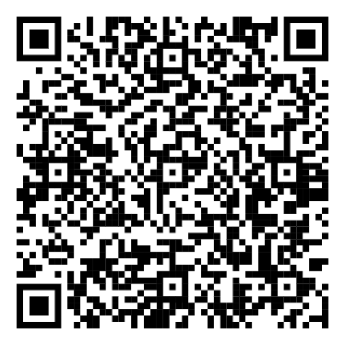
The MOODS Study Guide is currently under revision. The new version should be available in March. The study guide is designed to cover, in summary form, the major content areas of the Certification Examination for Tumor Registrars. It is not designed to present new information, but rather to highlight areas of relevance. Users of the Missouri ODS Study Guide are not guaranteed a passing score on the examination. Particularly, the quizzes and practice exam herein are in no way associated with the Certification Examination for Tumor Registrars offered by the National Cancer Registrars' Association. The cost of the study guide is $50. To purchase the MOODS Study Guide, point your smartphone camera at the QR code or CTRL click on the direct catalog link https://umsystem-mcr.catalog.instructure.com/courses/mcr-moodsquiz

MOODS Study Guide quizzes are now available on-line via Canvas. The quizzes can be taken multiple times. If you previously purchased the MOODS Study Guide and would like to take advantage of this new feature, please email us at umhshmimcr@health.missouri.edu
to get started.

SEER Educate
February 2025 Release
In Training, Disease Information, Breast, there are 10 multiple choice tests for Treatment. These are not eligible for CEs.
Commission on Cancer (CoC) – Full Replacement
On November 19th, 2024, SEER*Educate moved to a public view Training Menu, ODS Prep, the NEW Commission on Cancer multiple choice tests. It is a full replacement. SEER*Educate broke out this content into three groups: Standards, Synoptic Reports, and Quality Measures. Good luck to Calendar Year 2025 ODS Exam Takers!
2025 Updates
As of November 7, 2024, standard setters are releasing updated manuals for 2025. It will take the SEER*Educate team some time to review and update the coding exercises. Anticipated updates will be released in January and February.
SEER Advanced Topics for Registry Professionals Workshop held in September 2024 are still available on NCRA’s Cancer Registry Education website. All registrars, whether you attended the Workshop or not, can complete any or all 4 modules between now and 12/31/2027 for CEs, including Category A CEs. Click the link www.cancerregistryeducation.org/SEER Scroll down to SEER Workshop Encore Sessions. Find “2024 Workshop: SEER Advanced Topics for Registry Professionals” and click on the “Add to Cart” button. Log in or sign up at SEER*Educate today by visiting https://educate.fredhutch.org/ and Learn by Doing!
Help Desk will be CLOSED or Limited (in addition to weekends)
- May 5-8 Limited during NCRA
- May 24-26 (Memorial Day)
- June 2-6 Limited during NAACCR
- Jun 19 (Juneteenth)
- July 4-6 (July 4th weekend)

NCRA ODS Exam
NCRA ODS Exam Testing Window: March 21-April 12, 2025, Application Deadline: March 7
https://www.ncra-usa.org/ODS-Credential/Certification-Exam

MCR NEWS
Missouri Cancer Registry Annual Report
The Missouri Cancer Registry Annual Report is now available online. Access the report by visiting the Missouri Cancer Registry, scrolling down to the Missouri Cancer Stats & Facts section. To view the latest report, click on "View Annual Report" on that page. The reports provide key insights, trends, and analyses to help understand the prevalence and impact of cancer across Missouri. This year's report was prepared by Vishwa Bhayani, Informatics Specialist. https://cancerregistry.missouri.edu/



2025 MCR Abstract Code Manual has been updated and posted to the MCR website. The manual can be found in two locations: https://cancerregistry.missouri.edu/reporting/abstracting-resources/ and https://cancerregistry.missouri.edu/reporting/cancer-reporting-hospital/

MCR is required by NPCR to submit 90% of 2024 data during the Call for Data this November. We need your cases and support to meet this goal!

Gold Level Certificates
This year 27 facilities received the Gold Level Certificate from MCR for timely reporting and completeness of case load. The criteria to receive the Gold Level Certificate is to report monthly or quarterly as required and to report 95% or greater of the average caseload according to reporting guidelines. If you feel like you met these criteria, but did not receive a letter and certificate, please let me know. Seven facilities have achieved Gold Level status for three or more years in a row!
Congratulations to all our Gold Certificate recipients!

NEWS FROM THE STANDARD SETTERS
SOLID TUMOR RULES UPDATE – NOVEMBER 2024
The Solid Tumor Rules have been updated for 2025 based on 5th Ed WHO Classification of Tumor books, College of American Pathologist Cancer Protocols, and review of questions and feedback from registrars. Recommendations from Cancer PathCHART expert pathologist review have also been incorporated into the update. Minor updates include new terminology, additional definitions, notes, and examples. New M and H rules were added to select site specific modules. It is best to download the Solid Tumor Rules Manual for ease of finding site specific information and viewing the Table of Contents in the left border.
The updated Solid Tumor Rules may be accessed at: seer.cancer.gov/tools/solidtumor
NAACCR 2025 Implementation Guidelines
The 2025 Implementation Guidelines and Recommendations are also available on the NAACCR website at https://www.naaccr.org/implementation-guidelines/ The NAACCR Implementation Guidelines and Recommendations provide cancer registries and software vendors with a plan to assist with the implementation of the NAACCR Data Standards and Data Dictionary (DS&DD) in a timely manner. It is advised to review the new data items and changes pages so you will know what is expected in V25.

Warm regards,
Lucinda Ham, RHIA, ODS-C  Operations/QA Manager, Missouri Cancer Registry  Department of Public Health  1095 Hospital Drive | Columbia MO 65211  O: 573-882-7775 | C: 573-220-2438  F: 573-884-9655 | E: lahf5p@health.missouri.edu  W: https://cancerregistry.missouri.edu/ | “Great things are done by a series of small things brought together” – Vincent Van Gough
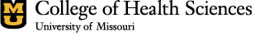
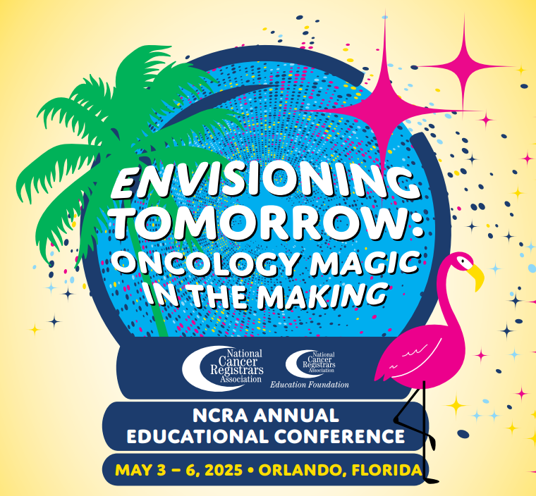

Missouri Cancer Registry and Research Center is supported in part by a cooperative agreement between the Centers for Disease Control and Prevention (CDC) and the Missouri Department of Health and Senior Services (DHSS) (DP2202-22-02) and a Surveillance Contract between DHSS and the University of Missouri.

