
Missouri Cancer Registry
December 2024
Fellow Registrars,
We wish you a blessed holiday season and hope that you have the time to enjoy all the things that make the holidays special to you. We have successfully submitted 1996-2023 data to NAACCR and NPCR for the Annual Call for Data. Thank you for your support and efforts in sending timely, quality data!

DUE DATES
To be on track, large hospitals (>500 cases/yr.) typically would be expected to have abstracted June 2024 diagnosis cases by December 15, 2024. Smaller facilities (<300 cases /yr.) are expected to report the 2nd Quarter of 2024 by January 15, 2025.
EDUCATION
MCR Helpline
Reach us at 1-800-392-2829 during regular office hours or leave a message; a member of our QA team will return your call within one business day.

NAACCR Webinars:
NAACCR Webinars are now available on the MCR website at https://cancerregistry.missouri.edu/education/educational-webinars-and-recordings/ Contact Lucinda Ham at lahf5p@health.missouri.edu for the password. After gaining access to the webinars, click on the file folder for the month. The webinar materials are readily accessible.

NAACCR Webinar: Hematopoietic 2024/2025 Part 1
December 5, 2024, 8-11 a.m. This webinar we will focus on anatomy, physiology, genetics, and vocabulary related to hematopoietic cases. It will also focus on staging (lymphoma) and treatment. To attend the live broadcast in Columbia, Mo, sign up here: https://www.signupgenius.com/go/30E0E4BA9A823A6FB6-53399415-naaccr

Show Me Tip
The attached Show Me Tip is “Ovary Abstracting Tips.” This tip provides a great explanation of how to determine the primary site if there are multiple pelvic sites involved.

NEW MCR COURSE CATALOG
MCR now has its own course catalog. Scan the QR code to access available courses or click on the https://umsystem-mcr.catalog.instructure.com/ MCR plans to add more courses to the catalog over the next few months.
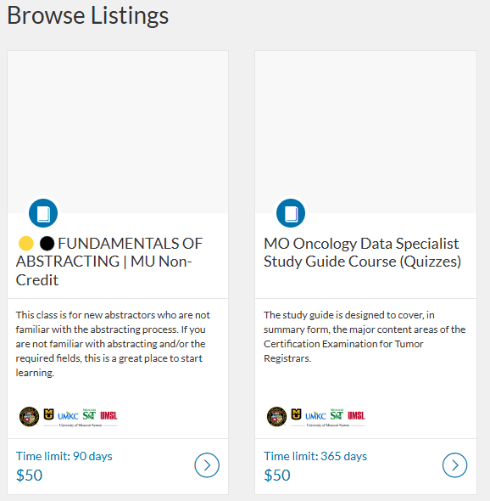


MOODS Study Guide
The Missouri Cancer Registry and Research Center is pleased to announce the Missouri Oncology Data Specialist (MOODS) Study Guide has been updated and available to order! The cost of the study guide is $50. To purchase the MOODS Study Guide, point your smartphone camera at the QR code or CTRL click on the direct catalog link https://umsystem-mcr.catalog.instructure.com/courses/mcr-moodsquiz

MOODS Study Guide quizzes are now available on-line via Canvas. The quizzes can be taken multiple times. If you previously purchased the MOODS Study Guide and would like to take advantage of this new feature, please email us at umhshmimcr@health.missouri.edu
to get started.

Fundamentals of Abstracting Course Now Available


The Missouri Cancer Registry is offering this online course for new abstractors who are not familiar with abstracting cancer cases. This course is a fantastic way to learn the basics of cancer abstraction. The course contains ten modules which follow the Missouri Cancer Registry Abstract Code Manual. When you have completed the modules, five practice cases can be taken to assess your knowledge. Keep in mind that cancer abstraction and coding rules are constantly changing. This course will direct you to the necessary resources used daily by cancer registrars. The fee for the course is $50. A certificate will be available at the end of the course. The course will remain open for 90 days. Contact Lucinda Ham at lahf5p@health.missouri.edu with any questions. The direct link to register for this course is https://umsystem-mcr.catalog.instructure.com/courses/mcr-fundamentals-of-abstracting

SEER Educate
September 2024 SEER Workshop cases
The September 2024 Workshop cases are still available under the Training Tab. All registrars, whether you attended the Workshop or not, can complete any or all these 4 modules between now and 12/31/2027 for CEs, including Category A CEs. The sessions are being recorded and will eventually be available on the NCRA website, 2024 SEER Workshop.
Help Desk will be CLOSED or Limited (in addition to weekends)
- Nov 28 - Dec 1
- Dec 24 – 26
- Jan 1

MCR NEWS
IN KIND LETTERS
In Kind estimate letters will be sent out soon. We are requesting an estimate of what it will cost in the next fiscal year to comply with statutes and report data to MCR. Please respond to the letters by December 20, 2024.

JAIN DESIGNIATED FELLOW OF AMERICAN MEDICAL INFORMATICS ASSOCIATION (AMIA)
Congratulations to Dr. Nishant Jain of the Missouri Cancer Registry on being awarded the esteemed designation of Fellow of AMIA (FAMIA) by the American Medical Informatics Association (AMIA). Nishant will be formally inducted at the AMIA 2025 Clinical Informatics Conference in Anaheim, CA on May 20-22, 2025. Nishant also had the privilege of presenting alongside Dr. James Cimino and others at the AMIA Year-in-Review (YIR) closing keynote, where his collaborative work with Dr. Zachary and Dr. Boren on the COVID-19 Vaccine and Health Equity paper was featured. The Year in Review team appreciated the visualization of real-time reflections on COVID-19 cases and health equity topics. You can read the full paper here. This video describes the process of year in Review for AMIA. https://youtu.be/-iVAUzbiYzI?t=155

MCR CLOSED
MCR will be closed December 25th through January 1st for Winter Break

NEWS FROM THE STANDARD SETTERS
NAACCR V25A Metafile
NAACCR has identified a problem with the V25 metafile that requires an updated version. Table SUMST1809 includes all the v9 schemas used for N4900 Summary Stage 2018, Schema ID (NAACCR) and N4910 Derived Summary Stage 2018, Schema ID (SEER). The new schemas for 2025, 09090, 09350, 09360, 09370, were not added to the table. This would cause the edit mentioned above to fail any case with one of the missing schemas. A new Missouri V25A metafile will be created and posted to the NAACCR Clearinghouse by the middle of December.
NCRA Continuing Education Requirement Beginning in 2025
Beginning in 2025, Oncology Data Specialists must earn a minimum of 8 CE credits of in-person education every 4 years. We plan to continue hosting an annual MOODS Educational Conference in Columbia, Missouri. We hope this will help with meeting your CE requirements if you are unable to attend another conference in person.
SOLID TUMOR RULES UPDATE – NOVEMBER 2024
The Solid Tumor Rules have been updated for 2025 based on 5th Ed WHO Classification of Tumor books, College of American Pathologist Cancer Protocols, and review of questions and feedback from registrars. Recommendations from Cancer PathCHART expert pathologist review have also been incorporated into the update. Minor updates include new terminology, additional definitions, notes, and examples. New M and H rules were added to select site specific modules.
The Solid Tumor Rules are revised annually to reflect new terminology, ICD-O codes, and other changes. The most recent Solid Tumor Rules should be used as soon as it is released. Each update contains start years for when new codes become valid and when new instructions become active. Rules and other information from previous updates carry over to every annual update.
Important Information: A comprehensive review of the current solid tumor format is underway with the goal of streamlining contents where needed and adding references such as illustrations and site-specific rule examples. Table formatting will also be revised for ease of use in the future. Minor revisions, based on initial review, have been incorporated into the 2025 solid tumor update. These revisions involved removing repetitious instructions in each module and moving them to a single location which may be in the General Instructions, M rules or H rules sections.
It is strongly recommended to review the change log to understand what changes were made. Using the 2025 rules will require you to become familiar with the General Instructions. Beginning with the 2025 Solid Tumor Update, the rules will be available in a combined file only. Individual site-specific modules will no longer be provided.
The updated Solid Tumor Rules may be accessed at: seer.cancer.gov/tools/solidtumor

NAACCR 2025 Implementation Guidelines
The 2025 Implementation Guidelines and Recommendations are also available on the NAACCR website at https://www.naaccr.org/implementation-guidelines/ The NAACCR Implementation Guidelines and Recommendations provide cancer registries and software vendors with a plan to assist with the implementation of the NAACCR Data Standards and Data Dictionary (DS&DD) in a timely manner. It is advised to review the new data items and changes pages so you will know what is expected in V25.
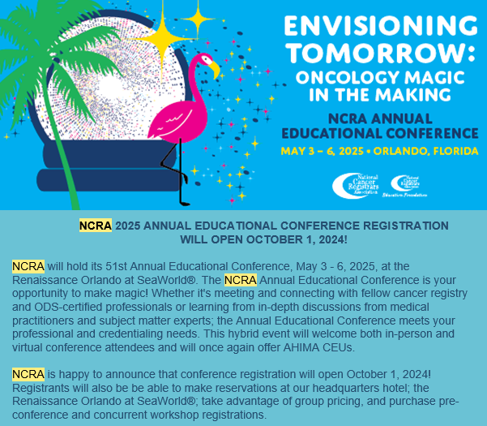

REGISTRY TO RESEARCH
Cutaneous Malignant Melanoma Incidence Increasing Among the Elderly https://www.xiahepublishing.com/2835-3315/CSP-2024-00019

Study Looks at Increasing Incidence of Pancreatic Cancer in Younger Adults https://www.acpjournals.org/doi/10.7326/ANNALS-24-00635

RESOURCES AND ITEMS OF INTEREST
Few High-Risk Individuals Have Heard of or Discussed Lung Cancer Screening https://jamanetwork.com/journals/jamanetworkopen/fullarticle/2825631
Long-Term Complications After Prostate Cancer Treatment Not Uncommon https://jamanetwork.com/journals/jamaoncology/fullarticle/2826069

Warm regards,
Lucinda Ham, RHIA, ODS-C  Operations/QA Manager, Missouri Cancer Registry  Department of Public Health  1095 Hospital Drive | Columbia MO 65211  O: 573-882-7775 | C: 573-220-2438  F: 573-884-9655 | E: lahf5p@health.missouri.edu  W: https://cancerregistry.missouri.edu/ | “The only impossible journey is the one you never begin” – Tony Robbins

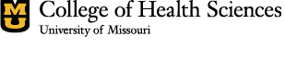
Missouri Cancer Registry and Research Center is supported in part by a cooperative agreement between the Centers for Disease Control and Prevention (CDC) and the Missouri Department of Health and Senior Services (DHSS) (DP2202-22-02) and a Surveillance Contract between DHSS and the University of Missouri.

