
Missouri Cancer Registry
November 2024
Fellow Registrars,
Happy Thanksgiving in advance!
November is Lung Cancer Awareness month. The attached one-pager provides statistical information on lung cancers in Missouri.
DUE DATES
To be on track, large hospitals (>500 cases/yr.) typically would be expected to have abstracted March 2024 diagnosis cases by October 15, 2024. Smaller facilities (<300 cases /yr.) were expected to report the 1st Quarter of 2024 by October 15, 2024.
EDUCATION
MCR Helpline
Reach us at 1-800-392-2829 during regular office hours or leave a message; a member of our QA team will return your call within one business day.

NAACCR Webinars:
MCR is revising its website to include links to the 2024-2025 NAACCR Webinars series. This will replace FLccSC.

NAACCR Webinar: Bladder 2024
November 7, 2024, 8-11 a.m. This webinar will cover anatomy, solid tumor rules, staging and treatment of bladder primary malignancies. Examples, quizzes and case scenarios are included. To attend the live broadcast in Columbia, Mo, sign up here: https://www.signupgenius.com/go/30E0E4BA9A823A6FB6-52623684-naaccr

Visitor Parking at Parking Structure 7 (PS7) for NAACCR Webinars
Only those with a valid PS7 visitor permission pass will be allowed to park there. A daily visitor permit is $7 for parking in lots and $9 for parking garages. Violators are subject to ticketing and towing. You can purchase a visitor pass online at https://missouri.nupark.com/v2/Portal/Login

FlccSC
The Florida Cancer Data System (FLccSC) is currently offline. FLccSC is working diligently to resolve the issue and restore service as quickly as possible.

YouTube
Vulvar Cancer and HPV
MCR has a YouTube video created by Jeff Steffens, BS, ODS-C. This video will review the new histology codes for HPV positive/negative squamous cell carcinoma of the vulva and how the Human Papilloma Virus (HPV) increases the risk of developing this cancer. Includes information not covered in the show-me-tip. Watch the recording on YouTube at:
https://www.youtube.com/watch?v=3Js4X78pUf4

MOODS Study Guide
Exciting news! The Missouri Cancer Registry and Research Center is pleased to announce the Missouri Oncology Data Specialist (MOODS) Study Guide has been updated and available to order! The cost of the study guide is $50. To purchase the MOODS Study Guide, point your smartphone camera at the QR code or CTRL click on the Marketplace link. Add to Cart to place your order.
https://secure.touchnet.net/C20067_ustores/web/product_detail.jsp?PRODUCTID=4863&SINGLESTORE=true


MOODS Study Guide quizzes are now available on-line via Canvas. The quizzes can be taken multiple times. If you previously purchased the MOODS Study Guide and would like to take advantage of this new feature, please email us at umhshmimcr@health.missouri.edu
to get started.

SEER Educate – October 14th News
September 2024 SEER Workshop cases
The September 2024 Workshop cases are still available under the Training Tab. All registrars, whether you attended the Workshop or not, can complete any or all these 4 modules between now and 12/31/2027 for CEs, including Category A CEs. The sessions are being recorded and will eventually be available on the NCRA website, 2024 SEER Workshop.
Usability Issues-Logging On
If you receive a "fredhutch.org says it could not process the request" message from clicking on a bookmark to SEER*Educate, delete that bookmark and create a new one for https://educate.fredhutch.org/ or google SEER*Educate to get to the correct url.
Help Desk will be CLOSED or Limited (in addition to weekends)
- Nov 9 -11 (Veteran’s Day weekend)
- Nov 28 - Dec 1
- Dec 24 - 26
- Jan 1

MCR NEWS
DEATH CLEARANCE
It is especially important to report MISSED CASES once the death clearance list has been reviewed. We still need those cases to clean up our database. We genuinely appreciate your contributions to make this project successful; the information you provide is an essential part for MCR in meeting our annual goals!

MOODS EDUCATIONAL CONFERENCE
MCR was delighted to host the first annual MOODS Educational Conference! Attendees learned about the Cancer Statistics in Missouri, Galleri Multi Cancer Early Detection testing, Solid Tumor Rules for Other Sites, Ingredients to Quality Data, Bladder Cancer abstracting, Brain Tumor Diagnosis and Treatment, and Lung Cancer Diagnosis and Treatment. The day concluded with a rousing game of Jeopardy. The conference was well received, and we are looking forward to providing this FREE educational opportunity again next year as this will meet the new continuing education in-person requirement. See the excerpt from NCRA The Connection under News from Standard Setters.

Next year, we plan to focus on breast, ovary, and hematopoietic sites. If you are interested in being a presenter, please let me know. We would love to hear from you!

Special thanks to our presenters, Jeanie Shaneberger at Boone for providing the location, and the MCR team for their contributions and assistance with the conference.

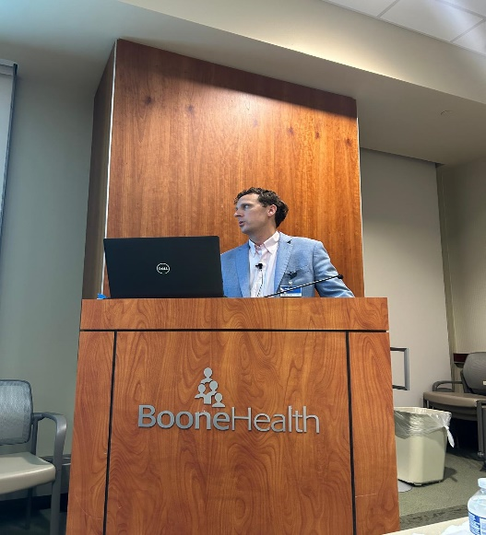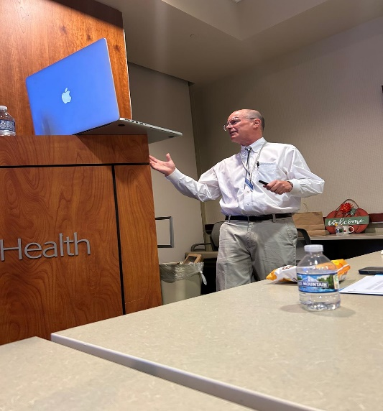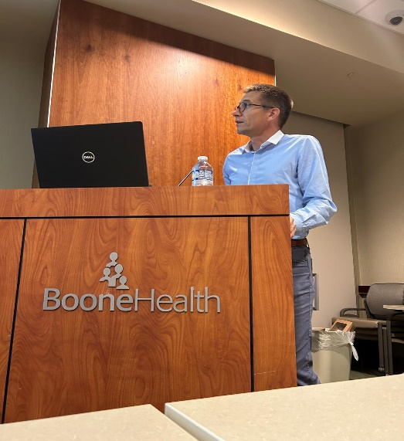
Dr. Andrew Iliff Dr. Charles Bondurant Dr. Sebastian Wiesemann

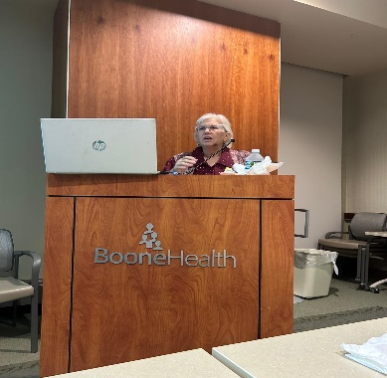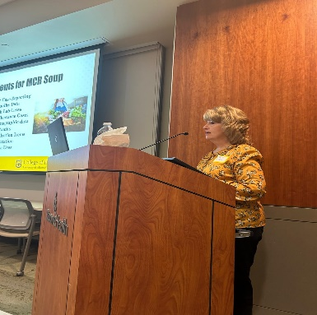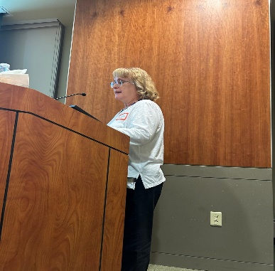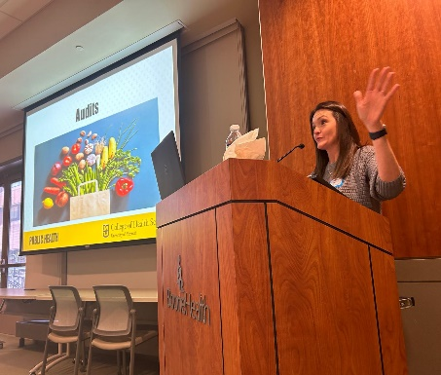
Louanne Currence Lucinda Ham Babette Langeneckert Deborah Carey

MCR CLOSED
MCR will be closed November 28th and 29th for the Thanksgiving holiday

NEWS FROM THE STANDARD SETTERS
NAACCR V25A Metafile
NAACCR has identified a problem with the V25 metafile that requires an updated version. Table SUMST1809 includes all the v9 schemas used for N4900 Summary Stage 2018, Schema ID (NAACCR) and N4910 Derived Summary Stage 2018, Schema ID (SEER). The new schemas for 2025, 09090, 09350, 09360, 09370, were not added to the table. This would cause the edit mentioned above to fail any case with one of the missing schemas. A new Missouri V25A metafile will be created and posted to the NAACCR Clearinghouse by the middle of November.
NCRA
National Cancer Registrars Association's New National Workload and Staffing Study Provides Key Data to Inform Cancer Registry Staff Planning and Budgeting – Excerpt from The Connection, Fall 2024

• For single-institution registries, for every 1,000 cases, staffing should increase by 1.8 to 2.1 FTEs, on average.
• For multi-institution registries, for every 1,000 cases, staffing should increase by 1.6 to 1.9 FTEs, on average.
• There was a 22% increase in the mean number of budgeted FTEs reported from 5.6 in 2019 to 6.8 in 2022. While the number of budgeted FTEs increased, the percentage of filled FTE positions declined slightly from 96.4% in 2019 to 94.1% in 2022.
• Registry leads were most concerned with recruiting well-trained staff (87.6%), compensating staff well enough to retain them (82.3%), and funding additional positions (77%).
• Registry leads reported that nearly half (49.1%) of their staff needed additional training in data analysis, followed by case finding software (26.5%), abstracting software (24.4%), and follow-up (23.3%).
• Nineteen percent of study respondents who are currently working plan to retire or leave the profession in the next five years.

NCRA Continuing Education Requirement Beginning in 2025 Excerpt from The Connection, Fall 2024
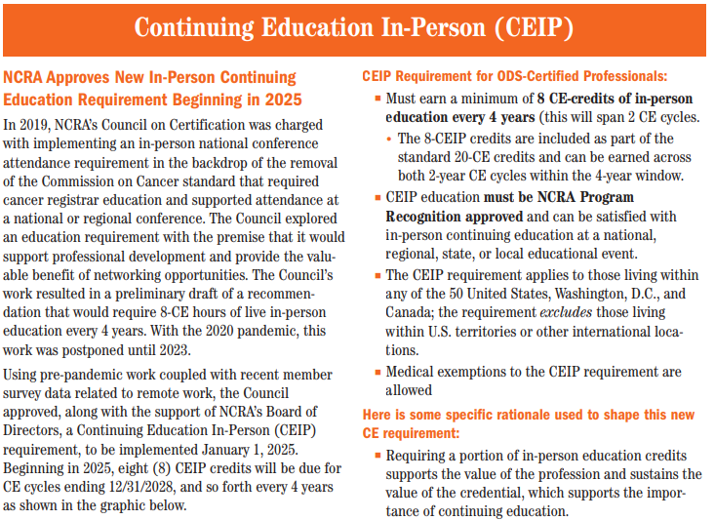

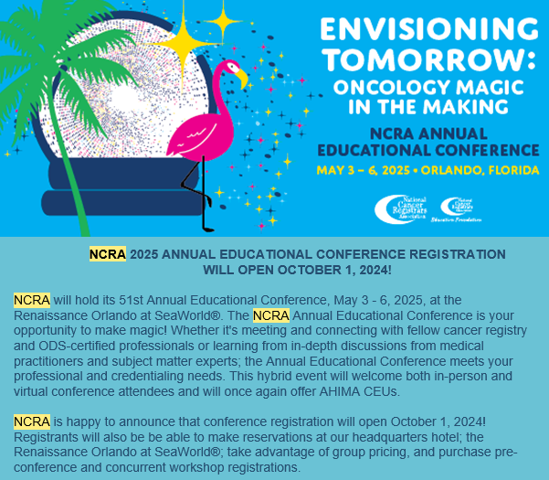
RESOURCES AND ITEMS OF INTEREST
Novel Imaging Technique Accurate for Detecting Clear-Cell Renal Cell Cancer https://www.thelancet.com/journals/lanonc/article/PIIS1470-2045(24)00402-9/fulltext
Pembrolizumab Aids Survival with High-Risk Endometrial Cancer https://ascopubs.org/doi/10.1200/JCO-24-01887

Warm regards,
Lucinda Ham, RHIA, ODS-C  Operations/QA Manager, Missouri Cancer Registry  Department of Public Health  1095 Hospital Drive | Columbia MO 65211  O: 573-882-7775 | C: 573-220-2438  F: 573-884-9655 | E: lahf5p@health.missouri.edu  W: https://cancerregistry.missouri.edu/ | “The only impossible journey is the one you never begin” – Tony Robbins

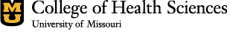
Missouri Cancer Registry and Research Center is supported in part by a cooperative agreement between the Centers for Disease Control and Prevention (CDC) and the Missouri Department of Health and Senior Services (DHSS) (DP2202-22-02) and a Surveillance Contract between DHSS and the University of Missouri.

