**Missouri Cancer Registry**

June 1, 2024

*Fellow Registrars,*

*June is National Cancer Survivor month. Celebrate those who have faced cancer and emerged as survivors.*

*The attached Show-Me-Tip created by Babette focuses on Colorectal Summary Stage.*



DUE DATES

To be on track, large hospitals (>500 cases/yr.) typically would be expected to have abstracted November 2023 diagnosis cases by June 15, 2024. Smaller facilities (<300 cases /yr.) are expected to report the 4th Quarter of 2023 by July 15, 2024.

EDUCATION

**MCR Help-Line**

Reach us at 1-800-392-2829 during regular office hours or leave a message; a member of our QA team will return your call within one business day.

**FlccSC-New Course Available!**

**Earn 3 CE’s** NAACCR Webinar – **Ovary 2024** presented May 2024

**NAACCR Webinars:**

**NAACCR Webinar: Thyroid 2024**

**June 6, 2024,** 8-11 a.m. This webinar will cover anatomy, solid tumor rules, staging and treatment of thyroid primary malignancies. Examples, quizzes, and case scenarios included. **To attend the live broadcast in Columbia**, MO, sign up here: [**https://www.signupgenius.com/go/30E0E4BA9A823A6FB6-49690643-naaccr**](https://www.signupgenius.com/go/30E0E4BA9A823A6FB6-49690643-naaccr)

**Visitor Parking at Parking Structure 7 (PS7) for NAACCR Webinars**

Only those with a valid PS7 visitor permission pass will be allowed to park there. A daily visitor permit is $7 for parking in lots and $9 for parking garages. Violators are subject to ticketing and towing. You can purchase a visitor pass online at[**https://missouri.nupark.com/v2/Portal/Login**](https://missouri.nupark.com/v2/Portal/Login)

**Show-Me-Tips**

June 2024 Show-Me-Tip **is “Colorectal SEER Summary Stage”.** This show-me-tip will review anatomy of the colon and rectum (nonperitonealized versus peritonealized tissue) and SEER summary stage rules regarding coding colorectal primaries based on invasion into the pericolorectal tissue.

**MOODS Study Guide**

Exciting news! The Missouri Cancer Registry and Research Center is pleased to announce the Missouri Oncology Data Specialist (MOODS) Study Guide has been updated and available to order! The cost of the study guide is $50. To purchase the **MOODS Study Guide**, point your smartphone camera at the QR code or CTRL click on the Marketplace link. **Add to C**art to place your order.

[**https://secure.touchnet.net/C20067_ustores/web/product_detail.jsp?PRODUCTID=4863&SINGLESTORE=true**](https://nam02.safelinks.protection.outlook.com/?url=https%3A%2F%2Fsecure.touchnet.net%2FC20067_ustores%2Fweb%2Fproduct_detail.jsp%3FPRODUCTID%3D4863%26SINGLESTORE%3Dtrue&data=05%7C02%7Clahf5p%40health.missouri.edu%7C685e21bd4f8b49cabd1a08dc394435e1%7Ce3fefdbef7e9401ba51a355e01b05a89%7C0%7C0%7C638448212475332259%7CUnknown%7CTWFpbGZsb3d8eyJWIjoiMC4wLjAwMDAiLCJQIjoiV2luMzIiLCJBTiI6Ik1haWwiLCJXVCI6Mn0%3D%7C0%7C%7C%7C&sdata=XAFjOt8ILi7BikfkcMSVEZpBenor%2FSEijvXYw%2FGzezk%3D&reserved=0)

**MOODS Study Guide quizzes are now available on-line via Canvas. The quizzes can be taken multiple times. If you previously purchased the MOODS Study Guide and would like to take advantage of this new feature, please email us at** [**umhshmimcr@health.missouri.edu**](mailto:umhshmimcr@health.missouri.edu)

**to get started.**

**Abstracting Tip**



**SEER Educate**

**2024 Case Coding Updates**

SEER Educate completed updating existing coding exercises to include notes for any impact of the 2024 changes. Please note, most of SEERs coding exercises have a diagnosis date prior to 2024. SEER has updated the rationales for the cases if there were any coding guideline that would differ on a case in 2024. The tests have links to the correct Dx Year of the SEER Coding and Staging Program Manual for the case scenario. Log in or sign up at **SEER*Educate** today by visiting [**https://educate.fredhutch.org/**](https://nam02.safelinks.protection.outlook.com/?url=https%3A%2F%2Feducate.fredhutch.org%2F&data=05%7C02%7Clahf5p%40health.missouri.edu%7C612a0257746043ed9a0308dc799a19a6%7Ce3fefdbef7e9401ba51a355e01b05a89%7C0%7C0%7C638518950257942955%7CUnknown%7CTWFpbGZsb3d8eyJWIjoiMC4wLjAwMDAiLCJQIjoiV2luMzIiLCJBTiI6Ik1haWwiLCJXVCI6Mn0%3D%7C0%7C%7C%7C&sdata=oqXJV%2FHCrrzVFffddzWpdyxbEuHZJCrnACxC8ZrJY9Q%3D&reserved=0)  and Learn by Doing!

Help Desk will be CLOSED or Limited (in addition to weekends)

* June 19th
* June 24-26 (Extremely limited due to NAACCR Annual Conference)
* July 4-7 (July 4th extended weekend)

***MCR NEWS***

GOLD CERTIFICATION

Missouri Cancer Registry is pleased to announce we received the NAACCR Gold Certification for 2021 data. We could not have reached this goal without your dedication and cooperation in providing accurate, timely data! Congratulations to the MCR team and to you!

MCR SOFTWARE UPGRADED TO V24

We have successfully upgrade Web Plus and our other software programs to **accept 2024 cases**. Thank you for your patience during the downtime and for sending test files upon request. Please contact me if you have any questions.

SAVE THE DATE!

Mark your calendars for the **MOODS Educational** Day at Boone Hospital Center on **Friday,** **October 4, 2024**. This will be a free one-day educational opportunity with lunch included. We will be offering 6 CE NCRA approved hours.

ELLIS FISCHEL CANCER RESEARCH DAY

Research and studies on data are part of the activities performed at MCR. Several MCR staff participated in the Ellis Fischel Research Day on April 30th by presenting poster presentations on the following topics: Childhood Cancers, Hematopoietic Cancers, Lung Cancer Treatment Delays, Patterns of Cancer Statistics in Central Missouri, Cervical Cancers, and Social Media Rare Cancer Discussions. Mohammad Beheshti, MSHI, our Graduate Research Assistant, won an award for his abstract on Lung Cancer Treatment Delays.

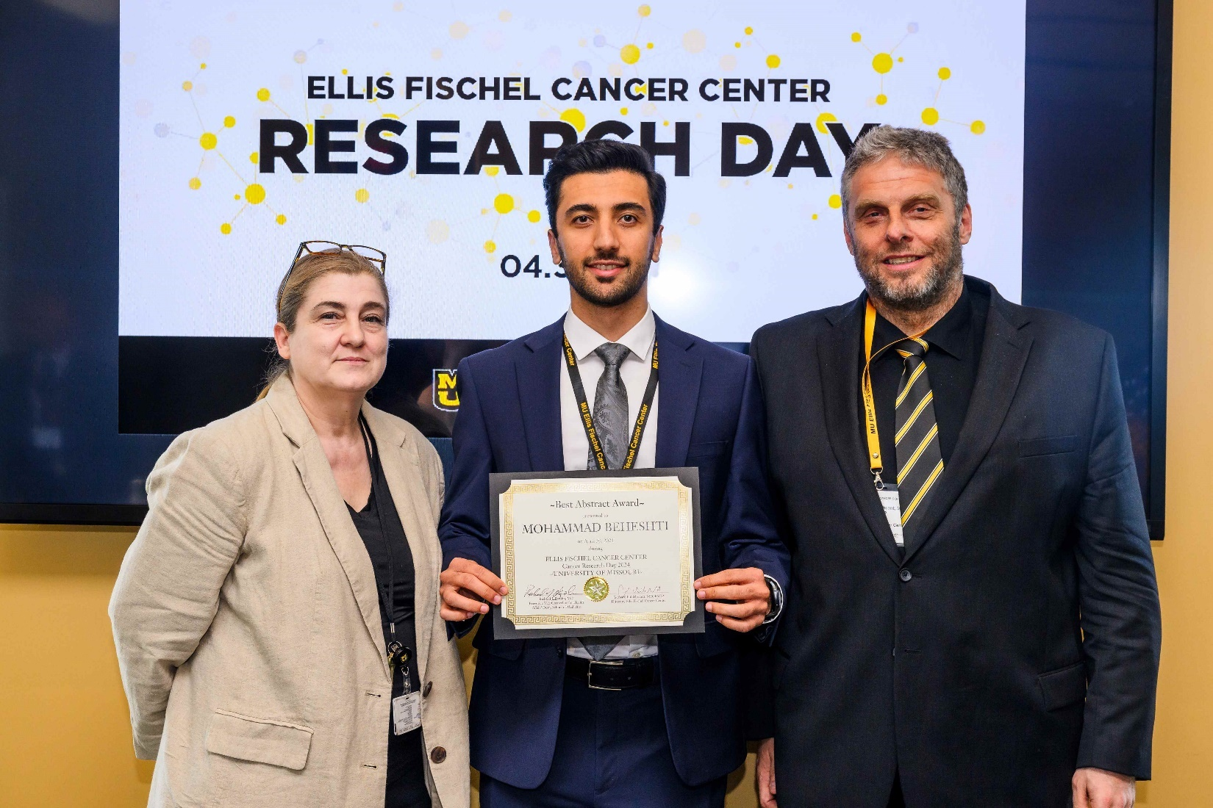

Pictured above: Dr. Iris Zachary, Mohammad Beheshti, and Dr. Gerhard Hildebrandt

Left: Nishant Jain explains his poster on Social Media Rare Cancer Discussions. Right: Vishwa Bhayani explains her poster on Cervical Cancers.

Left: Deborah Carey presented a poster on Hematopoietic and Lymphoid Cancers. Center: Lucinda Ham presented a poster on Childhood cancers. Right: Dr. Chester Schmaltz presented a poster on Cancers in Central Missouri.

FAMIA INDUCTEE

**Congratulations to Dr. Iris Zachary, MCR Director and Associate Research Professor** in the Department of Public Health, on being selected for induction as a Fellow of the American Medical Informatics Association (FAMIA). Dr. Zachary is among [84 new fellows selected](https://amia.org/news-publications/new-fellows-american-medical-informatics-association-famia-honored-achievements) to join the community of more than 500 FAMIA inductees.

The American Medical Informatics Association is the leading professional association for informatics professionals and the center of action for more than 5,500 informatics professionals from more than sixty-five countries. The AMIA and its members help assess the effect of health innovations on health policy and advance the field of informatics.

NEWS FROM THE STANDARD SETTERS

**NAACCR v24A**

NAACCR v24A metafile, published May 15, 2024, includes new edits and corrections to v24. A new Missouri v24A metafile has been posted to the clearinghouse for cancer registry vendors.

**Cancer Path Chart**

Cancer Path Chart is new for 2024 cases. CPC*Search is an interactive webtool on the SEER website that allows cancer registrars and other users to search the[**2024 Cancer PathCHART ICD-O-3 Site Morphology Validation List (CPC*SMVL)**](https://seer.cancer.gov/cancerpathchart/products.html) validity standards by tumor site, histology, and behavior terms and associated codes. Seach results include the validity status of tumor histology and behavior by site and organ system which indicates if specific tumor site-morphology combinations are biologically valid, impossible, or unlikely. Use this link to check questionable code combinations. [**https://seer.cancer.gov/cancerpathchart/search/tool/**](https://seer.cancer.gov/cancerpathchart/search/tool/)

REGISTRY TO RESEARCH

DDW: 1999 to 2020 Saw Rise in Incidence of Colorectal Cancer in People Under 45 (CDC) <https://news.ddw.org/news/alarming-increases-in-crc-incidence-among-younger-adults/>

Racial, Ethnic Differences Seen in Breast Cancer Treatment Declination (NCDB) <https://jamanetwork.com/journals/jamanetworkopen/fullarticle/2818493>

Persistent Sociodemographic Differences Seen in Use of AutoHCT for Multiple Myeloma <https://www.clinical-lymphoma-myeloma-leukemia.com/article/S2152-2650(23)02199-7/abstract>

Lower Prevalence of Employment Seen for Survivors of Childhood Cancer (NCI) <https://jamanetwork.com/journals/jamanetworkopen/fullarticle/2818556>

RESOURCES AND ITEMS OF INTEREST

Symptom Burden Prevalent in Childhood Cancer Survivors <https://jamanetwork.com/journals/jamanetworkopen/fullarticle/2818384>

Second Primary Breast Cancer in Young Breast Cancer Survivors <https://jamanetwork.com/journals/jamaoncology/fullarticle/2817452>

Warm regards,

|  |  |  |
| --- | --- | --- |
| *Lucinda Ham, RHIA, ODS-C*  *Operations/QA Manager, Missouri Cancer Registry*   |  | | --- | |  |   Department of Public Health  **1095 Hospital Drive** | Columbia MO 65211  **O:**573-882-7775 | **C:**573-220-2438 **F:**573-884-9655 | **E:**[lahf5p@health.missouri.edu](mailto:lahf5p@health.missouri.edu) **W:** [**https://cancerregistry.missouri.edu/**](https://cancerregistry.missouri.edu/) | *“The only impossible journey is the one you never begin” – Tony Robbins* |



Missouri Cancer Registry and Research Center is supported in part by a cooperative agreement between the Centers for Disease Control and Prevention (CDC) and the Missouri Department of Health and Senior Services (DHSS) (DP2202-22-02) and a Surveillance Contract between DHSS and the University of Missouri.