**Missouri Cancer Registry**

April 1, 2024

*Fellow Registrars,*

*Happy Spring! National Cancer Registrar’s week is April 8-12th. We hope you have a great week! We appreciate your knowledge, dedication and efforts in abstracting and submitting data.*

DUE DATES

To be on track, large hospitals (>500 cases/yr.) typically would be expected to have abstracted September 2023 diagnosis cases by April 15, 2024. Smaller facilities (<300 cases /yr.) are expected to report the 3rd Quarter of 2023 by April 15, 2024.

EDUCATION

**MCR Help-Line**

Reach us at 1-800-392-2829 during regular office hours or leave a message; a member of our QA team will return your call within one business day.

**FlccSC-New Course Available!**

**Earn 3 CE’s**

NAACCR Webinar – Boot Camp 1 2024 presented March 2024

**NAACCR Webinars:**

**NAACCR Webinar: Boot Camp 2 2024**

**April 4, 2024,** 8-11 a.m., We will have 2 boot camps this year! This will allow us to spend more time on core casefinding and abstracting activities. We will spend most of our time completing and reviewing quizzes, exercises, and case scenarios. There will be minimal lecture. To attend the live broadcast in Columbia, Mo, sign up here:[**https://www.signupgenius.com/go/30E0E4BA9A823A6FB6-48693627-naaccr**](https://www.signupgenius.com/go/30E0E4BA9A823A6FB6-48693627-naaccr)

**Visitor Parking at Parking Structure 7 (PS7) for NAACCR Webinars**

Only those with a valid PS7 visitor permission pass will be allowed to park there. A daily visitor permit is $7 for parking in lots and $9 for parking garages. Violators are subject to ticketing and towing. You can purchase a visitor pass online at[**https://missouri.nupark.com/v2/Portal/Login**](https://missouri.nupark.com/v2/Portal/Login)

**YouTube Video**

**MCR Solid Tumor Rules-Other Sites YouTube Video**

Check out the new video on YouTube by Babette Langeneckert, ODS-C. This video covers the Solid Tumor Rules-Other Sites for 2023 & 2024. There are new instructions for assigning primary sites for liver and intrahepatic bile duct neoplasms. [**https://www.youtube.com/watch?v=o-C0bAqrEXY**](https://nam02.safelinks.protection.outlook.com/?url=https%3A%2F%2Fwww.youtube.com%2Fwatch%3Fv%3Do-C0bAqrEXY&data=05%7C02%7Clahf5p%40health.missouri.edu%7C685e21bd4f8b49cabd1a08dc394435e1%7Ce3fefdbef7e9401ba51a355e01b05a89%7C0%7C0%7C638448212475318191%7CUnknown%7CTWFpbGZsb3d8eyJWIjoiMC4wLjAwMDAiLCJQIjoiV2luMzIiLCJBTiI6Ik1haWwiLCJXVCI6Mn0%3D%7C0%7C%7C%7C&sdata=lshx2ngGziwT1Y8vlnvHRltboQzndlegu%2F4laX82ZH8%3D&reserved=0)

**Fundamentals of Abstracting Workshop – Spring 2024**

MCR is hosting an on-line Fundamentals of Abstracting course beginning April 1, 2024, to be taken at your own pace through May 15, 2024.  This class is geared toward new abstractors who are not familiar with the abstracting process. If you are not familiar with abstracting and/or the required fields, this is a great place to start learning. Students will view fifteen pre-recorded VoiceThread presentations of the Missouri Cancer Registry Abstract Code Manual. When completed with the VoiceThread presentations students can work through five practice cases. The cost of the course is $50 and will be available on the University of Missouri Canvas platform. You can register and pay for the course by pointing your smartphone camera at the QR code or CTRL click on the Marketplace link. Click on **MCR Fundamentals of Abstracting Course** to place your order.

[**https://secure.touchnet.net/C20067_ustores/web/store_main.jsp?STOREID=248&SINGLESTORE=true**](https://nam02.safelinks.protection.outlook.com/?url=https%3A%2F%2Fsecure.touchnet.net%2FC20067_ustores%2Fweb%2Fstore_main.jsp%3FSTOREID%3D248%26SINGLESTORE%3Dtrue&data=05%7C02%7Clahf5p%40health.missouri.edu%7C685e21bd4f8b49cabd1a08dc394435e1%7Ce3fefdbef7e9401ba51a355e01b05a89%7C0%7C0%7C638448212475325077%7CUnknown%7CTWFpbGZsb3d8eyJWIjoiMC4wLjAwMDAiLCJQIjoiV2luMzIiLCJBTiI6Ik1haWwiLCJXVCI6Mn0%3D%7C0%7C%7C%7C&sdata=ioNzYrxlHZo7o6mozKnKjLedGTagMJIIUK3P9fZXb4c%3D&reserved=0)

**Registration is due by March 31, 2024**

**MOODS Study Guide**

Exciting news! The Missouri Cancer Registry and Research Center is pleased to announce the Missouri Oncology Data Specialist (MOODS) Study Guide has been updated and available to order! The cost of the study guide is $50. To purchase the **MOODS Study Guide**, point your smartphone camera at the QR code or CTRL click on the Marketplace link. Add to Cart to place your order.

[**https://secure.touchnet.net/C20067_ustores/web/product_detail.jsp?PRODUCTID=4863&SINGLESTORE=true**](https://nam02.safelinks.protection.outlook.com/?url=https%3A%2F%2Fsecure.touchnet.net%2FC20067_ustores%2Fweb%2Fproduct_detail.jsp%3FPRODUCTID%3D4863%26SINGLESTORE%3Dtrue&data=05%7C02%7Clahf5p%40health.missouri.edu%7C685e21bd4f8b49cabd1a08dc394435e1%7Ce3fefdbef7e9401ba51a355e01b05a89%7C0%7C0%7C638448212475332259%7CUnknown%7CTWFpbGZsb3d8eyJWIjoiMC4wLjAwMDAiLCJQIjoiV2luMzIiLCJBTiI6Ik1haWwiLCJXVCI6Mn0%3D%7C0%7C%7C%7C&sdata=XAFjOt8ILi7BikfkcMSVEZpBenor%2FSEijvXYw%2FGzezk%3D&reserved=0)

**SEER Educate – March 5th News**

**System Upgrade**

SEER Educate performed software maintenance activities February 9-11. There were two sets of issues resulting from this upgrade: 1) Major pieces of functionality that require further upgrading and 2) Bugs that are inconvenient.

SEERS’ priority during February and March is to complete the upgrading of these major issues. Log in or sign up at SEER*Educate today by visiting[**https://educate.fredhutch.org/**](https://educate.fredhutch.org/) and Learn by Doing!

**Help Desk will be CLOSED (in addition to weekends)**

April 4-5 (content issues)

WEBSITE UPDATE

Our website has a new streamlined look! Click on the Missouri Cancer Registry and Research banner on any page to return to the Home page. The Web Plus Login button is available on every page in the yellow banner. The Web Plus Login page includes all Web Plus user instructions. Overall, you will be able to find information and resources in the same location. If you have any issues, please let us know. Here is the new website address: [**https://cancerregistry.missouri.edu/**](https://cancerregistry.missouri.edu/)

NEWS FROM THE STANDARD SETTERS

**NCRA 50th Annual Educational Conference**

The National Cancer Registrars Association will hold its 50th Annual Educational Conference, April 24-27, 2024, at the JW Marriott in Indianapolis, Indiana. This hybrid event will welcome both in-person and virtual conference registrants. For in-person registrants, the destination city Indianapolis offers world-class attractions and amusements all convenient to the downtown location of the JW Marriott Indianapolis.

The 2024 Conference Program Committee has designed the educational sessions to showcase critical cancer registry topics and help registrars stay current. To celebrate its 50th anniversary, NCRA will host three special keynote panels. The first will kick off the conference with a look back at NCRA’s history, the second will focus on where we are now and include updates from NCRA’s national partners, and the final day will include a panel discussion on what the future holds for the cancer registry profession. 20 + CE hours will be available. [**https://www.ncra-usa.org/Conference/2024-NCRA-Annual-Conference/2024-Conference-Information**](https://www.ncra-usa.org/Conference/2024-NCRA-Annual-Conference/2024-Conference-Information)



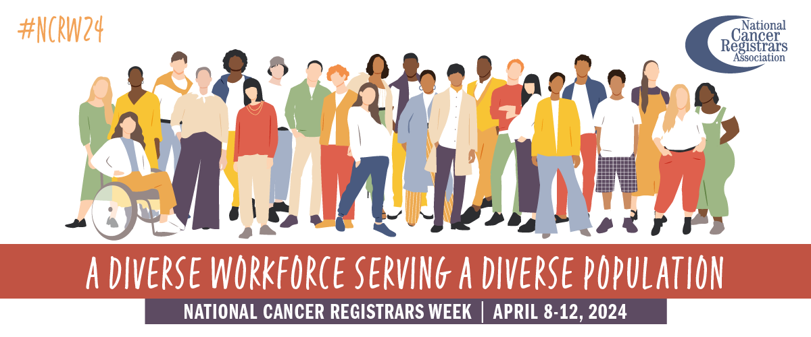

**NAACCR Annual Conference – Discovering Gems Using Cancer Surveillance Data**

The 2024 NAACCR Annual Conference will be held in Boise, Idaho June 25-27, 2024. The program committee is developing a plenary program with the theme “Discovering Gems Using Cancer Surveillance Data.” For more information see [**https://www.naaccr24boise.org/**](https://www.naaccr24boise.org/)

REGISTRY TO RESEARCH

Eligibility for Lung Cancer Screening Up With 2021 USPSTF Recommendations <https://jamanetwork.com/journals/jamanetworkopen/fullarticle/2816601>

RESOURCES AND ITEMS OF INTEREST

Calcium, Vitamin D Supplements May Reduce Cancer Mortality in Long Term <https://www.acpjournals.org/doi/10.7326/M23-2598>

Childhood Cancer Survivors Often Not Adherent to Surveillance Tests <https://www.cmaj.ca/content/196/9/E282>

Metabolic Syndrome Score Trajectories Associated with Risk for Cancer <https://acsjournals.onlinelibrary.wiley.com/doi/full/10.1002/cncr.35235>

Experimental Prophylaxis Beneficial for Patients Undergoing HSCT <https://www.nejm.org/doi/full/10.1056/NEJMoa2215943>

Iptacopan Improves Hematologic, Clinical Outcomes in Persistent Anemia <https://www.nejm.org/doi/full/10.1056/NEJMoa2308695>

Warm regards,

|  |  |  |
| --- | --- | --- |
| *Lucinda Ham, RHIA, ODS-C*  *Operations/QA Manager, Missouri Cancer Registry*   |  | | --- | |  |   Department of Public Health  **1095 Hospital Drive** | Columbia MO 65211  **O:**573-882-7775 | **C:**573-220-2438 **F:**573-884-9655 | **E:**[lahf5p@health.missouri.edu](mailto:lahf5p@health.missouri.edu) **W:** [**https://cancerregistry.missouri.edu/**](https://cancerregistry.missouri.edu/) | *“The only impossible journey is the one you never begin” – Tony Robbins* |



Missouri Cancer Registry and Research Center is supported in part by a cooperative agreement between the Centers for Disease Control and Prevention (CDC) and the Missouri Department of Health and Senior Services (DHSS) (DP2202-22-02) and a Surveillance Contract between DHSS and the University of Missouri.